**BAB IV**

**RANCANGAN SISTEM DAN PROGRAM USULAN**

**4.1. Analisa Kebutuhan Software**

**A. Tahapan Analisis**

Pada bab ini akan dimulai dilakukan rancangan komputerisasi sistem informasi penggajian karyawan berdasarkan analisa yang diperoleh pada bab-bab sebelumnya sesuai analisa perancangan terstruktur. Berikut ini spesifikasi kebutuhan (*system requirement)* dari sistem informasi penggajian karyawan.

Halaman Admin :

A.1 Admin dapat mengelola karyawan

A.2 Admin dapat mengelola data absensi

A.3 Admin dapat mengelola *salary*

A.4 Admin dapat mencetak laporan

A.5 Admin dapat mengelola akun login

Halaman *Finance* :

B.1 *Finance* dapat melihat dan proses rekap absensi

B.2 *Finance* dapat melihat dan proses rekap *salary*

B.3 *Finance* dapat mencetak laporan

Halaman Direktur :

C.1 Direkturdapat melihat dan proses rekap *salary*

C.2 Direktur dapat melihat laporan

**B. *Use Case Diagram***

**1. *Use Case Diagram* Halaman Admin**

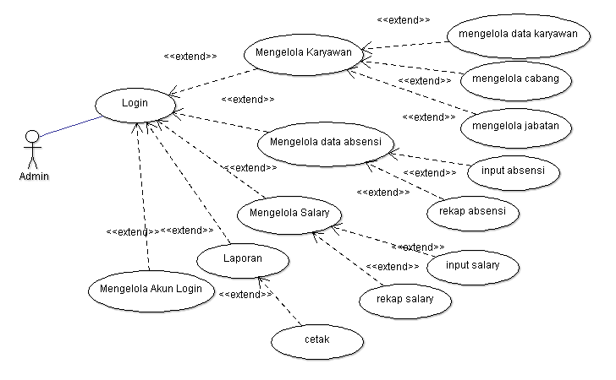

**Gambar IV.1.**

***Detail Use Case* *Diagram* Halaman Admin**

1. Deskripsi *Use Case Diagram* Mengelola Karyawan

**Tabel IV.1.**

**Deskripsi *Use Case Diagram* Mengelola Karyawan**

|  |  |
| --- | --- |
| **Use Case Name** | **Mengelola Karyawan** |
| Requirements | A1 |
| Goal | Admin dapat melihat, menambah, mengupdate, dan menghapus data karyawan, cabang dan jabatan |
| Pre-conditions | Admin telah *Login* |
| Post-conditions | Data karyawan, cabang dan jabatan tampil, Data karyawan, cabang dan jabatan berhasil di *input* |
| Failed end condition | Gagal menampilkan data karyawan, cabang dan jabatan. Gagal menginput data karyawan, cabang dan jabatan. |
| Primary Actors | *Administrator* |
| Main Flow / Basic Path | 1. Melihat data karyawan, cabang dan jabatan 2. *System* menampilkan form tambah data karyawan, cabang dan jabatan 3. Input data karyawan, cabang dan jabatan. 4. Admin klik tombol ‘simpan’ 5. *System m*enyimpan data karyawan, cabang dan jabatan |
| Invariant A | **-** |
| Invariant B | **-** |

1. Deskripsi *Use Case Diagram* Mengelola data absensi

**Tabel IV.2.**

**Deskripsi *Use Case Diagram* Mengelola data absensi**

|  |  |
| --- | --- |
| **Use Case Name** | **Mengelola data absensi** |
| Requirements | A2 |
| Goal | Admin dapat melihat data menginput dan edit data absensi |
| Pre-conditions | Admin telah *Login* |
| Post-conditions | Data absensi terinput dan tersimpan |
| Failed end condition | Gagal edit dan menyimpan |
| Primary Actors | *Administrator* |
| Main Flow / Basic Path | 1. Admin dapat melihat data absensi 2. Admin memilih tombol *detail* 3. *System* menampilkan update data absensi 4. *Admin Input* data absensi 5. *Admin memilih tombol save* 6. *System* menyimpan data absensi |
| Invariant A | **-** |
| Invariant B | **-** |

1. Deskripsi *Use Case Diagram* Mengelola *Salary*

**Tabel IV.3.**

**Deskripsi *Use Case Diagram* Mengelola *Salary***

|  |  |
| --- | --- |
| **Use Case Name** | **Mengelola *Salary*** |
| Requirements | A3 |
| Goal | dapat menambah, mengubah, dan menghapus data gaji |
| Pre-conditions | Admin telah *Login* |
| Post-conditions | Data *Salary* tersimpan, ter*update,* atau terhapus |
| Failed end condition | Gagal menyimpan, meng*update,* atau menghapus data *salary* |
| Primary Actors | *Administrator* |
| Main Flow / Basic Path | 1. Melihat data *salary* 2. Menambah data *salary* 3. Menyimpan data *salary* |
| Invariant A | 2a. Mengedit data *salary* |
| Invariant B | 2b. Menghapus data *salary* |

1. Deskripsi *Use Case Diagram* Laporan

**Tabel IV.4.**

**Deskripsi *Use Case Diagram* Laporan**

|  |  |
| --- | --- |
| **Use Case Name** | **Laporan** |
| Requirements | A4 |
| Goal | dapat mencetak laporan gaji |
| Pre-conditions | Admin telah *Login* |
| Post-conditions | Mencetak laporan |
| Failed end condition | Gagal mencetak laporan |
| Primary Actors | *Administrator* |
| Main Flow / Basic Path | 1. Admin dapat melihat laporan *salary* 2. Admin dapat mencetak laporan *salary* |
| Invariant A | *-* |
| Invariant B | *-* |

1. Deskripsi *Use Case Diagram* Mengelola Akun *Login*

**Tabel IV.5.**

**Deskripsi *Use Case Diagram* Mengelola Akun *Login***

|  |  |
| --- | --- |
| **Use Case Name** | **Mengelola Akun *Login*** |
| Requirements | A6 |
| Goal | dapat menambah, mengubah, dan menghapus akun |
| Pre-conditions | Admin telah *Login* |
| Post-conditions | Akun tersimpan, ter*update,* atau terhapus |
| Failed end condition | Gagal menyimpan, meng*update,* atau menghapus akun |
| Primary Actors | *Administrator* |
| Main Flow / Basic Path | 1. Melihat data akun 2. Menambah data akun 3. Menyimpan data akun |
| Invariant A | 2a. Mengedit data akun |
| Invariant B | 2b. Menghapus data akun |

1. ***Use Case Diagram* Halaman *Finance***

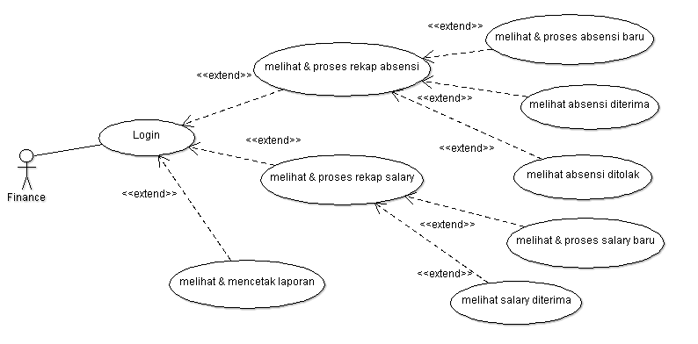

**Gambar IV.2.**

***Detail Use Case* *Diagram* Halaman *Finance***

1. Deskripsi *Use Case Diagram* Melihat dan Proses Rekap Absensi

**Tabel IV.6.**

**Deskripsi *Use Case Diagram* Melihat dan Proses Rekap Absensi**

|  |  |
| --- | --- |
| **Use Case Name** | **Melihat dan Proses Rekap Absensi** |
| Requirements | B1 |
| Goal | *Finance* proses rekap absensi |
| Pre-conditions | *Finance* telah *login* |
| Post-conditions | Rekap absensi di proses |
| Failed end condition | Rekap absensi di tolak |
| Primary Actors | *Finance* |
| Main Flow / Basic Path | 1. *Finance* melihat dan proses rekap absensi baru 2. *Finance* dapat melihat rekap absensi diterima 3. *Finance* dapat melihat rekap absensi di tolak |
| Alternate Flow / Invariant 1 | **-** |
| Invariant 2 | **-** |

1. Deskripsi *Use Case Diagram* Melihat dan Proses rekap *salary*

**Tabel IV.7.**

**Deskripsi *Use Case Diagram* Proses Rekap *Salary***

|  |  |
| --- | --- |
| **Use Case Name** | **Proses Rekap Salary** |
| Requirements | B2 |
| Goal | *Finance* proses rekap *salary* |
| Pre-conditions | *Finance* telah *login* |
| Post-conditions | Rekap *salary* di proses |
| Failed end condition | Rekap *salary* di tolak |
| Primary Actors | *Finance* |
| Main Flow / Basic Path | 1. *Finance* dapat melihat dan proses rekap *salary* 2. *Finance* dapat melihat rekap *salary* diterima |
| Alternate Flow / Invariant 1 | **-** |
| Invariant 2 | **-** |

1. Deskripsi *Use Case Diagram* Melihat dan MencetakLaporan

**Tabel IV.7.**

**Deskripsi *Use Case Diagram* Melihat dan MencetakLaporan**

|  |  |
| --- | --- |
| **Use Case Name** | **Melihat dan MencetakLaporan** |
| Requirements | B3 |
| Goal | *Finance* mencetak laporan *salary* |
| Pre-conditions | *Finance* telah *login* |
| Post-conditions | *Finance* berhasil mencetak laporan |
| Failed end condition | *Finance gagal* mencetak laporann |
| Primary Actors | *Finance* |
| Main Flow / Basic Path | 1. *Finance* dapat melihat laporan *salary* 2. *Finance* dapat mencetak laporan *salary* |
| Alternate Flow / Invariant 1 | **-** |
| Invariant 2 | **-** |

1. ***Use Case Diagram* Halaman Direktur**

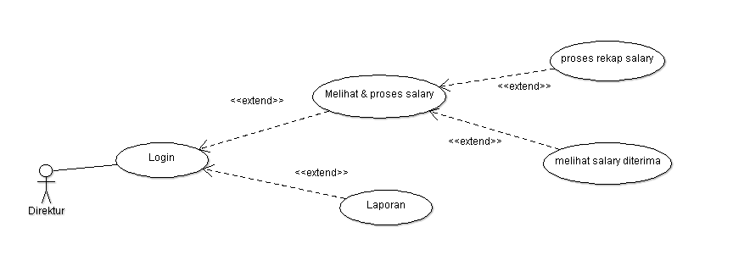

**Gambar IV.3.**

***Detail Use Case* *Diagram* Halaman Direktur**

1. Deskripsi *Use Case Diagram* Melihat dan Proses Rekap *Salary*

**Tabel IV.8.**

**Deskripsi *Use Case Diagram Salary***

|  |  |
| --- | --- |
| **Use Case Name** | **Proses Rekap *Salary*** |
| Requirements | C1 |
| Goal | Direktur proses rekap *salary* |
| Pre-conditions | Direktur telah *login* |
| Post-conditions | Rekap *salary* di proses |
| Failed end condition | Rekap *salary* di tolak |
| Primary Actors | Direktur |
| Main Flow / Basic Path | 1. Direkturdapat melihat dan proses rekap *salary* 2. Direkturdapat melihat rekap *salary* diterima |
| Alternate Flow / Invariant 1 | **-** |
| Invariant 2 | **-** |

1. Deskripsi *Use Case Diagram* MelihatLaporan

**Tabel IV.9.**

**Deskripsi *Use Case Diagram* Laporan**

|  |  |
| --- | --- |
| **Use Case Name** | **Melihat Laporan** |
| Requirements | C2 |
| Goal | Direktur dapat mencetak laporan *salary* |
| Pre-conditions | Direktur telah *login* |
| Post-conditions | Direktur berhasil mencetak laporan *salary* |
| Failed end condition | Direktur gagal mencetak laporan *salary* |
| Primary Actors | Direktur |
| Main Flow / Basic Path | 1. Direkturdapat melihat laporan *salary* 2. Direkturdapat mencetak laporan *salary* |
| Alternate Flow / Invariant 1 | - |
| Invariant 2 | - |

**C. *Activity Diagram***

**1. *Activity Diagram* Penggajian Karyawan Halaman Admin**

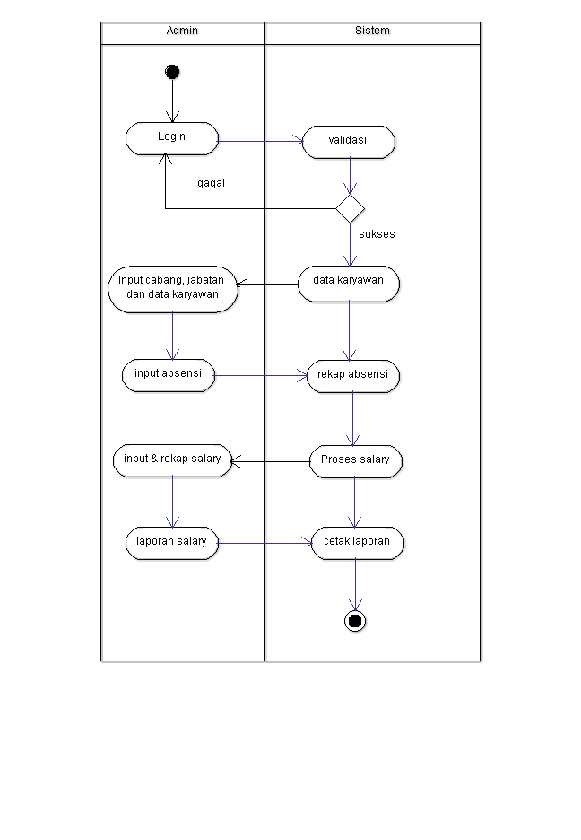

**Gambar IV.4.**

**Activity Diagram Penggajian Karyawan Halaman Admin**

**2. *Activity Diagram* Penggajian Karyawan Halaman *Finance***

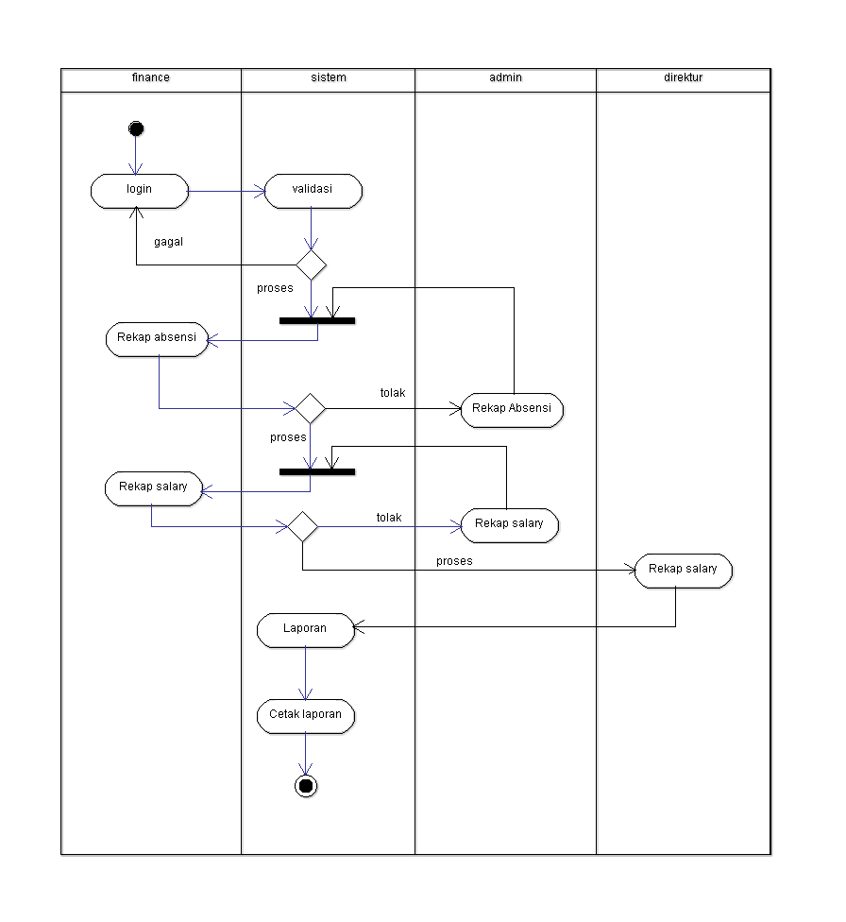

**Gambar IV.5.**

**Activity Diagram Penggajian Karyawan Halaman *Finance***

**3. *Activity Diagram* Penggajian Karyawan Halaman Direktur**

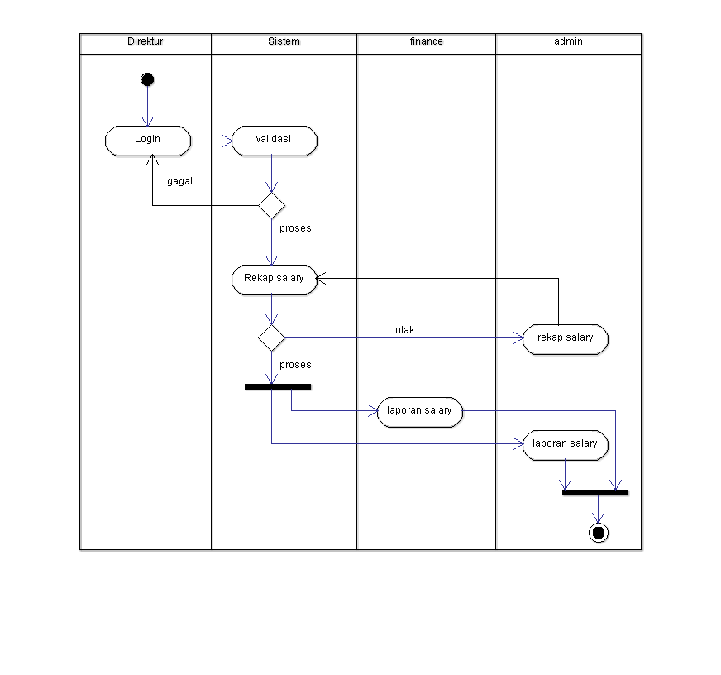

**Gambar IV.6.**

**Activity Diagram Penggajian Karyawan Halaman Direktur**

**4.2. Desain**

**4.2.1 *Database***

1. ***Entity Relationship Diagram***



**Gambar IV.7.**

***Entity Relationship Diagram* Sistem Penggajian Karyawan**

1. ***Logical Record Structure***



**Gambar IV.8.**

***Logical Record Structure* Sistem Penggajian Karyawan**

1. **Spesifikasi *File***
2. **Spesifikasi Tabel Karyawan**

Nama *Database* : penggajian

Nama *File* : karyawan

Akronim : karyawan.myd

Tipe *File* : *File Master*

Akses *File* : *Random*

Panjang *Record* : 110 *byte*

Kunci *Field* : nik_karyawan

**Tabel IV.10.**

**Spesifikasi *File* Tabel Karyawan**

|  |  |  |  |  |  |
| --- | --- | --- | --- | --- | --- |
| **No.** | **Elemen Data** | **Nama *Field*** | **Type** | **Size** | **Keterangan** |
| 1 | NIK Karyawan | nik_karyawan | *vachar* | 6 | *Primary Key* |
| 2 | Nama Lengkap | nama_karyawan | *vachar* | 50 |  |
| 3 | Agama | agama_karyawan | *enum* | 0 |  |
| 4 | Jenis Kelamin | jkel_kelamin | *enum* | 0 |  |
| 5 | Tanggal lahir | lhr_karyawan | *date* |  |  |
| 6 | Email | email_karyawan | *text* |  |  |
| 7 | No Telp / HP | tlp_karyawan | *varchar* | 20 |  |
| 8 | Alamat | alamat_karyawan | *text* |  |  |
| 9 | No Rekening | norek_karyawan | *varchar* | 20 |  |
| 10 | Tanggal Masuk | masuk_karyawan | *date* |  |  |

1. **Spesifikasi Tabel Jabatan**

Nama *Database* : penggajian

Nama *File* : jabatan

Akronim : jabatan.myd

Tipe *File* : *File Master*

Akses *File* : *Random*

Panjang *Record* : 78 *byte*

Kunci *Field* : kd_jabatan

**Tabel IV.11.**

**Spesifikasi *File* Tabel Jabatan**

|  |  |  |  |  |  |
| --- | --- | --- | --- | --- | --- |
| **No.** | **Elemen Data** | **Nama *Field*** | **Type** | **Size** | **Keterangan** |
| 1 | Kode Jabatan | kd_jabatan | *varchar* | 7 | *Primary Key* |
| 2 | Nama Jabatan | nama_jabatan | *varchar* | 35 |  |
| 3 | Gaji Pokok | gapok_jabatan | *Int* | 9 |  |
| 4 | Uang Makan | makan_jabatan | *Int* | 9 |  |
| 5 | Uang Transport | transport_jabatan | *Int* | 9 |  |
| 6 | Tunjangan Jabatan | tunjangan_jabatan | *Int* | 9 |  |

1. **Spesifikasi Tabel Cabang**

Nama *Database* : penggajian

Nama *File* : cabang

Akronim : cabang.myd

Tipe *File* : *File Master*

Akses *File* : *Random*

Panjang *Record* : 42 *byte*

Kunci *Field* : kd_cabang

**Tabel IV.12.**

**Spesifikasi *File* Tabel Cabang**

|  |  |  |  |  |  |
| --- | --- | --- | --- | --- | --- |
| **No.** | **Elemen Data** | **Nama *Field*** | **Type** | **Size** | **Keterangan** |
| 1 | Kode Cabang | kd_cabang | *varchar* | 7 | *Primary Key* |
| 2 | Nama Cabang | nama_cabang | *varchar* | 35 |  |

1. **Spesifikasi Tabel Absensi**

Nama *Database* : penggajian

Nama *File* : absensi

Akronim : absensi.myd

Tipe *File* : *File Master*

Akses *File* : *Random*

Panjang *Record* : 22 *byte*

Kunci *Field* : kd_absensi

**Tabel IV.13.**

**Spesifikasi *File* Tabel Absensi**

|  |  |  |  |  |  |
| --- | --- | --- | --- | --- | --- |
| **No.** | **Elemen Data** | **Nama *Field*** | **Type** | **Size** | **Keterangan** |
| 1 | Kode Absensi | kd_absensi | *varchar* | 7 | *Primary Key* |
| 2 | Jumlah Masuk | masuk_absensi | *Int* | 2 |  |
| 3 | Jumlah Sakit | sakit_absensi | *Int* | 2 |  |
| 4 | Jumlah Ijin | ijin_absensi | *Int* | 2 |  |
| 5 | Jumlah Cuti | cuti_absensi | *Int* | 2 |  |
| 6 | Periode Absensi | periode_absensi | *varchar* | 7 |  |

1. **Spesifikasi Tabel *Salary***

Nama *Database* : penggajian

Nama *File* : *salary*

Akronim : salary.myd

Tipe *File* : *File Master*

Akses *File* : *Random*

Panjang *Record* : 77 *byte*

Kunci *Field* : kd_salary

**Tabel IV.14.**

**Spesifikasi *File* Tabel *Salary***

|  |  |  |  |  |  |
| --- | --- | --- | --- | --- | --- |
| **No.** | **Elemen Data** | **Nama *Field*** | **Type** | **Size** | **Keterangan** |
| 1 | Kode *Salary* | kd_salary | *varchar* | 7 | *Primary Key* |
| 2 | Thr | thr_salary | *int* | 10 |  |
| 3 | Bonus | bonus_salary | *int* | 10 |  |
| 4 | Potongan Absen | pot_absen_salary | *int* | 10 |  |
| 5 | Potongan Bpjs Ketenagakerjaan | pot_bpjs1_salary | *int* | 10 |  |
| 6 | Potongan Bpjs Kesehatan | pot_bpjs2_salary | *int* | 10 |  |
| 7 | Potongan Bpjs Pensiun | pot_bpjs3_salary | *int* | 10 |  |
| 8 | Potongan Lainnya | pot_lain_salary | *int* | 10 |  |

**4.2.2. *Software Architecture***

**A. *Deployment Diagram***



**Gambar IV.9.**

***Deployment* Diagram Sistem Penggajian**

**B. *Component Diagram***



**Gambar IV.10.**

***Deployment* Diagram Sistem Penggajian**

**4.2.3. *User Interface***

Merupakan gambaran sistem yang sudah berjalan. Berikut detail tampilan-tampilan tiap halaman program penggajian PT. Probesco Disatama :

1. **Tampilan Proses Penggajian**

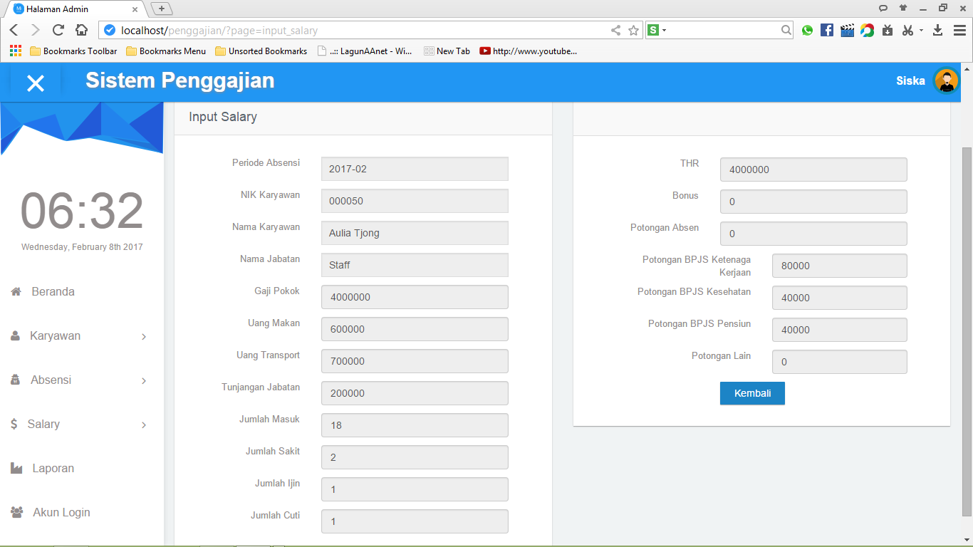

1. **Tampilan Halaman *Finance***

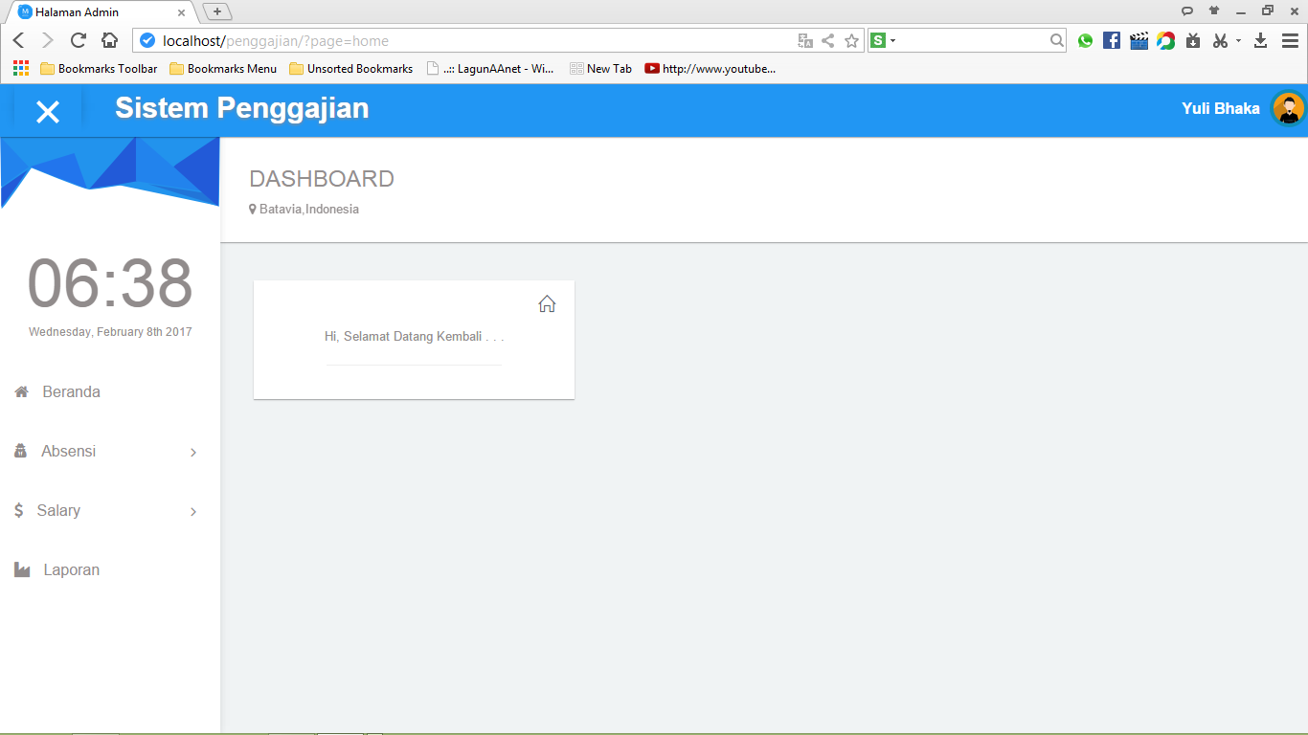

1. **Tampilan Halaman *Salary***

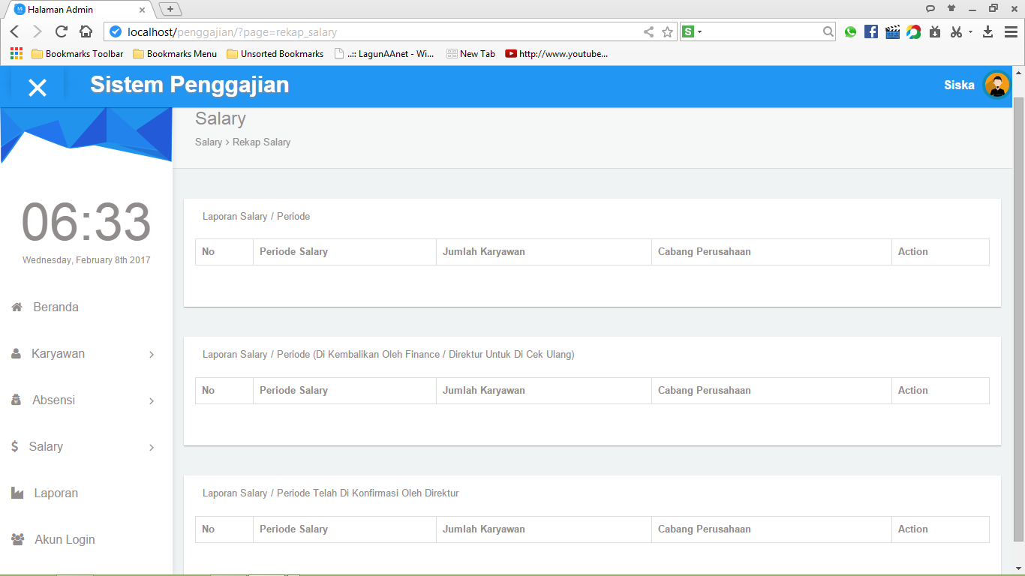

1. **Tampilan Halaman Input Absensi**

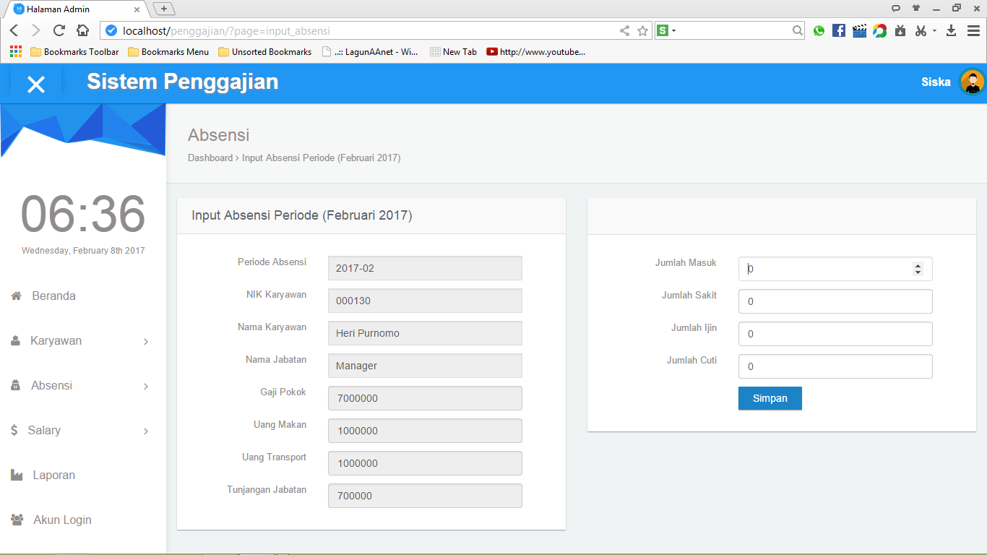

1. **Tampilan Halaman Direktur**

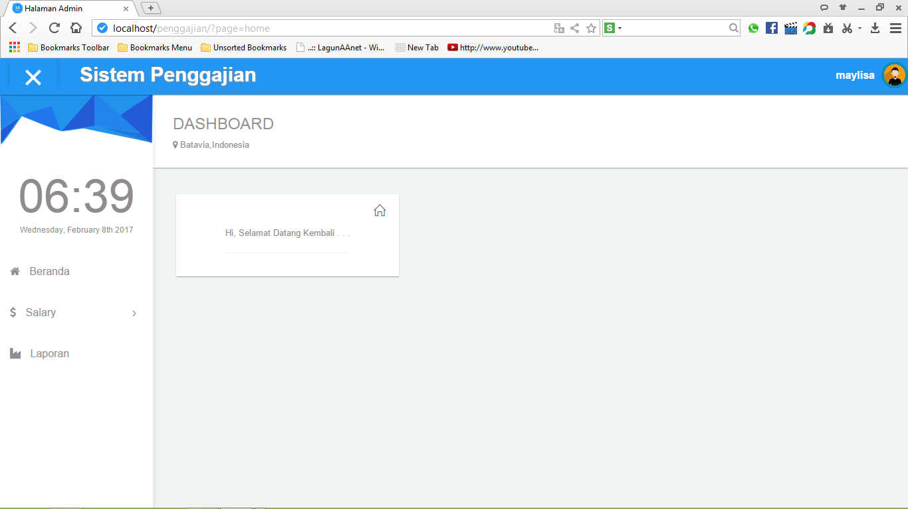

**4.3. *Code Generation***

**A. *Form* Data Karyawan**

|  |
| --- |
| <!-- start: Content -->  <div id="content">  <div class="panel box-shadow-none content-header">  <div class="panel-body">  <div class="col-md-12">  <h3 class="animated fadeInLeft">Karyawan</h3>  <p class="animated fadeInDown">  Karyawan <span class="fa-angle-right fa"></span> Data Karyawan  </p>  </div>  </div>  </div>  <div class="form-element">  <div class="col-md-12 padding-0">  <?php if(!empty($_GET['id'])){ $set->edit_karyawan();?>  <div class="col-md-6">  <div class="panel form-element-padding">  <div class="panel-heading">  <h4>Edit Karyawan</h4>  </div>  <form method="POST" action="?page=update_karyawan">  <div class="panel-body" style="padding-bottom:30px;">  <div class="col-md-12">  <div class="form-group"><label class="col-sm-4 control-label text-right">NIK Karyawan</label>  <div class="col-sm-8"><input name="a" value="<?php echo $set->nik;?>" placeholder="Input Nama" type="text" class="form-control" readonly="1"></div>  </div>  <div class="form-group"><label class="col-sm-4 control-label text-right">Nama Lengkap</label>  <div class="col-sm-8"><input name="b" value="<?php echo $set->nama?>" placeholder="Input Nama" type="text" class="form-control" autofocus="1"></div>  </div>  <div class="form-group"><label class="col-sm-4 control-label text-right">Agama</label>  <div class="col-sm-8">  <?php echo $set->agama;?>  </div>  </div>  <div class="form-group"><label class="col-sm-4 control-label text-right">Jenis Kelamin</label>  <div class="col-sm-8">  <?php echo $set->jkel;?>  </div>  </div>  <div class="form-group"><label class="col-sm-4 control-label text-right">Tanggal Lahir</label>  <div class="col-sm-8"><input name="e" id="datepicker" value="<?php echo $set->lhr;?>" placeholder="YYYY-MM-DD" type="date" class="form-control" ></div>  </div>  <div class="form-group"><label class="col-sm-4 control-label text-right">E-mail</label>  <div class="col-sm-8"><input name="f" value="<?php echo $set->email;?>" type="email" placeholder="abcd@email.com" class="form-control" ></div>  </div>  <div class="form-group"><label class="col-sm-4 control-label text-right">No Telp / HP</label>  <div class="col-sm-8"><input name="g" value="<?php echo $set->tlp;?>" type="number" placeholder="0123456789" class="form-control" ></div>  </div>  <div class="form-group"><label class="col-sm-4 control-label text-right">Alamat</label>  <div class="col-sm-8" style="padding-bottom: 10px;"><textarea name="h" class="form-control" placeholder="Alamat Lengkap"><?php echo $set->alamat; ?></textarea></div>  </div>  <div class="form-group"><label class="col-sm-4 control-label text-right">No Rekening</label>  <div class="col-sm-8" style="padding-bottom: 10px;"><input name="i" value="<?php echo $set->norek;?>" type="number" placeholder="0123456789" class="form-control" ></div>  </div>  <div class="form-group"><label class="col-sm-4 control-label text-right">Tanggal Masuk</label>  <div class="col-sm-8"><input name="j" id="datepicker2" value="<?php echo $set->masuk;?>" placeholder="YYYY-MM-DD" type="date" class="form-control" ></div>  </div>  </div>  </div>  </div>  </div>  <div class="col-md-6">  <div class="panel form-element-padding">  <div class="panel-heading">  <h4>&nbsp;</h4>  </div>  <div class="panel-body" style="padding-bottom:30px;">  <div class="col-md-12">  <div class="form-group"><label class="col-sm-4 control-label text-right"><br><br>Cabang</label>  <div class="col-sm-8 padding-0">  <select name="k" class="form-control">  <?php echo $set->cabang; ?>  </select>  </div>  </div>  <div class="form-group"><label class="col-sm-4 control-label text-right"><br><br>Jabatan</label>  <div class="col-sm-8 padding-0">  <select name="l" class="form-control">  <?php echo $set->jabatan; ?>  </select>  </div>  </div>  <div class="form-group"><label class="col-sm-4 control-label text-right"></label>  <div class="col-sm-8" style="padding-top:10px;"><input class="submit btn btn-info" type="submit" value="Update"></div>  </div>  </div>  </div>  </form>  </div>  </div>  <?php } else{ ?>  <div class="col-md-6">  <div class="panel form-element-padding">  <div class="panel-heading">  <h4>Input Karyawan</h4>  </div>  <form method="POST" action="?page=simpan_karyawan">  <div class="panel-body" style="padding-bottom:30px;">  <div class="col-md-12">  <div class="form-group"><label class="col-sm-4 control-label text-right">NIK Karyawan</label>  <div class="col-sm-8"><input name="a" placeholder="Input Nama" type="text" class="form-control" autofocus="1"></div>  </div>  <div class="form-group"><label class="col-sm-4 control-label text-right">Nama Lengkap</label>  <div class="col-sm-8"><input name="b" placeholder="Input Nama" type="text" class="form-control"></div>  </div>  <div class="form-group"><label class="col-sm-4 control-label text-right">Agama</label>  <div class="col-sm-8">  <div class="col-sm-4 padding-0">  <input type="radio" name="c" value="islam"> Islam  </div>  <div class="col-sm-4 padding-0">  <input type="radio" name="c" value="katolik"> Katolik  </div>  <div class="col-sm-4 padding-0">  <input type="radio" name="c" value="kristen"> Kristen  </div>  <div class="col-sm-4 padding-0">  <input type="radio" name="c" value="hindu"> Hindu  </div>  <div class="col-sm-4 padding-0">  <input type="radio" name="c" value="budha"> Budha  </div>  </div>  </div>  <div class="form-group"><label class="col-sm-4 control-label text-right">Jenis Kelamin</label>  <div class="col-sm-8">  <div class="col-sm-4 padding-0">  <input type="radio" name="d" value="pria"> Pria  </div>  <div class="col-sm-4 padding-0">  <input type="radio" name="d" value="wanita"> Wanita  </div>  </div>  </div>  <div class="form-group"><label class="col-sm-4 control-label text-right">Tanggal Lahir</label>  <div class="col-sm-8"><input name="e" id="datepicker" placeholder="YYYY-MM-DD" type="date" class="form-control" ></div>  </div>  <div class="form-group"><label class="col-sm-4 control-label text-right">E-mail</label>  <div class="col-sm-8"><input name="f" type="text" placeholder="abcd@email.com" class="form-control" ></div>  </div>  <div class="form-group"><label class="col-sm-4 control-label text-right">No Telp / HP</label>  <div class="col-sm-8"><input name="g" type="text" placeholder="0123456789" class="form-control" ></div>  </div>  <div class="form-group"><label class="col-sm-4 control-label text-right">Alamat</label>  <div class="col-sm-8" style="padding-bottom: 10px;"><textarea name="h" class="form-control" placeholder="Alamat Lengkap"></textarea></div>  </div>  <div class="form-group"><label class="col-sm-4 control-label text-right">No Rekening</label>  <div class="col-sm-8" style="padding-bottom: 10px;"><input name="i" type="text" placeholder="0123456789" class="form-control" ></div>  </div>  <div class="form-group"><label class="col-sm-4 control-label text-right">Tanggal Masuk</label>  <div class="col-sm-8"><input name="j" id="datepicker2" placeholder="YYYY-MM-DD" type="date" class="form-control" ></div>  </div>  </div>  </div>  </div>  </div>  <div class="col-md-6">  <div class="panel form-element-padding">  <div class="panel-heading">  <h4>&nbsp;</h4>  </div>  <div class="panel-body" style="padding-bottom:30px;">  <div class="col-md-12">  <div class="form-group"><label class="col-sm-4 control-label text-right"><br><br>Cabang</label>  <div class="col-sm-8 padding-0">  <select name="k" class="form-control">  <option value="none">- Pilih Cabang -</option>  <?php $set->list_cabang(); ?>  </select>  </div>  </div>  <div class="form-group"><label class="col-sm-4 control-label text-right"><br><br>Jabatan</label>  <div class="col-sm-8 padding-0">  <select name="l" class="form-control">  <option value="none">- Pilih Jabatan -</option>  <?php $set->list_jabatan(); ?>  </select>  </div>  </div>  <div class="form-group"><label class="col-sm-4 control-label text-right"></label>  <div class="col-sm-8" style="padding-top:10px;"><input class="submit btn btn-info" type="submit" value="Simpan"></div>  </div>  </div>  </div>  </form>  </div>  </div>  <?php } ?>  <div class="col-md-12 top-20 padding-0">  <div class="col-md-12">  <div class="panel">  <div class="panel-body">  <div class="col-md-12 padding-0" style="padding-bottom:20px;">  <div class="col-md-6" style="padding-left:10px;">  </div>  <div class="col-md-6">  <div class="col-lg-12">  <!--  <div class="input-group">  <input type="text" class="form-control" aria-label="...">  <div class="input-group-btn">  <button type="button" class="btn btn-default dropdown-toggle" data-toggle="dropdown" aria-haspopup="true" aria-expanded="false">Search<span class="caret"></span></button>  <ul class="dropdown-menu dropdown-menu-right">  <li><a href="#">Action</a></li>  <li><a href="#">Another action</a></li>  <li><a href="#">Something else here</a></li>  <li role="separator" class="divider"></li>  <li><a href="#">Separated link</a></li>  </ul>  </div>  </div> -->  </div><!-- /.col-lg-6 -->  </div>  </div>  <div class="responsive-table">  <table class="table table-striped table-bordered" width="100%" cellspacing="0">  <thead>  <tr>  <th>No</th>  <th>NIK</th>  <th>Nama Lengkap</th>  <th>Jenis Kelamin</th>  <th>Tanggal Lahir</th>  <th>E-Mail</th>  <th>No Telepon</th>  <th>Tanggal Masuk</th>  <th>Jabatan</th>  <th>Action</th>  </tr>  </thead>  <tbody>  <?php $set->tampil_karyawan();?>  </tbody>  </table>  </div>  <div class="col-md-6" style="padding-top:20px;">  <span></span>  </div>  <div class="col-md-6">  <!--  <ul class="pagination pull-right">  <li>  <a href="#" aria-label="Previous">  <span aria-hidden="true">&laquo;</span>  </a>  </li>  <li class="active"><a href="#">1</a></li>  <li><a href="#">2</a></li>  <li><a href="#">3</a></li>  <li><a href="#">4</a></li>  <li><a href="#">5</a></li>  <li>  <a href="#" aria-label="Next">  <span aria-hidden="true">&raquo;</span>  </a>  </li>  </ul>  -->  </div>  </div>  </div>  </div>  </div>  </div>  </div>  </div>  <!-- end: content --> |

**B. *Form* Data Absensi**

|  |
| --- |
| <!-- start: Content -->  <div id="content">  <div class="panel box-shadow-none content-header">  <div class="panel-body">  <div class="col-md-12">  <h3 class="animated fadeInLeft">Absensi</h3>  <p class="animated fadeInDown">  Absensi <span class="fa-angle-right fa"></span> Input Absensi Periode (<?php echo $set->date(date("Y-m"), "indo_periode"); ?>)  </p>  </div>  </div>  </div>  <div class="form-element">  <div class="col-md-12 padding-0">  <div class="col-md-12 top-20 padding-0">  <div class="col-md-12">  <div class="panel">  <div class="panel-body">  <div class="col-md-12 padding-0" style="padding-bottom:20px;">  <div class="col-md-6" style="padding-left:10px;">  </div>  <div class="col-md-6">  <div class="col-lg-12">  <!--  <div class="input-group">  <input type="text" class="form-control" aria-label="...">  <div class="input-group-btn">  <button type="button" class="btn btn-default dropdown-toggle" data-toggle="dropdown" aria-haspopup="true" aria-expanded="false">Search<span class="caret"></span></button>  <ul class="dropdown-menu dropdown-menu-right">  <li><a href="#">Action</a></li>  <li><a href="#">Another action</a></li>  <li><a href="#">Something else here</a></li>  <li role="separator" class="divider"></li>  <li><a href="#">Separated link</a></li>  </ul>  </div>  </div> -->  </div><!-- /.col-lg-6 -->  </div>  </div>  <?php if (!empty($_GET['id'])) { ?>  <div class="responsive-table">  <table class="table table-striped table-bordered" width="100%" cellspacing="0">  <thead>  <tr>  <th>No</th>  <th>NIK</th>  <th>Nama Lengkap</th>  <th>Jenis Kelamin</th>  <th>Tanggal Lahir</th>  <th>E-Mail</th>  <th>No Telepon</th>  <th>Jabatan</th>  <th>Absensi</th>  <th>Action</th>  </tr>  </thead>  <tbody>  <?php $set->detail_karyawan(); ?>  </tbody>  </table>  </div>  <div class="col-md-12" style="padding-top:20px;">  <span class="right"><button onclick="document.location.href='?page=absensi'" class="btn btn-primary">Kembali</button></span>  </div>  <?php } else { ?>  <div class="responsive-table">  <table class="table table-striped table-bordered" width="100%" cellspacing="0">  <thead>  <tr>  <th>No</th>  <th>Cabang</th>  <th>Jumlah Karyawan</th>  <th>Sudah Absensi</th>  <th>Belum Absensi</th>  <th>Action</th>  </tr>  </thead>  <tbody>  <?php $set->karyawan(); ?>  </tbody>  </table>  </div>  <?php } ?>  <div class="col-md-6" style="padding-top:20px;">  <span></span>  </div>  <div class="col-md-6">  <!--  <ul class="pagination pull-right">  <li>  <a href="#" aria-label="Previous">  <span aria-hidden="true">&laquo;</span>  </a>  </li>  <li class="active"><a href="#">1</a></li>  <li><a href="#">2</a></li>  <li><a href="#">3</a></li>  <li><a href="#">4</a></li>  <li><a href="#">5</a></li>  <li>  <a href="#" aria-label="Next">  <span aria-hidden="true">&raquo;</span>  </a>  </li>  </ul>  -->  </div>  </div>  </div>  </div>  </div>  </div>  </div>  </div>  <!-- end: content --> |

**C. *Form* *Salary***

|  |
| --- |
| <!-- start: Content -->  <div id="content">  <div class="panel box-shadow-none content-header">  <div class="panel-body">  <div class="col-md-12">  <h3 class="animated fadeInLeft">Salary</h3>  <p class="animated fadeInDown">  Salary <span class="fa-angle-right fa"></span> Input Salary  </p>  </div>  </div>  </div>  <div class="form-element">  <div class="col-md-12 padding-0">  <div class="col-md-6">  <div class="panel form-element-padding">  <div class="panel-heading">  <h4>Input Salary</h4>  </div>  <?php  if (!empty($_POST['id'])) {  $set->cek_salary();  ?>  <form method="POST" action="?page=simpan_salary">  <div class="panel-body" style="padding-bottom:30px;">  <div class="col-md-12">  <div class="form-group"><label class="col-sm-4 control-label text-right">Periode Absensi</label>  <div class="col-sm-8"><input name="kd" type="hidden" value="<?php echo $set->kd_absen; ?>"><input name="perid" value="<?php echo $set->perid; ?>" placeholder="YYYY-MM" type="text" class="form-control" readonly></div>  </div>  <div class="form-group"><label class="col-sm-4 control-label text-right">NIK Karyawan</label>  <div class="col-sm-8"><input name="id" value="<?php echo $set->nik; ?>" placeholder="Input NIK Karyawan" type="text" class="form-control" readonly></div>  </div>  <div class="form-group"><label class="col-sm-4 control-label text-right">Nama Karyawan</label>  <div class="col-sm-8"><input name="a" value="<?php echo $set->nama; ?>" placeholder="Nama Karyawan" type="text" class="form-control" required="1" readonly></div>  </div>  <div class="form-group"><label class="col-sm-4 control-label text-right">Nama Jabatan</label>  <div class="col-sm-8"><input name="b" value="<?php echo $set->jabatan; ?>" placeholder="Nama Jabatan" type="text" class="form-control" required="1" readonly></div>  </div>  <div class="form-group"><label class="col-sm-4 control-label text-right">Gaji Pokok</label>  <div class="col-sm-8"><input name="c" value="<?php echo $set->gapok; ?>" placeholder="0" type="number" class="form-control" required="1" readonly></div>  </div>  <div class="form-group"><label class="col-sm-4 control-label text-right">Uang Makan</label>  <div class="col-sm-8"><input name="d" value="<?php echo $set->makan; ?>" placeholder="0" type="number" class="form-control" required="1" readonly></div>  </div>  <div class="form-group"><label class="col-sm-4 control-label text-right">Uang Transport</label>  <div class="col-sm-8"><input name="e" value="<?php echo $set->transport; ?>" placeholder="0" type="number" class="form-control" required="1" readonly></div>  </div>  <div class="form-group"><label class="col-sm-4 control-label text-right">Tunjangan Jabatan</label>  <div class="col-sm-8"><input name="f" value="<?php echo $set->tunjangan; ?>" placeholder="0" type="number" class="form-control" required="1" readonly></div>  </div>  <div class="form-group"><label class="col-sm-4 control-label text-right">Jumlah Masuk</label>  <div class="col-sm-8"><input name="g" value="<?php echo $set->masuk; ?>" placeholder="0" type="number" class="form-control" required="1" readonly></div>  </div>  <div class="form-group"><label class="col-sm-4 control-label text-right">Jumlah Sakit</label>  <div class="col-sm-8"><input name="h" value="<?php echo $set->sakit; ?>" placeholder="0" type="number" class="form-control" required="1" readonly></div>  </div>  <div class="form-group"><label class="col-sm-4 control-label text-right">Jumlah Ijin</label>  <div class="col-sm-8"><input name="i" value="<?php echo $set->ijin; ?>" placeholder="0" type="number" class="form-control" required="1" readonly></div>  </div>  <div class="form-group"><label class="col-sm-4 control-label text-right">Jumlah Cuti</label>  <div class="col-sm-8"><input name="j" value="<?php echo $set->cuti; ?>" placeholder="0" type="number" class="form-control" required="1" readonly></div>  </div>  </div>  </div>  </div>  </div>  <div class="col-md-6">  <div class="panel form-element-padding">  <div class="panel-heading">  <h4 style="width:1px;height:20px;"> </h4>  </div>  <div class="panel-body" style="padding-bottom:30px;">  <div class="col-md-12">  <?php if ($set->mode > 0) { ?>  <div class="form-group"><label class="col-sm-4 control-label text-right">THR</label>  <div class="col-sm-8"><input name="k" value="<?php echo $set->thr; ?>" placeholder="0" type="number" class="form-control" required="1" readonly="1"></div>  </div>  <div class="form-group"><label class="col-sm-4 control-label text-right">Bonus</label>  <div class="col-sm-8"><input name="l" value="<?php echo $set->bonus; ?>" placeholder="0" type="number" class="form-control" required="1" readonly="1"></div>  </div>  <div class="form-group"><label class="col-sm-4 control-label text-right">Potongan Absen</label>  <div class="col-sm-8"><input name="m" value="<?php echo $set->pot_absen; ?>" placeholder="0" type="number" class="form-control" required="1" readonly="1"></div>  </div>  <div class="form-group"><label class="col-sm-6 control-label text-right">Potongan BPJS Ketenaga Kerjaan</label>  <div class="col-sm-6"><input name="n" value="<?php echo $set->bpjs1; ?>" placeholder="0" type="number" class="form-control" required="1" readonly="1"></div>  </div>  <div class="form-group"><label class="col-sm-6 control-label text-right">Potongan BPJS Kesehatan</label>  <div class="col-sm-6"><input name="o" value="<?php echo $set->bpjs2; ?>" placeholder="0" type="number" class="form-control" required="1" readonly="1"></div>  </div>  <div class="form-group"><label class="col-sm-6 control-label text-right">Potongan BPJS Pensiun</label>  <div class="col-sm-6"><input name="p" value="<?php echo $set->bpjs3; ?>" placeholder="0" type="number" class="form-control" required="1" readonly="1"></div>  </div>  <div class="form-group"><label class="col-sm-6 control-label text-right">Potongan Lain</label>  <div class="col-sm-6"><input name="q" value="<?php echo $set->lain; ?>" placeholder="0" type="number" class="form-control" required="1" readonly="1"></div>  </div>  <div class="form-group"><label class="col-sm-4 control-label text-right"></label>  <div class="col-sm-8"><input onclick="history.go(-1)" class="submit btn btn-primary" type="button" value="Kembali"></div>  </div>  <?php } else { ?>  <div class="form-group"><label class="col-sm-4 control-label text-right">THR</label>  <div class="col-sm-8"><input name="k" value="0" placeholder="0" type="number" class="form-control" required="1" autofocus="1"></div>  </div>  <div class="form-group"><label class="col-sm-4 control-label text-right">Bonus</label>  <div class="col-sm-8"><input name="l" value="<?php echo $set->bonus; ?>" placeholder="0" type="number" class="form-control" required="1"></div>  </div>  <div class="form-group"><label class="col-sm-4 control-label text-right">Potongan Absen</label>  <div class="col-sm-8"><input name="m" value="<?php echo $set->pot_absen; ?>" placeholder="0" type="number" class="form-control" required="1" readonly="1"></div>  </div>  <div class="form-group"><label class="col-sm-4 control-label text-right">Potongan BPJS Ketenagakerjaan</label>  <div class="col-sm-8"><input name="n" value="<?php echo $set->bpjs1; ?>" placeholder="0" type="number" class="form-control" required="1" readonly="1"></div>  </div>  <div class="form-group"><label class="col-sm-4 control-label text-right">Potongan BPJS Kesehatan</label>  <div class="col-sm-8"><input name="o" value="<?php echo $set->bpjs2; ?>" placeholder="0" type="number" class="form-control" required="1" readonly="1"></div>  </div>  <div class="form-group"><label class="col-sm-4 control-label text-right">Potongan BPJS Pensiun</label>  <div class="col-sm-8"><input name="p" value="<?php echo $set->bpjs3; ?>" placeholder="0" type="number" class="form-control" required="1" readonly="1"></div>  </div>  <div class="form-group"><label class="col-sm-4 control-label text-right">Potongan Lain</label>  <div class="col-sm-8"><input name="q" value="<?php echo $set->lain; ?>" placeholder="0" type="number" class="form-control" required="1"></div>  </div>  <div class="form-group"><label class="col-sm-4 control-label text-right"></label>  <div class="col-sm-8"><input class="submit btn btn-primary" type="submit" value="Simpan"></div>  </div>  <?php } ?>  </div>  </div>  </form>  <?php } else { ?>  <form method="POST" action="?page=salary">  <div class="panel-body" style="padding-bottom:30px;">  <div class="col-md-12">  <div class="form-group"><label class="col-sm-4 control-label text-right">Periode Salary</label>  <div class="col-sm-8"><input name="perid" value="<?php echo date("Y-m"); ?>" placeholder="YYYY-MM" type="text" class="form-control"></div>  </div>  <div class="form-group"><label class="col-sm-4 control-label text-right">NIK Karyawan</label>  <div class="col-sm-8"><input name="id" placeholder="Input NIK Karyawan" type="text" class="form-control" autofocus="1"></div>  </div>  <div class="form-group"><label class="col-sm-4 control-label text-right"></label>  <div class="col-sm-8"><input class="submit btn btn-primary" type="submit" value="Lanjutkan"></div>  </div>  </div>  </div>  </form>  <?php } ?>  </div>  </div>  </div>  </div>  </div>  <!-- end: content --> |

**4.4. Testing**

Berikut adalah hasil pengujian sistem usulan dengan menggunakan blackbox testing untuk pengujian proses input dan outputnya.

**4.4.1 *Testing Form Login***

**Tabel IV.16.**

**Hasil Pengujian Black Box *TestingForm Login***

|  |  |  |  |  |  |
| --- | --- | --- | --- | --- | --- |
| No | Skenario  Pengujian | Text Case | Hasil yang diharapkan | Hasil Pengujian | Kesimpulan |
| 1. | *Username* dan *Password* tidak di isi kemudian klik tombol *login* | *Username* : (kosong)  *Password* : (kosong) | Sistem akan menolak akses, *username* dan *password* anda salah!! Silahkan coba kembali | Sesuai Harapan | valid |
| 2. | *Username* di isi dan *password kosong* kemudian klik tombol *Login* | *Username* : admin  *Password* :  (kosong) | Sistem akan menolak akses, *username* atau *password* anda salah!! silahkan coba kembali | Sesuai Harapan | valid |
| 3. | *Username* dan *password* di isi namun salah satu data salahkemudian klik tombol *Login* | *Username* : admin  *Password* :  Admin (salah) | Sistem akan menolak akses, *username* atau *password* anda salah!! silahkan coba kembali | Sesuai Harapan | valid |
| 4. | Mengisi dengan kondisi data benar kemudian klik tombol *Login* | *Username* : admin  *Password* :  password | Sistem menerima akses *Login* dan kemudian menampilkan menu *finance*. | Sesuai Harapan | valid |
| 5. | *Username* di isi dan *password kosong* kemudian klik tombol *Login* | *Username* : yuli  *Password* :  (kosong) | Sistem akan menolak akses, *username* atau *password* anda salah!! silahkan coba kembali | Sesuai Harapan | valid |
| 6. | *Username* dan *password* di isi namun salah satu data salahkemudian klik tombol *Login* | *Username* : yuli  *Password* :  yuli (salah) | Sistem akan menolak akses, *username* atau *password* anda salah!! silahkan coba kembali | Sesuai Harapan | valid |
| 7. | Mengisi dengan kondisi data benar kemudian klik tombol *Login* | *Username* : yuli  *Password* :  password | Sistem menerima akses *Login* dan kemudian menampilkan halaman *finance*. | Sesuai Harapan | valid |
| 8. | *Username* di isi dan *password kosong* kemudian klik tombol *Login* | *Username* : lisa  *Password* :  (kosong) | Sistem akan menolak akses, *username* atau *password* anda salah!! silahkan coba kembali | Sesuai Harapan | valid |
| 9. | *Username* dan *password* di isi namun salah satu data salahkemudian klik tombol *Login* | *Username* : lisa  *Password* :  lisa (salah) | Sistem akan menolak akses, *username* atau *password* anda salah!! silahkan coba kembali | Sesuai Harapan | valid |
| 10. | Mengisi dengan kondisi data benar kemudian klik tombol *Login* | *Username* : lisa  *Password* :  password | Sistem menerima akses *Login* dan kemudian menampilkan halaman direktur. | Sesuai Harapan | valid |

**4.4.2 *Testing Form Input*  Karyawan**

**Tabel IV.17.**

**Hasil Pengujian Black Box *TestingForm Input* Karyawan**

|  |  |  |  |  |  |
| --- | --- | --- | --- | --- | --- |
| No | Skenario  Pengujian | Text Case | Hasil yang diharapkan | Hasil Pengujian | Kesimpulan |
| 1. | Mengosongkan semua *field* kemudian klik tombol simpan | *Field:* kosong | Sistem menampilkan pesan isi semua form dengan benar, jangan biarkan kosong!! | Sesuai Harapan | valid |
| 2. | Mengosongkan *field* nik karyawan dan mengisi semua field kemudian klik tombol simpan | Nik karyawan: kosong  *Field:* terisi | Sistem menampilkan pesan isi semua form dengan benar, jangan biarkan kosong!! | Sesuai Harapan | valid |
| 3. | Mengisi semua *field* namun data no telp dan no rekening diisi huruf | *Field:* terisi  No telp dan no rekening : huruf | Sistem menampilkan pesan isi masukkan no telp dengan benar. Input no rekening dengan benar. | Sesuai Harapan | valid |
| 4. | Mengisi dengan kondisi data benar kemudian klik tombol simpan | *Field:* terisi | Sistem akan menerima akses dan akan menampilkan pesan berhasil menyimpan data karyawan. | Sesuai Harapan | valid |

**4.4.2 *Testing Form* Absensi**

**Tabel IV.18.**

**Hasil Pengujian Black Box *TestingForm* Absensi**

|  |  |  |  |  |  |
| --- | --- | --- | --- | --- | --- |
| No | Skenario  Pengujian | Text Case | Hasil yang diharapkan | Hasil Pengujian | Kesimpulan |
| 1. | Mengosongkan jumlah masuk dan jumlah tidak masuk (sakit,ijin,cuti) kemudian klik tombol simpan | Jumlah masuk:  kosong  Jumlah sakit:  Kosong  Jumlah Ijin:  Kosong  Jumlah Cuti:  Kosong | Sistem akan menolak akses dan akan menampilkan pesan isi semua form absensi dengan benar. | Sesuai Harapan | valid |
| 2. | Mengosongkan jumlah masuk dan mengisijumlah tidak masuk (sakit,ijin,cuti) kemudian klik tombol simpan | Jumlah masuk:  kosong  Jumlah sakit:  2  Jumlah Ijin:  1  Jumlah Cuti:  1 | Sistem akan menolak akses dan akan menampilkan pesan isi semua form absensi dengan benar*.* | Sesuai Harapan | valid |
| 3. | Mengisi dengan kondisi data benar kemudian klik tombol simpan | Jumlah masuk:  18  Jumlah sakit:  2  Jumlah Ijin:  1  Jumlah Cuti:  1 | Sistem akan menerima akses dan akan menampilkan pesan berhasil menyimpan absensi. | Sesuai Harapan | valid |

**4.4.3 *Testing Form Input Salary***

**Tabel IV.19.**

**Hasil Pengujian Black Box *TestingForm Input Salary***

|  |  |  |  |  |  |
| --- | --- | --- | --- | --- | --- |
| No | Skenario  Pengujian | Text Case | Hasil yang diharapkan | Hasil Pengujian | Kesimpulan |
| 1. | Mengosongkan nik karyawan kemudian klik tombol lanjutkan | Nik karyawan:  kosong | Sistem akan menolak akses dan akan menampilkan pesan nik karyawan harus diisi. | Sesuai Harapan | valid |
| 2. | Mengisi dengan kondisi data tidak benar kemudian klik tombol lanjutkan | Nik karyawan:  000000 | Sistem akan menolak akses dan akan menampilkan pesan nik karyawan tidak ditemukan, pastikan anda menginput nik dengan benar. | Sesuai Harapan | valid |
| 3. | Mengisi dengan kondisi data benar kemudian klik tombol simpan | Nik karyawan:  000050 | Sistem akan menerima akses dan akan menampilkan halaman transaksi data gaji. | Sesuai Harapan | valid |

**4.4.3 *Testing Form Input* Akun *Login***

**Tabel IV.20.**

**Hasil Pengujian Black Box *TestingForm Input* Akun *Login***

|  |  |  |  |  |  |
| --- | --- | --- | --- | --- | --- |
| No | Skenario  Pengujian | Text Case | Hasil yang diharapkan | Hasil Pengujian | Kesimpulan |
| 1. | Mengosongkan semua *field* kemudian klik tombol simpan | *field:*  kosong | Sistem akan menolak akses dan akan menampilkan pesan data harus di lengkapi. | Sesuai Harapan | valid |
| 2. | Mengisi semua *field* dan level kosong kemudian klik tombol simpan | *field*: terisi  level : kosong | Sistem akan menolak akses dan akan menampilkan pesan silahkan pilih level login terlebih dahulu. | Sesuai Harapan | valid |
| 3. | Mengisi semua *field* dan password kosong kemudian klik tombol simpan | *field*: terisi  *password*: kosong | Sistem akan menerima akses dan akan menampilkan pesan data harus dilengkapi. | Sesuai Harapan | valid |
| 4. | Mengisi semua data benardan *field* ulangi password salah kemudian klik tombol simpan | *Field:* terisi  *Password:*  Benar  Ulangi *password:*  salah | Sistem akan menolak aksesn dan akan menapilkan pesan Pastikan anda menginput password dengan benar, silahkan coba kembali. | Sesuai Harapan | valid |
| 5. | Mengisi dengan kondisi data benar kemudian klik tombol simpan | *Field:* terisi | Sistem akan menerima akses dan menampilkan halaman data akun *login.* | Sesuai Harapan | valid |

**4.5. Support**

**4.5.1 Spesifikasi *Hardware* dan *Software***

Pada saat mengakses *website* bisa dengan menggunakan *browser* yang telah banyak tersedia seperti *mozila firefox, internet explorer* dan yang lainnya. Caranya hanya dengan mengetikan alamat *website* yang dituju ke dalam *address bar* yang terdapat pada *browser* yang digunakan.

**Tabel IV. 21.**

**Spesifikasi Hardware Dan Software**

|  |  |
| --- | --- |
| Kebutuhan | Keterangan |
| Sistem Operasi | Windows 7 |
| Processor | Intel Pentium CPU 2 GHz |
| Ram | 2.00 GB |
| Hardisk | 320 GB |
| DVD-ROM | 52 x |
| Monitor | SVGA 14” |
| Keyboard | 108 Key |
| Printer | Laserjet |
| Mouse | Standart |
| Browser | Mozilla Firefox, Google chrome, Internet Explorer |
| Software | Dreamweaver, XAMPP |

**4.6. Spesifikasi Dokumen Sistem Usulan**

a.Nama Dokumen : Laporan Data Gaji

Fungsi : Menyimpan keseluruhan data gaji karyawan

Sumber : Admin

Tujuan : *Finance* dan Direktur

Media : Tampilan

Frekuensi : Setiap bulan

Format : Lampiran B1

1. Nama Dokumen : Slip Gaji

Fungsi : Bukti penerimaan gaji

Sumber : Admin

Tujuan : Karyawan

Media : Kertas

Frekuensi : Setiap bulan

Format : Lampiran B2