LAMPIRAN

Lampiran A. 1 Hasil Cek Plagiarisme BAB 1
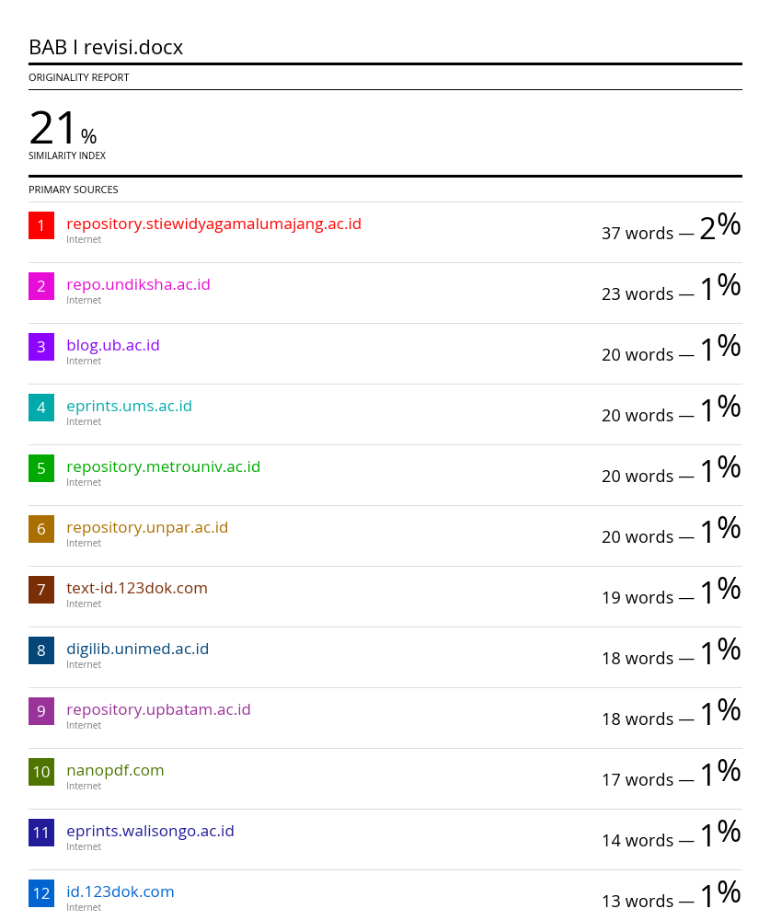
Lampiran A. 2 Hasil Cek Plagiarisme BAB 2
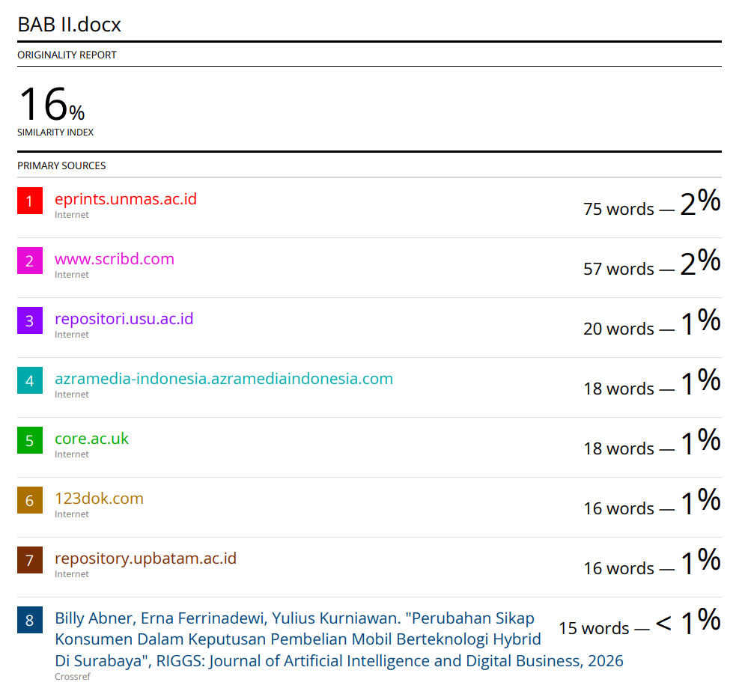
Lampiran A. 3 Hasil Cek Plagiarisme BAB 3
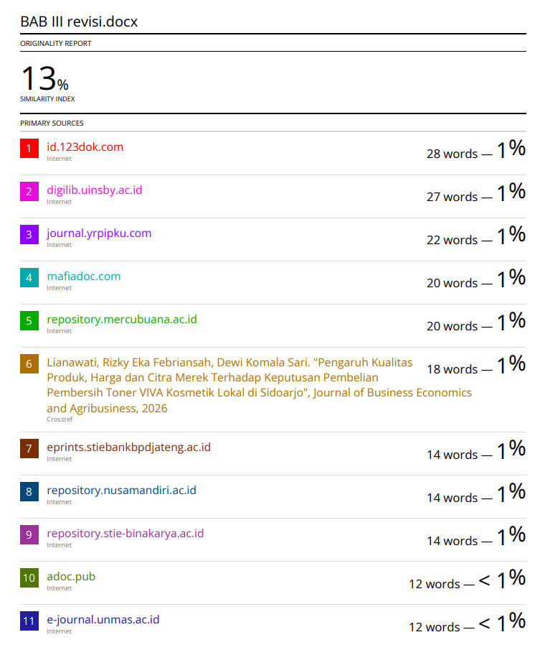
Lampiran A. 4 Hasil Cek Plagiarisme BAB 4
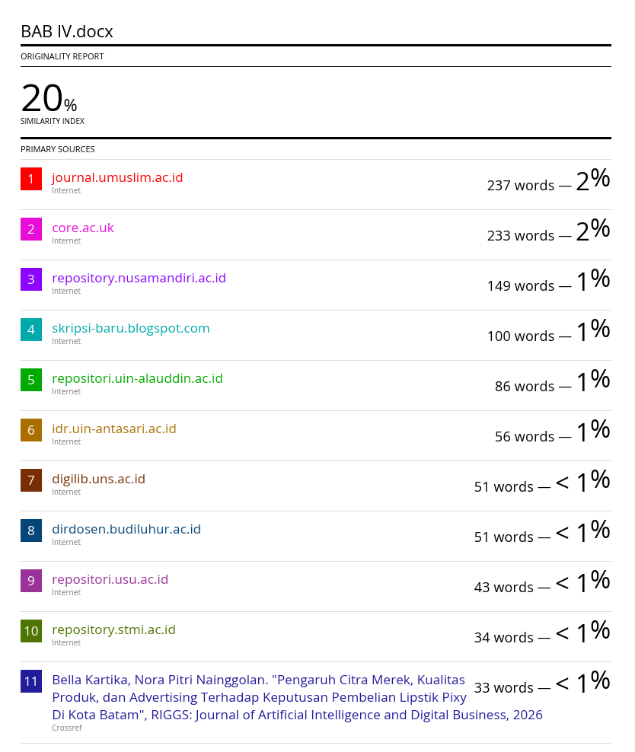
Lampiran A. 5 Hasil Cek Plagiarisme BAB 5
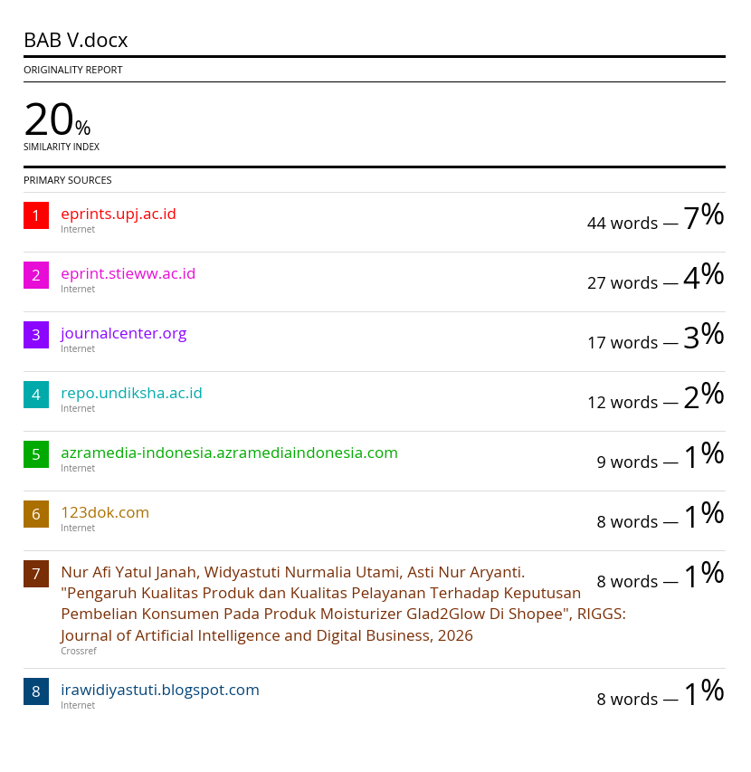

Lampiran B. 1 Bukti Hasil Submit Jurnal
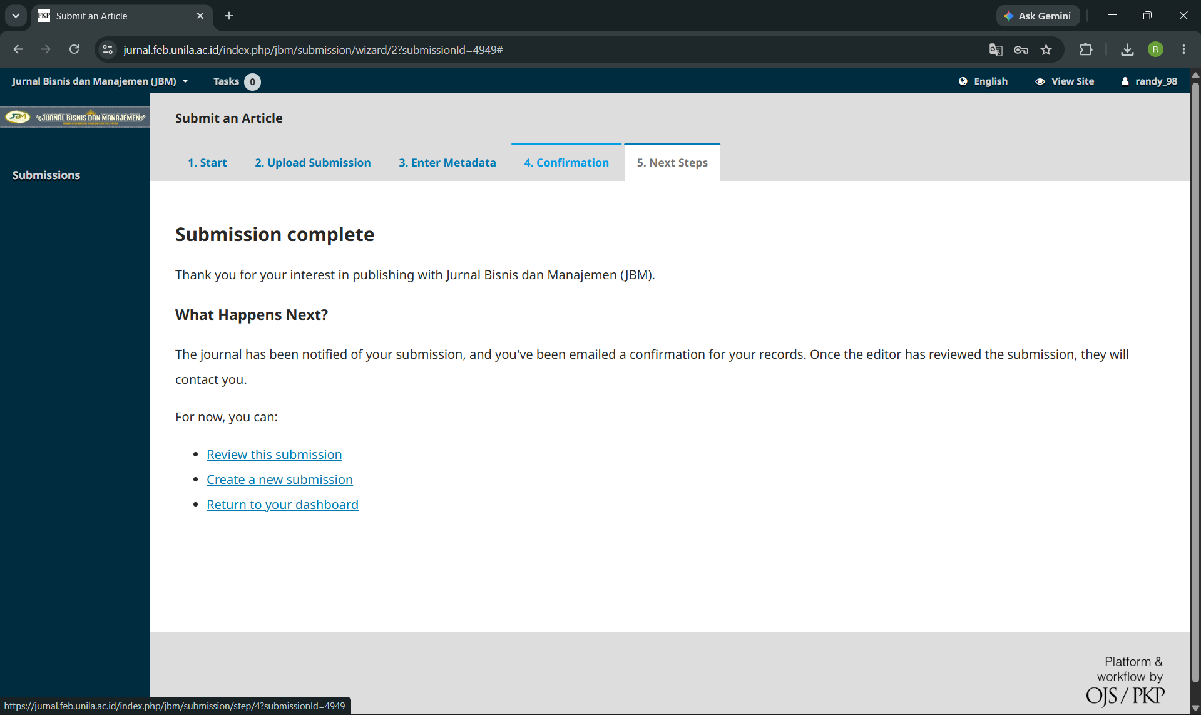

Lampiran C. 1 Daftar Penyataan Kuesioner
- Petunjuk pengisian kuesioner
- Bacalah sejumlah permyataan di bawah ini dengan teliti
- Anda dimohon untuk memberikan jawaban sesuai dengan keadaan anda secara objektif dengan memberikan tanda (V) pada salah satu yang paling mewakil dini anda untuk setiap pemytaan di bawah ini!
- Pilihlah jawaban yang tersedia adalah:
- STS = apabila Anda merasa Sangat Tidak Setuju
- TS = apabila Anda merasa Tidak Setuju
- N = apabila Anda merasa Ragu-raguNetral
- S = apabila Anda merasa Setuju
- SS = apabila Anda merasa Sangat Setuju
- Skor yang diberikan tidak mengandung tilai jawaban benar/salah melainkan menunjukan kesesuaian penilaian Anda terhadap isi setiap pertanyaan
- Dimohon dalam memberikan penilaian tidak ada pemyataan yang terlewatkan
- Hasil penelitian ini hany untuk kepentingan akadeis saja. Identitas diri Anda akan dirahasiakan dan hanya diketahui oleh peneliti.

Lampiran C. 2 Daftar Penyataan Kuesioner
NO | Penyataan | STS | TS | N | S | SS
NO | Penyataan | 1 | 2 | 3 | 4 | 5
Citra Merek
1 | Merek Hydro Coco lebih unggul dibandingkan merek minuman isotonik lain di pasaran
2 | Hydro Coco memberikan manfaat yang sesuai dengan janji pada kemasannya
3 | Saya memiliki kesan positif terhadap merek Hydro Coco dibandingkan merek lain
4 | Merek Hydro Coco mudah saya ingat dibandingkan merek minuman isotonik lainnya
5 | Informasi tentang Hydro Coco yang saya terima selalu konsisten dan dapat dipercaya
6 | Saya mengidentikkan Hydro Coco dengan kualitas minuman isotonik yang baik
7 | Hydro Coco memiliki ciri khas berbahan dasar air kelapa asli yang membedakannya dari merek lain
8 | Kemasan Hydro Coco memiliki tampilan yang unik dan mudah dikenal
9 | Hydro Coco menawarkan nilai yang berbeda dari merek minuman isotonik lainnya
Kualitas Produk
1 | Hydro Coco efektif mengembalikan energi dan elektrolit tubuh setelah beraktivitas
2 | Hydro Coco memberikan efek segar yang langsung terasa setelah dikonsumsi
3 | Hydro Coco menjalankan fungsinya sebagai minuman isotonik sesuai harapan saya
4 | Hydro Coco tersedia dalam berbagai pilihan ukuran kemasan yang sesuai kebutuhan
5 | Kandungan nutrisi dan elektrolit Hydro Coco tertera dengan jelas dan lengkap pada kemasan
6 | Keunggulan bahan dasar air kelapa asli menjadi fitur utama yang membedakan Hydro Coco
7 | Produk Hydro Coco yang saya beli selalu sesuai dengan standar kualitas yang tertera di kemasan
8 | Kandungan Hydro Coco aman dikonsumsi karena telah mendapatkan sertifikasi BPOM
9 | Reputasi PT Kalbe Farma memperkuat keyakinan saya terhadap standar kualitas Hydro Coco
10 | Rasa dan kualitas Hydro Coco selalu konsisten di setiap pembelian yang saya lakukan
11 | Hydro Coco tidak pernah mengecewakan saya dalam hal kualitas produk
12 | 21. Saya percaya Hydro Coco akan selalu memberikan kualitas yang sama dari waktu ke waktu 21. Saya percaya Hydro Coco akan selalu memberikan kualitas yang sama dari waktu ke waktu
13 | Tampilan kemasan Hydro Coco menarik dan mencerminkan identitas produk alami yang berkualitas
14 | Rasa Hydro Coco enak dan segar sehingga memberikan kesan menyenangkan saat dikonsumsi
15 | Desain dan warna kemasan Hydro Coco membuat produk ini mudah dikenal di antara produk lain
Keputusan Pembelian
1 | Saya yakin bahwa Hydro Coco adalah pilihan terbaik untuk kebutuhan minuman isotonik saya
2 | Saya selalu memilih Hydro Coco dibandingkan merek minuman isotonik lain saat berbelanja
3 | Saya merasa mantap memilih Hydro Coco karena kualitas dan mereknya sudah terpercaya
4 | Saya secara rutin membeli Hydro Coco setiap kali membutuhkan minuman isotonik
5 | Hydro Coco sudah menjadi pilihan tetap saya ketika membutuhkan minuman isotonik
6 | Saya terbiasa membeli Hydro Coco secara konsisten dari waktu ke waktu
7 | Saya merekomendasikan Hydro Coco kepada keluarga atau teman-teman saya
8 | Saya mengajak orang lain untuk mencoba dan mengonsumsi Hydro Coco
9 | Saya memberikan ulasan positif tentang Hydro Coco kepada orang lain
10 | Saya berencana untuk membeli Hydro Coco kembali di masa mendatang
11 | saya tetap memilih Hydro Coco meskipun ada merek isotonik lain yang harganya lebih murah
12 | Pengalaman positif mengonsumsi Hydro Coco membuat saya tidak ragu untuk membeli lagi

Lampiran C. 3 Tabulasi Citra Merek
NO | Citra Merek |  |  |  |  |  |  |  |  | Total
NO | x1_1 | x1_2 | x1_3 | x1_4 | x1_5 | x1_6 | x1_7 | x1_8 | x1_9 | Total
1 | 3 | 4 | 4 | 4 | 5 | 4 | 5 | 4 | 4 | 37
2 | 4 | 4 | 5 | 5 | 4 | 5 | 5 | 4 | 4 | 40
3 | 4 | 3 | 4 | 4 | 5 | 3 | 4 | 4 | 5 | 36
4 | 1 | 2 | 2 | 1 | 2 | 1 | 2 | 2 | 3 | 16
5 | 5 | 5 | 5 | 4 | 4 | 4 | 5 | 4 | 5 | 41
6 | 5 | 4 | 3 | 2 | 3 | 4 | 4 | 4 | 4 | 33
7 | 4 | 4 | 4 | 4 | 4 | 4 | 5 | 4 | 5 | 38
8 | 4 | 4 | 3 | 5 | 5 | 4 | 5 | 4 | 5 | 39
9 | 2 | 2 | 1 | 3 | 3 | 1 | 2 | 3 | 1 | 18
10 | 4 | 3 | 5 | 3 | 4 | 3 | 4 | 4 | 3 | 33
11 | 5 | 4 | 4 | 4 | 4 | 4 | 4 | 5 | 5 | 39
12 | 1 | 2 | 1 | 2 | 1 | 1 | 2 | 3 | 3 | 16
13 | 3 | 4 | 4 | 4 | 5 | 5 | 5 | 5 | 5 | 40
14 | 4 | 4 | 4 | 5 | 5 | 5 | 5 | 5 | 5 | 42
15 | 5 | 4 | 5 | 4 | 5 | 5 | 4 | 5 | 4 | 41
16 | 2 | 1 | 3 | 1 | 2 | 1 | 1 | 3 | 1 | 15
17 | 3 | 3 | 4 | 4 | 4 | 4 | 5 | 4 | 5 | 36
18 | 5 | 5 | 4 | 5 | 5 | 5 | 4 | 5 | 5 | 43
19 | 4 | 2 | 4 | 4 | 5 | 4 | 5 | 5 | 5 | 38
20 | 4 | 3 | 4 | 3 | 3 | 3 | 4 | 3 | 2 | 29
21 | 4 | 4 | 4 | 4 | 4 | 4 | 4 | 4 | 4 | 36
22 | 3 | 3 | 4 | 4 | 4 | 3 | 5 | 4 | 5 | 35
23 | 1 | 3 | 1 | 2 | 2 | 1 | 2 | 2 | 1 | 15
24 | 5 | 4 | 3 | 4 | 3 | 3 | 4 | 3 | 4 | 33
25 | 4 | 4 | 4 | 4 | 4 | 4 | 4 | 4 | 4 | 36
26 | 5 | 4 | 4 | 4 | 3 | 3 | 4 | 4 | 5 | 36
27 | 2 | 4 | 4 | 4 | 4 | 4 | 4 | 3 | 5 | 34
28 | 3 | 4 | 4 | 4 | 5 | 3 | 5 | 5 | 5 | 38
29 | 5 | 3 | 5 | 5 | 4 | 5 | 5 | 5 | 5 | 42
30 | 4 | 5 | 4 | 4 | 5 | 5 | 5 | 5 | 4 | 41
31 | 5 | 5 | 5 | 5 | 5 | 5 | 5 | 5 | 5 | 45
32 | 5 | 4 | 5 | 4 | 5 | 3 | 5 | 5 | 4 | 40
33 | 5 | 5 | 4 | 4 | 5 | 4 | 4 | 4 | 5 | 40
34 | 3 | 4 | 5 | 4 | 4 | 5 | 4 | 5 | 4 | 38
35 | 5 | 4 | 5 | 4 | 5 | 5 | 4 | 5 | 5 | 42
36 | 5 | 4 | 3 | 4 | 2 | 5 | 3 | 4 | 4 | 34
37 | 5 | 4 | 4 | 4 | 3 | 4 | 4 | 4 | 5 | 37
38 | 5 | 4 | 3 | 4 | 5 | 4 | 4 | 4 | 5 | 38
39 | 4 | 3 | 4 | 5 | 4 | 5 | 5 | 4 | 5 | 39
40 | 3 | 4 | 4 | 4 | 5 | 4 | 5 | 4 | 4 | 37
41 | 4 | 4 | 5 | 5 | 4 | 5 | 5 | 4 | 4 | 40
42 | 4 | 3 | 4 | 4 | 5 | 3 | 4 | 4 | 5 | 36
43 | 3 | 2 | 1 | 1 | 1 | 2 | 2 | 1 | 2 | 15
44 | 5 | 5 | 5 | 4 | 4 | 4 | 5 | 4 | 5 | 41
45 | 5 | 4 | 3 | 2 | 3 | 4 | 4 | 4 | 4 | 33
46 | 4 | 4 | 4 | 4 | 4 | 4 | 5 | 4 | 5 | 38
47 | 5 | 4 | 5 | 4 | 5 | 3 | 5 | 5 | 5 | 41
48 | 5 | 5 | 5 | 5 | 2 | 4 | 5 | 5 | 4 | 40
49 | 5 | 5 | 4 | 5 | 5 | 4 | 5 | 4 | 5 | 42
50 | 4 | 4 | 2 | 4 | 5 | 5 | 5 | 5 | 4 | 38
51 | 3 | 5 | 4 | 5 | 4 | 5 | 4 | 5 | 5 | 40
52 | 4 | 5 | 5 | 5 | 5 | 4 | 4 | 4 | 4 | 40
53 | 5 | 5 | 5 | 4 | 5 | 5 | 4 | 5 | 5 | 43
54 | 4 | 3 | 5 | 5 | 3 | 4 | 4 | 5 | 4 | 37
55 | 3 | 4 | 4 | 4 | 4 | 4 | 4 | 5 | 5 | 37
56 | 5 | 4 | 3 | 3 | 3 | 4 | 3 | 5 | 4 | 34
57 | 4 | 5 | 4 | 3 | 4 | 3 | 4 | 5 | 4 | 36
58 | 5 | 3 | 4 | 4 | 4 | 5 | 5 | 4 | 4 | 38
59 | 4 | 4 | 5 | 5 | 3 | 3 | 5 | 5 | 4 | 38
60 | 4 | 3 | 4 | 4 | 4 | 3 | 4 | 5 | 5 | 36
61 | 3 | 4 | 5 | 5 | 3 | 4 | 5 | 5 | 4 | 38
62 | 4 | 4 | 4 | 5 | 4 | 4 | 5 | 5 | 4 | 39
63 | 3 | 5 | 5 | 4 | 4 | 4 | 5 | 5 | 4 | 39
64 | 4 | 4 | 4 | 5 | 4 | 5 | 4 | 5 | 4 | 39
65 | 4 | 4 | 5 | 5 | 4 | 5 | 4 | 4 | 5 | 40
66 | 4 | 4 | 5 | 5 | 3 | 4 | 5 | 5 | 4 | 39
67 | 3 | 3 | 3 | 5 | 4 | 5 | 4 | 5 | 4 | 36
68 | 2 | 4 | 5 | 5 | 5 | 3 | 5 | 4 | 4 | 37
69 | 4 | 4 | 5 | 5 | 5 | 4 | 5 | 5 | 4 | 41
70 | 2 | 4 | 5 | 5 | 4 | 5 | 5 | 5 | 5 | 40
71 | 4 | 4 | 4 | 5 | 4 | 5 | 5 | 5 | 5 | 41
72 | 5 | 3 | 4 | 5 | 4 | 5 | 5 | 5 | 5 | 41
73 | 4 | 4 | 4 | 5 | 5 | 4 | 5 | 5 | 5 | 41
74 | 5 | 3 | 4 | 5 | 3 | 4 | 5 | 5 | 5 | 39
75 | 4 | 5 | 5 | 5 | 5 | 3 | 5 | 5 | 5 | 42
76 | 4 | 3 | 4 | 5 | 5 | 3 | 5 | 5 | 5 | 39
77 | 3 | 5 | 5 | 5 | 5 | 4 | 5 | 5 | 5 | 42
78 | 4 | 5 | 4 | 5 | 4 | 3 | 4 | 5 | 3 | 37
79 | 3 | 4 | 5 | 5 | 5 | 4 | 5 | 3 | 4 | 38
80 | 4 | 4 | 5 | 3 | 5 | 4 | 5 | 4 | 5 | 39
81 | 4 | 4 | 5 | 4 | 3 | 5 | 4 | 3 | 5 | 37
82 | 4 | 4 | 5 | 3 | 4 | 4 | 5 | 3 | 4 | 36
83 | 4 | 5 | 3 | 4 | 4 | 4 | 5 | 3 | 4 | 36
84 | 5 | 5 | 4 | 4 | 5 | 5 | 4 | 5 | 4 | 41
85 | 4 | 3 | 3 | 4 | 4 | 5 | 4 | 4 | 5 | 36
86 | 2 | 5 | 4 | 5 | 5 | 3 | 4 | 5 | 3 | 36
87 | 4 | 5 | 4 | 5 | 3 | 4 | 3 | 4 | 5 | 37
88 | 5 | 4 | 5 | 4 | 4 | 3 | 5 | 4 | 5 | 39
89 | 5 | 4 | 5 | 5 | 4 | 3 | 4 | 3 | 5 | 38
90 | 5 | 4 | 5 | 4 | 4 | 5 | 4 | 5 | 3 | 39
91 | 3 | 4 | 4 | 3 | 5 | 5 | 4 | 5 | 4 | 37
92 | 5 | 5 | 4 | 5 | 4 | 3 | 4 | 3 | 5 | 38
93 | 4 | 5 | 3 | 4 | 3 | 5 | 3 | 4 | 5 | 36
94 | 4 | 5 | 3 | 4 | 3 | 5 | 3 | 4 | 4 | 35
95 | 4 | 5 | 4 | 5 | 5 | 4 | 4 | 3 | 5 | 39
96 | 5 | 4 | 5 | 4 | 4 | 4 | 3 | 5 | 4 | 38
97 | 4 | 5 | 4 | 5 | 3 | 5 | 3 | 4 | 5 | 38
98 | 5 | 3 | 4 | 5 | 3 | 4 | 4 | 5 | 3 | 36
99 | 5 | 5 | 4 | 5 | 5 | 4 | 3 | 5 | 4 | 40
100 | 3 | 4 | 5 | 3 | 4 | 4 | 4 | 5 | 3 | 35

Lampiran C. 4 Tabulasi Kualitas Produk
NO | Kualitas Produk |  |  |  |  |  |  |  |  |  |  |  |  |  |  | Total
NO | x2_1 | x2_2 | x2_3 | x2_4 | x2_5 | x2_6 | x2_7 | x2_8 | x2_9 | x2_10 | x2_11 | x2_12 | x2_13 | x2_14 | x2_15 | Total
1 | 4 | 4 | 5 | 4 | 4 | 4 | 5 | 5 | 4 | 4 | 5 | 4 | 4 | 5 | 4 | 65
2 | 4 | 5 | 5 | 5 | 4 | 5 | 5 | 4 | 3 | 4 | 4 | 4 | 5 | 5 | 5 | 67
3 | 5 | 5 | 5 | 5 | 5 | 5 | 5 | 5 | 4 | 5 | 4 | 4 | 3 | 4 | 5 | 69
4 | 2 | 1 | 2 | 1 | 2 | 1 | 1 | 2 | 3 | 1 | 3 | 3 | 1 | 2 | 2 | 27
5 | 5 | 5 | 4 | 5 | 5 | 4 | 4 | 4 | 5 | 5 | 4 | 5 | 4 | 5 | 5 | 69
6 | 3 | 3 | 2 | 3 | 2 | 3 | 3 | 3 | 4 | 4 | 5 | 5 | 4 | 4 | 3 | 51
7 | 4 | 4 | 4 | 5 | 5 | 4 | 4 | 4 | 4 | 5 | 4 | 4 | 4 | 4 | 4 | 63
8 | 5 | 4 | 4 | 5 | 5 | 4 | 5 | 5 | 4 | 4 | 4 | 2 | 2 | 4 | 2 | 59
9 | 1 | 3 | 2 | 3 | 1 | 2 | 3 | 3 | 2 | 1 | 1 | 2 | 1 | 1 | 4 | 30
10 | 4 | 5 | 2 | 1 | 3 | 2 | 3 | 4 | 5 | 5 | 5 | 4 | 4 | 5 | 4 | 56
11 | 4 | 5 | 4 | 4 | 5 | 5 | 4 | 4 | 4 | 5 | 5 | 4 | 4 | 4 | 4 | 65
12 | 1 | 2 | 3 | 1 | 2 | 3 | 1 | 1 | 1 | 1 | 2 | 1 | 1 | 1 | 1 | 22
13 | 4 | 5 | 4 | 4 | 4 | 4 | 4 | 4 | 4 | 4 | 4 | 5 | 5 | 4 | 4 | 63
14 | 5 | 4 | 4 | 3 | 3 | 4 | 4 | 5 | 4 | 4 | 4 | 5 | 5 | 5 | 5 | 64
15 | 4 | 4 | 4 | 4 | 4 | 4 | 3 | 5 | 5 | 4 | 5 | 4 | 5 | 5 | 4 | 64
16 | 1 | 1 | 2 | 3 | 1 | 2 | 3 | 1 | 1 | 1 | 1 | 2 | 1 | 1 | 1 | 22
17 | 4 | 5 | 5 | 5 | 5 | 5 | 5 | 4 | 2 | 4 | 4 | 3 | 3 | 5 | 4 | 63
18 | 5 | 4 | 5 | 5 | 5 | 4 | 5 | 5 | 5 | 4 | 5 | 5 | 5 | 5 | 4 | 71
19 | 4 | 4 | 4 | 5 | 5 | 5 | 5 | 5 | 5 | 5 | 5 | 5 | 5 | 5 | 5 | 72
20 | 4 | 2 | 4 | 3 | 2 | 5 | 2 | 3 | 2 | 4 | 2 | 3 | 3 | 3 | 3 | 45
21 | 4 | 4 | 4 | 4 | 4 | 4 | 4 | 4 | 4 | 5 | 4 | 4 | 4 | 4 | 4 | 61
22 | 4 | 5 | 5 | 5 | 5 | 5 | 5 | 4 | 3 | 4 | 4 | 4 | 4 | 4 | 4 | 65
23 | 3 | 2 | 3 | 2 | 1 | 2 | 3 | 2 | 1 | 1 | 2 | 1 | 1 | 2 | 1 | 27
24 | 3 | 3 | 3 | 3 | 3 | 4 | 4 | 3 | 4 | 4 | 3 | 4 | 4 | 4 | 3 | 52
25 | 4 | 4 | 5 | 5 | 4 | 4 | 4 | 4 | 4 | 5 | 4 | 4 | 4 | 4 | 4 | 63
26 | 5 | 5 | 5 | 5 | 5 | 5 | 5 | 3 | 3 | 4 | 4 | 4 | 4 | 4 | 5 | 66
27 | 5 | 4 | 4 | 5 | 5 | 5 | 5 | 4 | 4 | 4 | 4 | 4 | 4 | 4 | 5 | 66
28 | 5 | 5 | 5 | 5 | 5 | 5 | 5 | 5 | 5 | 5 | 5 | 4 | 4 | 5 | 5 | 73
29 | 4 | 5 | 4 | 5 | 3 | 5 | 5 | 4 | 5 | 4 | 5 | 3 | 5 | 5 | 4 | 66
30 | 4 | 4 | 4 | 5 | 4 | 4 | 4 | 5 | 5 | 5 | 5 | 4 | 4 | 5 | 5 | 67
31 | 5 | 5 | 4 | 4 | 4 | 5 | 5 | 5 | 5 | 4 | 4 | 5 | 5 | 5 | 5 | 70
32 | 4 | 5 | 3 | 5 | 5 | 5 | 5 | 5 | 5 | 5 | 5 | 5 | 4 | 5 | 3 | 69
33 | 5 | 5 | 5 | 5 | 4 | 5 | 3 | 5 | 5 | 4 | 5 | 4 | 5 | 4 | 5 | 69
34 | 5 | 4 | 5 | 4 | 5 | 4 | 5 | 4 | 3 | 4 | 4 | 5 | 4 | 5 | 5 | 66
35 | 4 | 5 | 5 | 4 | 5 | 5 | 5 | 5 | 4 | 5 | 5 | 5 | 5 | 5 | 5 | 72
36 | 3 | 4 | 5 | 3 | 4 | 5 | 4 | 2 | 2 | 4 | 5 | 5 | 4 | 4 | 5 | 59
37 | 5 | 5 | 5 | 4 | 4 | 4 | 4 | 3 | 2 | 4 | 4 | 4 | 4 | 4 | 4 | 60
38 | 5 | 5 | 5 | 4 | 4 | 4 | 4 | 5 | 4 | 4 | 4 | 4 | 4 | 4 | 4 | 64
39 | 5 | 5 | 5 | 5 | 5 | 5 | 5 | 4 | 4 | 5 | 5 | 5 | 5 | 5 | 5 | 73
40 | 4 | 4 | 5 | 4 | 4 | 4 | 5 | 5 | 4 | 4 | 5 | 4 | 4 | 5 | 4 | 65
41 | 4 | 5 | 5 | 5 | 4 | 5 | 5 | 4 | 3 | 4 | 4 | 4 | 5 | 5 | 5 | 67
42 | 5 | 5 | 5 | 5 | 5 | 5 | 5 | 5 | 4 | 5 | 4 | 4 | 3 | 4 | 5 | 69
43 | 1 | 3 | 2 | 2 | 4 | 1 | 2 | 1 | 3 | 1 | 2 | 3 | 1 | 1 | 2 | 29
44 | 5 | 5 | 4 | 5 | 5 | 4 | 4 | 4 | 5 | 5 | 4 | 5 | 4 | 5 | 5 | 69
45 | 5 | 4 | 5 | 4 | 2 | 3 | 3 | 3 | 4 | 4 | 5 | 5 | 4 | 4 | 3 | 58
46 | 5 | 5 | 5 | 5 | 5 | 4 | 4 | 4 | 4 | 5 | 4 | 4 | 4 | 4 | 4 | 66
47 | 5 | 5 | 4 | 5 | 5 | 5 | 5 | 5 | 5 | 5 | 5 | 5 | 5 | 5 | 5 | 74
48 | 5 | 5 | 5 | 5 | 4 | 5 | 3 | 2 | 3 | 4 | 3 | 3 | 3 | 4 | 4 | 58
49 | 4 | 4 | 5 | 4 | 3 | 4 | 4 | 5 | 4 | 4 | 4 | 5 | 5 | 5 | 5 | 65
50 | 5 | 5 | 4 | 4 | 2 | 3 | 3 | 2 | 1 | 2 | 3 | 4 | 3 | 4 | 4 | 49
51 | 5 | 5 | 4 | 5 | 4 | 5 | 5 | 4 | 4 | 5 | 3 | 4 | 4 | 5 | 4 | 66
52 | 4 | 4 | 5 | 5 | 4 | 5 | 4 | 4 | 5 | 4 | 4 | 4 | 2 | 4 | 4 | 62
53 | 5 | 4 | 5 | 5 | 4 | 5 | 4 | 3 | 4 | 5 | 4 | 5 | 5 | 4 | 4 | 66
54 | 5 | 4 | 5 | 5 | 4 | 4 | 4 | 3 | 3 | 4 | 4 | 4 | 4 | 5 | 5 | 63
55 | 5 | 5 | 5 | 5 | 4 | 4 | 4 | 4 | 3 | 4 | 3 | 4 | 4 | 5 | 5 | 64
56 | 5 | 5 | 5 | 5 | 5 | 5 | 5 | 3 | 3 | 4 | 4 | 4 | 5 | 5 | 5 | 68
57 | 5 | 5 | 4 | 5 | 4 | 4 | 5 | 4 | 4 | 3 | 3 | 4 | 3 | 4 | 4 | 61
58 | 5 | 5 | 5 | 4 | 4 | 4 | 3 | 4 | 4 | 4 | 4 | 4 | 5 | 5 | 5 | 65
59 | 5 | 4 | 4 | 4 | 5 | 5 | 4 | 3 | 3 | 5 | 5 | 4 | 4 | 4 | 5 | 64
60 | 5 | 4 | 4 | 5 | 5 | 5 | 4 | 4 | 4 | 5 | 5 | 4 | 5 | 5 | 4 | 68
61 | 5 | 4 | 5 | 5 | 5 | 5 | 4 | 3 | 3 | 5 | 5 | 4 | 4 | 5 | 5 | 67
62 | 5 | 4 | 5 | 4 | 5 | 5 | 3 | 4 | 4 | 5 | 5 | 4 | 4 | 5 | 5 | 67
63 | 5 | 4 | 5 | 5 | 4 | 4 | 4 | 4 | 4 | 5 | 5 | 4 | 4 | 5 | 5 | 67
64 | 5 | 4 | 5 | 4 | 5 | 5 | 5 | 4 | 4 | 4 | 5 | 5 | 5 | 5 | 5 | 70
65 | 5 | 4 | 5 | 5 | 5 | 5 | 3 | 5 | 5 | 5 | 4 | 5 | 5 | 5 | 5 | 71
66 | 5 | 4 | 5 | 4 | 4 | 4 | 4 | 5 | 5 | 5 | 4 | 4 | 5 | 5 | 4 | 67
67 | 4 | 4 | 5 | 4 | 4 | 4 | 4 | 4 | 5 | 5 | 4 | 5 | 5 | 5 | 5 | 67
68 | 5 | 4 | 5 | 5 | 5 | 4 | 4 | 5 | 5 | 5 | 4 | 5 | 4 | 5 | 5 | 70
69 | 5 | 5 | 4 | 5 | 5 | 5 | 4 | 5 | 4 | 5 | 4 | 5 | 5 | 5 | 5 | 71
70 | 5 | 5 | 5 | 5 | 5 | 5 | 4 | 5 | 5 | 5 | 4 | 4 | 4 | 5 | 5 | 71
71 | 5 | 5 | 4 | 5 | 5 | 5 | 3 | 3 | 5 | 5 | 5 | 4 | 4 | 5 | 5 | 68
72 | 4 | 4 | 5 | 5 | 5 | 4 | 4 | 3 | 5 | 4 | 5 | 5 | 4 | 4 | 5 | 66
73 | 5 | 5 | 5 | 5 | 5 | 5 | 4 | 4 | 5 | 5 | 5 | 4 | 4 | 5 | 5 | 71
74 | 5 | 4 | 4 | 4 | 4 | 4 | 4 | 3 | 3 | 5 | 5 | 4 | 4 | 5 | 5 | 63
75 | 4 | 4 | 5 | 5 | 5 | 5 | 4 | 4 | 4 | 4 | 4 | 3 | 3 | 5 | 3 | 62
76 | 5 | 4 | 4 | 4 | 4 | 4 | 3 | 3 | 3 | 4 | 4 | 3 | 4 | 5 | 5 | 59
77 | 4 | 3 | 4 | 4 | 4 | 4 | 4 | 3 | 3 | 4 | 4 | 4 | 4 | 5 | 5 | 59
78 | 5 | 3 | 4 | 5 | 4 | 5 | 3 | 4 | 5 | 3 | 4 | 5 | 4 | 3 | 5 | 62
79 | 4 | 5 | 4 | 4 | 5 | 3 | 4 | 5 | 4 | 5 | 5 | 4 | 3 | 4 | 5 | 64
80 | 5 | 4 | 5 | 4 | 5 | 4 | 4 | 5 | 4 | 5 | 3 | 4 | 5 | 4 | 5 | 66
81 | 5 | 3 | 5 | 5 | 4 | 5 | 4 | 3 | 5 | 4 | 5 | 3 | 4 | 5 | 4 | 64
82 | 4 | 5 | 4 | 3 | 4 | 3 | 5 | 4 | 5 | 4 | 4 | 5 | 4 | 5 | 3 | 62
83 | 4 | 3 | 4 | 5 | 3 | 4 | 5 | 4 | 5 | 4 | 4 | 5 | 4 | 3 | 4 | 61
84 | 4 | 3 | 5 | 4 | 5 | 3 | 4 | 5 | 3 | 4 | 4 | 5 | 3 | 4 | 5 | 61
85 | 5 | 5 | 4 | 3 | 4 | 5 | 3 | 4 | 5 | 4 | 5 | 5 | 3 | 4 | 5 | 64
86 | 4 | 4 | 5 | 3 | 4 | 5 | 4 | 5 | 4 | 5 | 5 | 5 | 3 | 4 | 5 | 65
87 | 5 | 3 | 4 | 5 | 3 | 4 | 5 | 3 | 4 | 5 | 3 | 4 | 5 | 3 | 5 | 61
88 | 5 | 4 | 5 | 4 | 3 | 4 | 5 | 4 | 3 | 4 | 4 | 5 | 4 | 3 | 5 | 62
89 | 5 | 3 | 4 | 5 | 4 | 5 | 4 | 4 | 5 | 3 | 4 | 5 | 5 | 4 | 5 | 65
90 | 5 | 4 | 5 | 4 | 5 | 3 | 4 | 4 | 5 | 3 | 4 | 4 | 5 | 4 | 5 | 64
91 | 5 | 4 | 5 | 4 | 5 | 3 | 4 | 5 | 4 | 5 | 4 | 5 | 4 | 5 | 4 | 66
92 | 4 | 5 | 3 | 4 | 5 | 4 | 5 | 4 | 5 | 4 | 4 | 5 | 3 | 4 | 5 | 64
93 | 5 | 3 | 4 | 5 | 4 | 4 | 5 | 3 | 4 | 5 | 5 | 4 | 5 | 4 | 5 | 65
94 | 5 | 3 | 4 | 3 | 5 | 4 | 5 | 3 | 5 | 5 | 4 | 5 | 4 | 5 | 4 | 64
95 | 5 | 4 | 5 | 4 | 3 | 5 | 4 | 5 | 4 | 5 | 4 | 5 | 4 | 3 | 4 | 64
96 | 4 | 5 | 4 | 5 | 4 | 3 | 5 | 4 | 5 | 4 | 3 | 4 | 4 | 5 | 3 | 62
97 | 5 | 4 | 5 | 3 | 4 | 4 | 5 | 3 | 4 | 5 | 3 | 4 | 5 | 3 | 4 | 61
98 | 5 | 3 | 4 | 5 | 3 | 4 | 5 | 3 | 5 | 5 | 4 | 5 | 3 | 4 | 5 | 63
99 | 5 | 4 | 5 | 4 | 5 | 4 | 3 | 5 | 4 | 5 | 5 | 4 | 3 | 4 | 5 | 65
100 | 4 | 5 | 4 | 5 | 4 | 5 | 3 | 4 | 4 | 5 | 3 | 4 | 5 | 4 | 5 | 64

Lampiran C. 5 Tabulasi Keputusan pembelian
NO | Keputusan Pembelian |  |  |  |  |  |  |  |  |  |  |  | Total
NO | y_1 | y_2 | y_3 | y_4 | y_5 | y_6 | y_7 | y_8 | y_9 | y_10 | y_11 | y_12 | Total
1 | 4 | 4 | 5 | 5 | 4 | 4 | 4 | 5 | 5 | 4 | 4 | 4 | 52
2 | 4 | 4 | 5 | 4 | 5 | 4 | 4 | 5 | 5 | 5 | 4 | 5 | 54
3 | 4 | 4 | 4 | 4 | 5 | 5 | 4 | 5 | 5 | 5 | 5 | 5 | 55
4 | 1 | 2 | 1 | 2 | 1 | 1 | 2 | 3 | 2 | 1 | 2 | 1 | 19
5 | 4 | 5 | 4 | 5 | 4 | 5 | 4 | 4 | 4 | 5 | 5 | 4 | 53
6 | 4 | 2 | 1 | 4 | 3 | 4 | 3 | 4 | 2 | 3 | 2 | 3 | 35
7 | 4 | 4 | 4 | 4 | 4 | 4 | 4 | 4 | 4 | 5 | 5 | 4 | 50
8 | 2 | 5 | 4 | 4 | 5 | 5 | 4 | 1 | 4 | 5 | 5 | 4 | 48
9 | 3 | 1 | 3 | 2 | 2 | 3 | 1 | 1 | 2 | 3 | 1 | 2 | 24
10 | 5 | 4 | 4 | 5 | 4 | 5 | 2 | 5 | 2 | 1 | 3 | 2 | 42
11 | 5 | 5 | 5 | 4 | 4 | 5 | 5 | 5 | 4 | 4 | 5 | 5 | 56
12 | 1 | 1 | 1 | 2 | 2 | 1 | 1 | 2 | 3 | 1 | 2 | 3 | 20
13 | 4 | 4 | 5 | 4 | 3 | 4 | 5 | 4 | 4 | 4 | 4 | 4 | 49
14 | 5 | 4 | 5 | 4 | 4 | 3 | 4 | 5 | 4 | 3 | 3 | 4 | 48
15 | 4 | 5 | 4 | 4 | 3 | 3 | 5 | 5 | 4 | 4 | 4 | 4 | 49
16 | 1 | 2 | 1 | 1 | 1 | 1 | 2 | 2 | 2 | 3 | 1 | 2 | 19
17 | 2 | 4 | 4 | 5 | 5 | 4 | 5 | 5 | 5 | 5 | 5 | 5 | 54
18 | 5 | 4 | 5 | 4 | 5 | 5 | 4 | 5 | 5 | 5 | 5 | 4 | 56
19 | 5 | 5 | 5 | 5 | 5 | 5 | 3 | 5 | 4 | 5 | 5 | 5 | 57
20 | 4 | 4 | 3 | 3 | 3 | 2 | 3 | 4 | 4 | 3 | 2 | 5 | 40
21 | 5 | 4 | 4 | 4 | 5 | 4 | 4 | 5 | 4 | 4 | 4 | 4 | 51
22 | 4 | 4 | 4 | 4 | 5 | 5 | 4 | 5 | 5 | 5 | 5 | 5 | 55
23 | 1 | 1 | 2 | 3 | 2 | 1 | 2 | 2 | 3 | 2 | 1 | 2 | 22
24 | 4 | 4 | 4 | 4 | 3 | 3 | 4 | 4 | 3 | 3 | 3 | 4 | 43
25 | 4 | 5 | 5 | 5 | 5 | 5 | 4 | 4 | 5 | 5 | 4 | 4 | 55
26 | 4 | 4 | 4 | 4 | 5 | 5 | 4 | 5 | 5 | 5 | 5 | 5 | 55
27 | 4 | 5 | 4 | 4 | 4 | 4 | 4 | 5 | 4 | 5 | 5 | 5 | 53
28 | 4 | 4 | 4 | 5 | 5 | 5 | 5 | 5 | 5 | 5 | 5 | 5 | 57
29 | 5 | 5 | 5 | 5 | 5 | 5 | 5 | 4 | 4 | 5 | 3 | 5 | 56
30 | 5 | 4 | 4 | 4 | 4 | 5 | 4 | 5 | 4 | 4 | 4 | 4 | 51
31 | 5 | 5 | 5 | 5 | 5 | 3 | 5 | 5 | 4 | 5 | 5 | 5 | 57
32 | 5 | 4 | 5 | 4 | 5 | 4 | 5 | 5 | 3 | 5 | 3 | 5 | 53
33 | 4 | 4 | 4 | 5 | 4 | 4 | 5 | 4 | 5 | 4 | 5 | 4 | 52
34 | 5 | 5 | 4 | 5 | 4 | 5 | 5 | 4 | 5 | 5 | 5 | 5 | 57
35 | 5 | 4 | 5 | 5 | 5 | 5 | 5 | 5 | 5 | 5 | 4 | 4 | 57
36 | 4 | 4 | 3 | 5 | 3 | 5 | 5 | 5 | 5 | 5 | 5 | 5 | 54
37 | 4 | 3 | 4 | 4 | 4 | 4 | 3 | 5 | 5 | 5 | 5 | 5 | 51
38 | 4 | 4 | 4 | 4 | 5 | 5 | 4 | 4 | 5 | 4 | 4 | 4 | 51
39 | 4 | 4 | 4 | 5 | 5 | 5 | 4 | 5 | 5 | 5 | 5 | 5 | 56
40 | 4 | 4 | 5 | 5 | 4 | 4 | 4 | 5 | 5 | 4 | 4 | 4 | 52
41 | 4 | 4 | 5 | 4 | 5 | 4 | 4 | 5 | 5 | 5 | 4 | 5 | 54
42 | 4 | 4 | 4 | 4 | 5 | 5 | 4 | 5 | 5 | 5 | 5 | 5 | 55
43 | 1 | 1 | 2 | 1 | 2 | 1 | 1 | 3 | 2 | 2 | 4 | 1 | 21
44 | 4 | 5 | 4 | 5 | 4 | 5 | 4 | 4 | 4 | 3 | 4 | 4 | 50
45 | 4 | 2 | 1 | 4 | 3 | 4 | 3 | 4 | 5 | 3 | 4 | 3 | 40
46 | 4 | 4 | 4 | 4 | 4 | 4 | 4 | 4 | 5 | 3 | 4 | 4 | 48
47 | 4 | 5 | 4 | 4 | 4 | 4 | 5 | 5 | 4 | 4 | 3 | 3 | 49
48 | 4 | 4 | 5 | 5 | 5 | 4 | 5 | 5 | 5 | 4 | 4 | 4 | 54
49 | 3 | 4 | 4 | 5 | 5 | 4 | 4 | 4 | 5 | 3 | 5 | 5 | 51
50 | 4 | 2 | 4 | 4 | 4 | 4 | 4 | 4 | 4 | 4 | 5 | 5 | 48
51 | 3 | 4 | 4 | 5 | 5 | 5 | 2 | 5 | 4 | 3 | 5 | 5 | 50
52 | 4 | 4 | 4 | 5 | 4 | 5 | 4 | 5 | 5 | 5 | 4 | 5 | 54
53 | 4 | 5 | 4 | 3 | 5 | 4 | 4 | 5 | 5 | 5 | 4 | 5 | 53
54 | 5 | 5 | 5 | 5 | 5 | 4 | 4 | 5 | 5 | 5 | 4 | 4 | 56
55 | 5 | 4 | 5 | 5 | 5 | 5 | 5 | 5 | 5 | 5 | 4 | 4 | 57
56 | 5 | 5 | 4 | 5 | 5 | 5 | 3 | 5 | 5 | 5 | 5 | 5 | 57
57 | 5 | 5 | 4 | 5 | 5 | 4 | 5 | 5 | 4 | 5 | 5 | 4 | 56
58 | 4 | 5 | 4 | 5 | 4 | 5 | 4 | 4 | 5 | 4 | 5 | 5 | 54
59 | 4 | 5 | 4 | 5 | 4 | 4 | 4 | 5 | 4 | 4 | 4 | 4 | 51
60 | 4 | 5 | 4 | 4 | 5 | 5 | 5 | 4 | 4 | 5 | 5 | 5 | 55
61 | 5 | 5 | 4 | 5 | 4 | 4 | 5 | 4 | 5 | 5 | 4 | 4 | 54
62 | 5 | 5 | 4 | 5 | 4 | 4 | 5 | 5 | 5 | 3 | 4 | 4 | 53
63 | 4 | 5 | 4 | 5 | 5 | 5 | 4 | 5 | 5 | 3 | 4 | 3 | 52
64 | 4 | 5 | 4 | 5 | 5 | 4 | 5 | 5 | 5 | 3 | 4 | 4 | 53
65 | 4 | 4 | 4 | 5 | 5 | 4 | 5 | 5 | 5 | 4 | 3 | 3 | 51
66 | 4 | 4 | 4 | 5 | 5 | 4 | 4 | 5 | 5 | 4 | 4 | 4 | 52
67 | 4 | 4 | 4 | 5 | 5 | 5 | 4 | 5 | 5 | 3 | 5 | 5 | 54
68 | 4 | 5 | 5 | 5 | 5 | 5 | 5 | 4 | 5 | 4 | 5 | 5 | 57
69 | 4 | 5 | 5 | 5 | 5 | 5 | 4 | 5 | 4 | 3 | 5 | 5 | 55
70 | 4 | 4 | 4 | 5 | 5 | 4 | 5 | 5 | 5 | 5 | 5 | 5 | 56
71 | 4 | 5 | 5 | 5 | 5 | 5 | 4 | 5 | 4 | 5 | 5 | 5 | 57
72 | 4 | 5 | 5 | 5 | 5 | 5 | 4 | 5 | 5 | 5 | 5 | 4 | 57
73 | 4 | 4 | 4 | 5 | 5 | 5 | 4 | 5 | 5 | 5 | 5 | 5 | 56
74 | 5 | 5 | 5 | 5 | 5 | 5 | 5 | 5 | 4 | 4 | 4 | 4 | 56
75 | 4 | 3 | 4 | 5 | 5 | 5 | 5 | 4 | 5 | 5 | 5 | 5 | 55
76 | 4 | 4 | 4 | 4 | 4 | 4 | 4 | 4 | 4 | 4 | 4 | 4 | 48
77 | 5 | 4 | 4 | 4 | 5 | 4 | 5 | 5 | 4 | 4 | 4 | 4 | 52
78 | 5 | 4 | 5 | 3 | 4 | 5 | 4 | 4 | 4 | 5 | 4 | 5 | 52
79 | 5 | 4 | 5 | 4 | 5 | 3 | 5 | 4 | 4 | 5 | 5 | 3 | 52
80 | 5 | 4 | 3 | 5 | 4 | 4 | 3 | 4 | 5 | 5 | 4 | 4 | 50
81 | 5 | 5 | 4 | 3 | 4 | 5 | 4 | 4 | 5 | 5 | 5 | 4 | 53
82 | 5 | 4 | 5 | 4 | 5 | 4 | 5 | 4 | 4 | 4 | 4 | 4 | 52
83 | 4 | 4 | 3 | 4 | 5 | 3 | 5 | 5 | 4 | 5 | 5 | 4 | 51
84 | 3 | 5 | 4 | 5 | 3 | 4 | 5 | 4 | 5 | 4 | 4 | 3 | 49
85 | 3 | 4 | 5 | 4 | 5 | 4 | 4 | 4 | 4 | 3 | 4 | 5 | 49
86 | 3 | 4 | 5 | 3 | 4 | 5 | 4 | 4 | 5 | 3 | 4 | 5 | 49
87 | 4 | 5 | 3 | 4 | 5 | 4 | 3 | 4 | 4 | 5 | 3 | 4 | 48
88 | 4 | 5 | 3 | 5 | 4 | 4 | 3 | 5 | 5 | 4 | 3 | 4 | 49
89 | 5 | 5 | 4 | 5 | 5 | 4 | 4 | 4 | 4 | 5 | 4 | 5 | 54
90 | 5 | 5 | 4 | 5 | 3 | 4 | 4 | 4 | 5 | 4 | 5 | 3 | 51
91 | 5 | 4 | 5 | 3 | 4 | 5 | 3 | 5 | 5 | 4 | 5 | 3 | 51
92 | 5 | 5 | 4 | 5 | 4 | 5 | 4 | 4 | 3 | 4 | 5 | 4 | 52
93 | 5 | 4 | 5 | 4 | 5 | 4 | 4 | 4 | 4 | 5 | 4 | 4 | 52
94 | 4 | 4 | 5 | 4 | 5 | 5 | 5 | 5 | 4 | 3 | 5 | 4 | 53
95 | 4 | 5 | 4 | 5 | 4 | 5 | 4 | 5 | 5 | 5 | 5 | 3 | 54
96 | 5 | 4 | 5 | 4 | 5 | 3 | 5 | 4 | 4 | 5 | 4 | 4 | 52
97 | 4 | 5 | 3 | 4 | 5 | 4 | 4 | 5 | 5 | 5 | 5 | 4 | 53
98 | 3 | 5 | 3 | 5 | 4 | 5 | 4 | 4 | 4 | 4 | 4 | 4 | 49
99 | 4 | 4 | 5 | 4 | 5 | 3 | 3 | 3 | 5 | 5 | 5 | 4 | 50
100 | 4 | 4 | 5 | 4 | 5 | 4 | 4 | 5 | 4 | 4 | 4 | 3 | 50

Lampiran C. 6 Tabulasi MSI Citra Merek
x1_1 | x1_2 | x1_3 | x1_4 | x1_5 | x1_6 | x1_7 | x1_8 | x1_9 | Total
2,315 | 3,638 | 2,939 | 2,943 | 4,479 | 3,010 | 4,545 | 3,234 | 2,775 | 29,879
3,176 | 3,638 | 4,213 | 4,234 | 3,303 | 4,201 | 4,545 | 3,234 | 2,775 | 33,319
3,176 | 2,600 | 2,939 | 2,943 | 4,479 | 2,055 | 3,243 | 3,234 | 4,082 | 28,752
1,000 | 1,816 | 1,507 | 1,000 | 1,704 | 1,000 | 1,816 | 1,596 | 1,913 | 13,351
4,365 | 4,913 | 4,213 | 2,943 | 3,303 | 3,010 | 4,545 | 3,234 | 4,082 | 34,608
4,365 | 3,638 | 1,983 | 1,612 | 2,420 | 3,010 | 3,243 | 3,234 | 2,775 | 26,282
3,176 | 3,638 | 2,939 | 2,943 | 3,303 | 3,010 | 4,545 | 3,234 | 4,082 | 30,870
3,176 | 3,638 | 1,983 | 4,234 | 4,479 | 3,010 | 4,545 | 3,234 | 4,082 | 32,382
1,696 | 1,816 | 1,000 | 2,056 | 2,420 | 1,000 | 1,816 | 2,317 | 1,000 | 15,121
3,176 | 2,600 | 4,213 | 2,056 | 3,303 | 2,055 | 3,243 | 3,234 | 1,913 | 25,793
4,365 | 3,638 | 2,939 | 2,943 | 3,303 | 3,010 | 3,243 | 4,495 | 4,082 | 32,019
1,000 | 1,816 | 1,000 | 1,612 | 1,000 | 1,000 | 1,816 | 2,317 | 1,913 | 13,474
2,315 | 3,638 | 2,939 | 2,943 | 4,479 | 4,201 | 4,545 | 4,495 | 4,082 | 33,638
3,176 | 3,638 | 2,939 | 4,234 | 4,479 | 4,201 | 4,545 | 4,495 | 4,082 | 35,789
4,365 | 3,638 | 4,213 | 2,943 | 4,479 | 4,201 | 3,243 | 4,495 | 2,775 | 34,353
1,696 | 1,000 | 1,983 | 1,000 | 1,704 | 1,000 | 1,000 | 2,317 | 1,000 | 12,700
2,315 | 2,600 | 2,939 | 2,943 | 3,303 | 3,010 | 4,545 | 3,234 | 4,082 | 28,971
4,365 | 4,913 | 2,939 | 4,234 | 4,479 | 4,201 | 3,243 | 4,495 | 4,082 | 36,951
3,176 | 1,816 | 2,939 | 2,943 | 4,479 | 3,010 | 4,545 | 4,495 | 4,082 | 31,485
3,176 | 2,600 | 2,939 | 2,056 | 2,420 | 2,055 | 3,243 | 2,317 | 1,513 | 22,320
3,176 | 3,638 | 2,939 | 2,943 | 3,303 | 3,010 | 3,243 | 3,234 | 2,775 | 28,261
2,315 | 2,600 | 2,939 | 2,943 | 3,303 | 2,055 | 4,545 | 3,234 | 4,082 | 28,017
1,000 | 2,600 | 1,000 | 1,612 | 1,704 | 1,000 | 1,816 | 1,596 | 1,000 | 13,328
4,365 | 3,638 | 1,983 | 2,943 | 2,420 | 2,055 | 3,243 | 2,317 | 2,775 | 25,741
3,176 | 3,638 | 2,939 | 2,943 | 3,303 | 3,010 | 3,243 | 3,234 | 2,775 | 28,261
4,365 | 3,638 | 2,939 | 2,943 | 2,420 | 2,055 | 3,243 | 3,234 | 4,082 | 28,921
1,696 | 3,638 | 2,939 | 2,943 | 3,303 | 3,010 | 3,243 | 2,317 | 4,082 | 27,170
2,315 | 3,638 | 2,939 | 2,943 | 4,479 | 2,055 | 4,545 | 4,495 | 4,082 | 31,492
4,365 | 2,600 | 4,213 | 4,234 | 3,303 | 4,201 | 4,545 | 4,495 | 4,082 | 36,038
3,176 | 4,913 | 2,939 | 2,943 | 4,479 | 4,201 | 4,545 | 4,495 | 2,775 | 34,466
4,365 | 4,913 | 4,213 | 4,234 | 4,479 | 4,201 | 4,545 | 4,495 | 4,082 | 39,527
4,365 | 3,638 | 4,213 | 2,943 | 4,479 | 2,055 | 4,545 | 4,495 | 2,775 | 33,509
4,365 | 4,913 | 2,939 | 2,943 | 4,479 | 3,010 | 3,243 | 3,234 | 4,082 | 33,208
2,315 | 3,638 | 4,213 | 2,943 | 3,303 | 4,201 | 3,243 | 4,495 | 2,775 | 31,126
4,365 | 3,638 | 4,213 | 2,943 | 4,479 | 4,201 | 3,243 | 4,495 | 4,082 | 35,659
4,365 | 3,638 | 1,983 | 2,943 | 1,704 | 4,201 | 2,372 | 3,234 | 2,775 | 27,216
4,365 | 3,638 | 2,939 | 2,943 | 2,420 | 3,010 | 3,243 | 3,234 | 4,082 | 29,875
4,365 | 3,638 | 1,983 | 2,943 | 4,479 | 3,010 | 3,243 | 3,234 | 4,082 | 30,978
3,176 | 2,600 | 2,939 | 4,234 | 3,303 | 4,201 | 4,545 | 3,234 | 4,082 | 32,314
2,315 | 3,638 | 2,939 | 2,943 | 4,479 | 3,010 | 4,545 | 3,234 | 2,775 | 29,879
3,176 | 3,638 | 4,213 | 4,234 | 3,303 | 4,201 | 4,545 | 3,234 | 2,775 | 33,319
3,176 | 2,600 | 2,939 | 2,943 | 4,479 | 2,055 | 3,243 | 3,234 | 4,082 | 28,752
2,315 | 1,816 | 1,000 | 1,000 | 1,000 | 1,464 | 1,816 | 1,000 | 1,513 | 12,924
4,365 | 4,913 | 4,213 | 2,943 | 3,303 | 3,010 | 4,545 | 3,234 | 4,082 | 34,608
4,365 | 3,638 | 1,983 | 1,612 | 2,420 | 3,010 | 3,243 | 3,234 | 2,775 | 26,282
3,176 | 3,638 | 2,939 | 2,943 | 3,303 | 3,010 | 4,545 | 3,234 | 4,082 | 30,870
4,365 | 3,638 | 4,213 | 2,943 | 4,479 | 2,055 | 4,545 | 4,495 | 4,082 | 34,816
4,365 | 4,913 | 4,213 | 4,234 | 1,704 | 3,010 | 4,545 | 4,495 | 2,775 | 34,254
4,365 | 4,913 | 2,939 | 4,234 | 4,479 | 3,010 | 4,545 | 3,234 | 4,082 | 35,801
3,176 | 3,638 | 1,507 | 2,943 | 4,479 | 4,201 | 4,545 | 4,495 | 2,775 | 31,759
2,315 | 4,913 | 2,939 | 4,234 | 3,303 | 4,201 | 3,243 | 4,495 | 4,082 | 33,725
3,176 | 4,913 | 4,213 | 4,234 | 4,479 | 3,010 | 3,243 | 3,234 | 2,775 | 33,277
4,365 | 4,913 | 4,213 | 2,943 | 4,479 | 4,201 | 3,243 | 4,495 | 4,082 | 36,934
3,176 | 2,600 | 4,213 | 4,234 | 2,420 | 3,010 | 3,243 | 4,495 | 2,775 | 30,166
2,315 | 3,638 | 2,939 | 2,943 | 3,303 | 3,010 | 3,243 | 4,495 | 4,082 | 29,968
4,365 | 3,638 | 1,983 | 2,056 | 2,420 | 3,010 | 2,372 | 4,495 | 2,775 | 27,116
3,176 | 4,913 | 2,939 | 2,056 | 3,303 | 2,055 | 3,243 | 4,495 | 2,775 | 28,956
4,365 | 2,600 | 2,939 | 2,943 | 3,303 | 4,201 | 4,545 | 3,234 | 2,775 | 30,905
3,176 | 3,638 | 4,213 | 4,234 | 2,420 | 2,055 | 4,545 | 4,495 | 2,775 | 31,552
3,176 | 2,600 | 2,939 | 2,943 | 3,303 | 2,055 | 3,243 | 4,495 | 4,082 | 28,836
2,315 | 3,638 | 4,213 | 4,234 | 2,420 | 3,010 | 4,545 | 4,495 | 2,775 | 31,646
3,176 | 3,638 | 2,939 | 4,234 | 3,303 | 3,010 | 4,545 | 4,495 | 2,775 | 32,115
2,315 | 4,913 | 4,213 | 2,943 | 3,303 | 3,010 | 4,545 | 4,495 | 2,775 | 32,512
3,176 | 3,638 | 2,939 | 4,234 | 3,303 | 4,201 | 3,243 | 4,495 | 2,775 | 32,004
3,176 | 3,638 | 4,213 | 4,234 | 3,303 | 4,201 | 3,243 | 3,234 | 4,082 | 33,323
3,176 | 3,638 | 4,213 | 4,234 | 2,420 | 3,010 | 4,545 | 4,495 | 2,775 | 32,506
2,315 | 2,600 | 1,983 | 4,234 | 3,303 | 4,201 | 3,243 | 4,495 | 2,775 | 29,149
1,696 | 3,638 | 4,213 | 4,234 | 4,479 | 2,055 | 4,545 | 3,234 | 2,775 | 30,869
3,176 | 3,638 | 4,213 | 4,234 | 4,479 | 3,010 | 4,545 | 4,495 | 2,775 | 34,565
1,696 | 3,638 | 4,213 | 4,234 | 3,303 | 4,201 | 4,545 | 4,495 | 4,082 | 34,406
3,176 | 3,638 | 2,939 | 4,234 | 3,303 | 4,201 | 4,545 | 4,495 | 4,082 | 34,613
4,365 | 2,600 | 2,939 | 4,234 | 3,303 | 4,201 | 4,545 | 4,495 | 4,082 | 34,764
3,176 | 3,638 | 2,939 | 4,234 | 4,479 | 3,010 | 4,545 | 4,495 | 4,082 | 34,598
4,365 | 2,600 | 2,939 | 4,234 | 2,420 | 3,010 | 4,545 | 4,495 | 4,082 | 32,691
3,176 | 4,913 | 4,213 | 4,234 | 4,479 | 2,055 | 4,545 | 4,495 | 4,082 | 36,192
3,176 | 2,600 | 2,939 | 4,234 | 4,479 | 2,055 | 4,545 | 4,495 | 4,082 | 32,606
2,315 | 4,913 | 4,213 | 4,234 | 4,479 | 3,010 | 4,545 | 4,495 | 4,082 | 36,286
3,176 | 4,913 | 2,939 | 4,234 | 3,303 | 2,055 | 3,243 | 4,495 | 1,913 | 30,271
2,315 | 3,638 | 4,213 | 4,234 | 4,479 | 3,010 | 4,545 | 2,317 | 2,775 | 31,526
3,176 | 3,638 | 4,213 | 2,056 | 4,479 | 3,010 | 4,545 | 3,234 | 4,082 | 32,433
3,176 | 3,638 | 4,213 | 2,943 | 2,420 | 4,201 | 3,243 | 2,317 | 4,082 | 30,233
3,176 | 3,638 | 4,213 | 2,056 | 3,303 | 3,010 | 4,545 | 2,317 | 2,775 | 29,033
3,176 | 4,913 | 1,983 | 2,943 | 3,303 | 3,010 | 4,545 | 2,317 | 2,775 | 28,965
4,365 | 4,913 | 2,939 | 2,943 | 4,479 | 4,201 | 3,243 | 4,495 | 2,775 | 34,354
3,176 | 2,600 | 1,983 | 2,943 | 3,303 | 4,201 | 3,243 | 3,234 | 4,082 | 28,765
1,696 | 4,913 | 2,939 | 4,234 | 4,479 | 2,055 | 3,243 | 4,495 | 1,913 | 29,967
3,176 | 4,913 | 2,939 | 4,234 | 2,420 | 3,010 | 2,372 | 3,234 | 4,082 | 30,380
4,365 | 3,638 | 4,213 | 2,943 | 3,303 | 2,055 | 4,545 | 3,234 | 4,082 | 32,379
4,365 | 3,638 | 4,213 | 4,234 | 3,303 | 2,055 | 3,243 | 2,317 | 4,082 | 31,450
4,365 | 3,638 | 4,213 | 2,943 | 3,303 | 4,201 | 3,243 | 4,495 | 1,913 | 32,314
2,315 | 3,638 | 2,939 | 2,056 | 4,479 | 4,201 | 3,243 | 4,495 | 2,775 | 30,142
4,365 | 4,913 | 2,939 | 4,234 | 3,303 | 2,055 | 3,243 | 2,317 | 4,082 | 31,451
3,176 | 4,913 | 1,983 | 2,943 | 2,420 | 4,201 | 2,372 | 3,234 | 4,082 | 29,324
3,176 | 4,913 | 1,983 | 2,943 | 2,420 | 4,201 | 2,372 | 3,234 | 2,775 | 28,018
3,176 | 4,913 | 2,939 | 4,234 | 4,479 | 3,010 | 3,243 | 2,317 | 4,082 | 32,392
4,365 | 3,638 | 4,213 | 2,943 | 3,303 | 3,010 | 2,372 | 4,495 | 2,775 | 31,115
3,176 | 4,913 | 2,939 | 4,234 | 2,420 | 4,201 | 2,372 | 3,234 | 4,082 | 31,571
4,365 | 2,600 | 2,939 | 4,234 | 2,420 | 3,010 | 3,243 | 4,495 | 1,913 | 29,220
4,365 | 4,913 | 2,939 | 4,234 | 4,479 | 3,010 | 2,372 | 4,495 | 2,775 | 33,583
2,315 | 3,638 | 4,213 | 2,056 | 3,303 | 3,010 | 3,243 | 4,495 | 1,913 | 28,186

Lampiran C. 7 Tabulasi MSI Kualitas Produk
x2_1 | x2_2 | x2_3 | x2_4 | x2_5 | x2_6 | x2_7 | x2_8 | x2_9 | x2_10 | x2_11 | x2_12 | x2_13 | x2_14 | x2_15 | Total
2,462 | 3,140 | 3,767 | 2,813 | 2,962 | 3,056 | 4,479 | 4,427 | 3,076 | 2,513 | 4,499 | 3,118 | 2,892 | 3,968 | 2,709 | 49,881
2,462 | 4,387 | 3,767 | 4,050 | 2,962 | 4,334 | 4,479 | 3,281 | 2,220 | 2,513 | 3,204 | 3,118 | 4,144 | 3,968 | 3,988 | 52,878
3,828 | 4,387 | 3,767 | 4,050 | 4,199 | 4,334 | 4,479 | 4,427 | 3,076 | 3,865 | 3,204 | 3,118 | 1,952 | 2,662 | 3,988 | 55,336
1,458 | 1,000 | 1,000 | 1,000 | 1,696 | 1,000 | 1,000 | 1,656 | 2,220 | 1,000 | 2,227 | 2,094 | 1,000 | 1,507 | 1,565 | 21,422
3,828 | 4,387 | 2,431 | 4,050 | 4,199 | 3,056 | 3,262 | 3,281 | 4,252 | 3,865 | 3,204 | 4,460 | 2,892 | 3,968 | 3,988 | 55,123
1,673 | 2,219 | 1,000 | 2,019 | 1,696 | 2,179 | 2,276 | 2,381 | 3,076 | 2,513 | 4,499 | 4,460 | 2,892 | 2,662 | 1,975 | 37,518
2,462 | 3,140 | 2,431 | 4,050 | 4,199 | 3,056 | 3,262 | 3,281 | 3,076 | 3,865 | 3,204 | 3,118 | 2,892 | 2,662 | 2,709 | 47,406
3,828 | 3,140 | 2,431 | 4,050 | 4,199 | 3,056 | 4,479 | 4,427 | 3,076 | 2,513 | 3,204 | 1,597 | 1,508 | 2,662 | 1,565 | 45,736
1,000 | 2,219 | 1,000 | 2,019 | 1,000 | 1,653 | 2,276 | 2,381 | 1,630 | 1,000 | 1,000 | 1,597 | 1,000 | 1,000 | 2,709 | 23,484
2,462 | 4,387 | 1,000 | 1,000 | 2,178 | 1,653 | 2,276 | 3,281 | 4,252 | 3,865 | 4,499 | 3,118 | 2,892 | 3,968 | 2,709 | 43,540
2,462 | 4,387 | 2,431 | 2,813 | 4,199 | 4,334 | 3,262 | 3,281 | 3,076 | 3,865 | 4,499 | 3,118 | 2,892 | 2,662 | 2,709 | 49,988
1,000 | 1,597 | 1,607 | 1,000 | 1,696 | 2,179 | 1,000 | 1,000 | 1,000 | 1,000 | 1,653 | 1,000 | 1,000 | 1,000 | 1,000 | 18,732
2,462 | 4,387 | 2,431 | 2,813 | 2,962 | 3,056 | 3,262 | 3,281 | 3,076 | 2,513 | 3,204 | 4,460 | 4,144 | 2,662 | 2,709 | 47,421
3,828 | 3,140 | 2,431 | 2,019 | 2,178 | 3,056 | 3,262 | 4,427 | 3,076 | 2,513 | 3,204 | 4,460 | 4,144 | 3,968 | 3,988 | 49,695
2,462 | 3,140 | 2,431 | 2,813 | 2,962 | 3,056 | 2,276 | 4,427 | 4,252 | 2,513 | 4,499 | 3,118 | 4,144 | 3,968 | 2,709 | 48,770
1,000 | 1,000 | 1,000 | 2,019 | 1,000 | 1,653 | 2,276 | 1,000 | 1,000 | 1,000 | 1,000 | 1,597 | 1,000 | 1,000 | 1,000 | 18,545
2,462 | 4,387 | 3,767 | 4,050 | 4,199 | 4,334 | 4,479 | 3,281 | 1,630 | 2,513 | 3,204 | 2,094 | 1,952 | 3,968 | 2,709 | 49,030
3,828 | 3,140 | 3,767 | 4,050 | 4,199 | 3,056 | 4,479 | 4,427 | 4,252 | 2,513 | 4,499 | 4,460 | 4,144 | 3,968 | 2,709 | 57,493
2,462 | 3,140 | 2,431 | 4,050 | 4,199 | 4,334 | 4,479 | 4,427 | 4,252 | 3,865 | 4,499 | 4,460 | 4,144 | 3,968 | 3,988 | 58,698
2,462 | 1,597 | 2,431 | 2,019 | 1,696 | 4,334 | 1,533 | 2,381 | 1,630 | 2,513 | 1,653 | 2,094 | 1,952 | 1,834 | 1,975 | 32,103
2,462 | 3,140 | 2,431 | 2,813 | 2,962 | 3,056 | 3,262 | 3,281 | 3,076 | 3,865 | 3,204 | 3,118 | 2,892 | 2,662 | 2,709 | 44,932
2,462 | 4,387 | 3,767 | 4,050 | 4,199 | 4,334 | 4,479 | 3,281 | 2,220 | 2,513 | 3,204 | 3,118 | 2,892 | 2,662 | 2,709 | 50,277
1,673 | 1,597 | 1,607 | 1,513 | 1,000 | 1,653 | 2,276 | 1,656 | 1,000 | 1,000 | 1,653 | 1,000 | 1,000 | 1,507 | 1,000 | 21,136
1,673 | 2,219 | 1,607 | 2,019 | 2,178 | 3,056 | 3,262 | 2,381 | 3,076 | 2,513 | 2,227 | 3,118 | 2,892 | 2,662 | 1,975 | 36,857
2,462 | 3,140 | 3,767 | 4,050 | 2,962 | 3,056 | 3,262 | 3,281 | 3,076 | 3,865 | 3,204 | 3,118 | 2,892 | 2,662 | 2,709 | 47,506
3,828 | 4,387 | 3,767 | 4,050 | 4,199 | 4,334 | 4,479 | 2,381 | 2,220 | 2,513 | 3,204 | 3,118 | 2,892 | 2,662 | 3,988 | 52,021
3,828 | 3,140 | 2,431 | 4,050 | 4,199 | 4,334 | 4,479 | 3,281 | 3,076 | 2,513 | 3,204 | 3,118 | 2,892 | 2,662 | 3,988 | 51,195
3,828 | 4,387 | 3,767 | 4,050 | 4,199 | 4,334 | 4,479 | 4,427 | 4,252 | 3,865 | 4,499 | 3,118 | 2,892 | 3,968 | 3,988 | 60,053
2,462 | 4,387 | 2,431 | 4,050 | 2,178 | 4,334 | 4,479 | 3,281 | 4,252 | 2,513 | 4,499 | 2,094 | 4,144 | 3,968 | 2,709 | 51,782
2,462 | 3,140 | 2,431 | 4,050 | 2,962 | 3,056 | 3,262 | 4,427 | 4,252 | 3,865 | 4,499 | 3,118 | 2,892 | 3,968 | 3,988 | 52,371
3,828 | 4,387 | 2,431 | 2,813 | 2,962 | 4,334 | 4,479 | 4,427 | 4,252 | 2,513 | 3,204 | 4,460 | 4,144 | 3,968 | 3,988 | 56,190
2,462 | 4,387 | 1,607 | 4,050 | 4,199 | 4,334 | 4,479 | 4,427 | 4,252 | 3,865 | 4,499 | 4,460 | 2,892 | 3,968 | 1,975 | 55,855
3,828 | 4,387 | 3,767 | 4,050 | 2,962 | 4,334 | 2,276 | 4,427 | 4,252 | 2,513 | 4,499 | 3,118 | 4,144 | 2,662 | 3,988 | 55,207
3,828 | 3,140 | 3,767 | 2,813 | 4,199 | 3,056 | 4,479 | 3,281 | 2,220 | 2,513 | 3,204 | 4,460 | 2,892 | 3,968 | 3,988 | 51,809
2,462 | 4,387 | 3,767 | 2,813 | 4,199 | 4,334 | 4,479 | 4,427 | 3,076 | 3,865 | 4,499 | 4,460 | 4,144 | 3,968 | 3,988 | 58,868
1,673 | 3,140 | 3,767 | 2,019 | 2,962 | 4,334 | 3,262 | 1,656 | 1,630 | 2,513 | 4,499 | 4,460 | 2,892 | 2,662 | 3,988 | 45,456
3,828 | 4,387 | 3,767 | 2,813 | 2,962 | 3,056 | 3,262 | 2,381 | 1,630 | 2,513 | 3,204 | 3,118 | 2,892 | 2,662 | 2,709 | 45,183
3,828 | 4,387 | 3,767 | 2,813 | 2,962 | 3,056 | 3,262 | 4,427 | 3,076 | 2,513 | 3,204 | 3,118 | 2,892 | 2,662 | 2,709 | 48,675
3,828 | 4,387 | 3,767 | 4,050 | 4,199 | 4,334 | 4,479 | 3,281 | 3,076 | 3,865 | 4,499 | 4,460 | 4,144 | 3,968 | 3,988 | 60,326
2,462 | 3,140 | 3,767 | 2,813 | 2,962 | 3,056 | 4,479 | 4,427 | 3,076 | 2,513 | 4,499 | 3,118 | 2,892 | 3,968 | 2,709 | 49,881
2,462 | 4,387 | 3,767 | 4,050 | 2,962 | 4,334 | 4,479 | 3,281 | 2,220 | 2,513 | 3,204 | 3,118 | 4,144 | 3,968 | 3,988 | 52,878
3,828 | 4,387 | 3,767 | 4,050 | 4,199 | 4,334 | 4,479 | 4,427 | 3,076 | 3,865 | 3,204 | 3,118 | 1,952 | 2,662 | 3,988 | 55,336
1,000 | 2,219 | 1,000 | 1,513 | 2,962 | 1,000 | 1,533 | 1,000 | 2,220 | 1,000 | 1,653 | 2,094 | 1,000 | 1,000 | 1,565 | 22,759
3,828 | 4,387 | 2,431 | 4,050 | 4,199 | 3,056 | 3,262 | 3,281 | 4,252 | 3,865 | 3,204 | 4,460 | 2,892 | 3,968 | 3,988 | 55,123
3,828 | 3,140 | 3,767 | 2,813 | 1,696 | 2,179 | 2,276 | 2,381 | 3,076 | 2,513 | 4,499 | 4,460 | 2,892 | 2,662 | 1,975 | 44,156
3,828 | 4,387 | 3,767 | 4,050 | 4,199 | 3,056 | 3,262 | 3,281 | 3,076 | 3,865 | 3,204 | 3,118 | 2,892 | 2,662 | 2,709 | 51,356
3,828 | 4,387 | 2,431 | 4,050 | 4,199 | 4,334 | 4,479 | 4,427 | 4,252 | 3,865 | 4,499 | 4,460 | 4,144 | 3,968 | 3,988 | 61,311
3,828 | 4,387 | 3,767 | 4,050 | 2,962 | 4,334 | 2,276 | 1,656 | 2,220 | 2,513 | 2,227 | 2,094 | 1,952 | 2,662 | 2,709 | 43,637
2,462 | 3,140 | 3,767 | 2,813 | 2,178 | 3,056 | 3,262 | 4,427 | 3,076 | 2,513 | 3,204 | 4,460 | 4,144 | 3,968 | 3,988 | 50,459
3,828 | 4,387 | 2,431 | 2,813 | 1,696 | 2,179 | 2,276 | 1,656 | 1,000 | 1,471 | 2,227 | 3,118 | 1,952 | 2,662 | 2,709 | 36,403
3,828 | 4,387 | 2,431 | 4,050 | 2,962 | 4,334 | 4,479 | 3,281 | 3,076 | 3,865 | 2,227 | 3,118 | 2,892 | 3,968 | 2,709 | 51,607
2,462 | 3,140 | 3,767 | 4,050 | 2,962 | 4,334 | 3,262 | 3,281 | 4,252 | 2,513 | 3,204 | 3,118 | 1,508 | 2,662 | 2,709 | 47,225
3,828 | 3,140 | 3,767 | 4,050 | 2,962 | 4,334 | 3,262 | 2,381 | 3,076 | 3,865 | 3,204 | 4,460 | 4,144 | 2,662 | 2,709 | 51,845
3,828 | 3,140 | 3,767 | 4,050 | 2,962 | 3,056 | 3,262 | 2,381 | 2,220 | 2,513 | 3,204 | 3,118 | 2,892 | 3,968 | 3,988 | 48,349
3,828 | 4,387 | 3,767 | 4,050 | 2,962 | 3,056 | 3,262 | 3,281 | 2,220 | 2,513 | 2,227 | 3,118 | 2,892 | 3,968 | 3,988 | 49,519
3,828 | 4,387 | 3,767 | 4,050 | 4,199 | 4,334 | 4,479 | 2,381 | 2,220 | 2,513 | 3,204 | 3,118 | 4,144 | 3,968 | 3,988 | 54,581
3,828 | 4,387 | 2,431 | 4,050 | 2,962 | 3,056 | 4,479 | 3,281 | 3,076 | 1,641 | 2,227 | 3,118 | 1,952 | 2,662 | 2,709 | 45,859
3,828 | 4,387 | 3,767 | 2,813 | 2,962 | 3,056 | 2,276 | 3,281 | 3,076 | 2,513 | 3,204 | 3,118 | 4,144 | 3,968 | 3,988 | 50,381
3,828 | 3,140 | 2,431 | 2,813 | 4,199 | 4,334 | 3,262 | 2,381 | 2,220 | 3,865 | 4,499 | 3,118 | 2,892 | 2,662 | 3,988 | 49,630
3,828 | 3,140 | 2,431 | 4,050 | 4,199 | 4,334 | 3,262 | 3,281 | 3,076 | 3,865 | 4,499 | 3,118 | 4,144 | 3,968 | 2,709 | 53,905
3,828 | 3,140 | 3,767 | 4,050 | 4,199 | 4,334 | 3,262 | 2,381 | 2,220 | 3,865 | 4,499 | 3,118 | 2,892 | 3,968 | 3,988 | 53,510
3,828 | 3,140 | 3,767 | 2,813 | 4,199 | 4,334 | 2,276 | 3,281 | 3,076 | 3,865 | 4,499 | 3,118 | 2,892 | 3,968 | 3,988 | 53,044
3,828 | 3,140 | 3,767 | 4,050 | 2,962 | 3,056 | 3,262 | 3,281 | 3,076 | 3,865 | 4,499 | 3,118 | 2,892 | 3,968 | 3,988 | 52,752
3,828 | 3,140 | 3,767 | 2,813 | 4,199 | 4,334 | 4,479 | 3,281 | 3,076 | 2,513 | 4,499 | 4,460 | 4,144 | 3,968 | 3,988 | 56,490
3,828 | 3,140 | 3,767 | 4,050 | 4,199 | 4,334 | 2,276 | 4,427 | 4,252 | 3,865 | 3,204 | 4,460 | 4,144 | 3,968 | 3,988 | 57,904
3,828 | 3,140 | 3,767 | 2,813 | 2,962 | 3,056 | 3,262 | 4,427 | 4,252 | 3,865 | 3,204 | 3,118 | 4,144 | 3,968 | 2,709 | 52,516
2,462 | 3,140 | 3,767 | 2,813 | 2,962 | 3,056 | 3,262 | 3,281 | 4,252 | 3,865 | 3,204 | 4,460 | 4,144 | 3,968 | 3,988 | 52,625
3,828 | 3,140 | 3,767 | 4,050 | 4,199 | 3,056 | 3,262 | 4,427 | 4,252 | 3,865 | 3,204 | 4,460 | 2,892 | 3,968 | 3,988 | 56,359
3,828 | 4,387 | 2,431 | 4,050 | 4,199 | 4,334 | 3,262 | 4,427 | 3,076 | 3,865 | 3,204 | 4,460 | 4,144 | 3,968 | 3,988 | 57,623
3,828 | 4,387 | 3,767 | 4,050 | 4,199 | 4,334 | 3,262 | 4,427 | 4,252 | 3,865 | 3,204 | 3,118 | 2,892 | 3,968 | 3,988 | 57,541
3,828 | 4,387 | 2,431 | 4,050 | 4,199 | 4,334 | 2,276 | 2,381 | 4,252 | 3,865 | 4,499 | 3,118 | 2,892 | 3,968 | 3,988 | 54,467
2,462 | 3,140 | 3,767 | 4,050 | 4,199 | 3,056 | 3,262 | 2,381 | 4,252 | 2,513 | 4,499 | 4,460 | 2,892 | 2,662 | 3,988 | 51,582
3,828 | 4,387 | 3,767 | 4,050 | 4,199 | 4,334 | 3,262 | 3,281 | 4,252 | 3,865 | 4,499 | 3,118 | 2,892 | 3,968 | 3,988 | 57,690
3,828 | 3,140 | 2,431 | 2,813 | 2,962 | 3,056 | 3,262 | 2,381 | 2,220 | 3,865 | 4,499 | 3,118 | 2,892 | 3,968 | 3,988 | 48,421
2,462 | 3,140 | 3,767 | 4,050 | 4,199 | 4,334 | 3,262 | 3,281 | 3,076 | 2,513 | 3,204 | 2,094 | 1,952 | 3,968 | 1,975 | 47,278
3,828 | 3,140 | 2,431 | 2,813 | 2,962 | 3,056 | 2,276 | 2,381 | 2,220 | 2,513 | 3,204 | 2,094 | 2,892 | 3,968 | 3,988 | 43,765
2,462 | 2,219 | 2,431 | 2,813 | 2,962 | 3,056 | 3,262 | 2,381 | 2,220 | 2,513 | 3,204 | 3,118 | 2,892 | 3,968 | 3,988 | 43,487
3,828 | 2,219 | 2,431 | 4,050 | 2,962 | 4,334 | 2,276 | 3,281 | 4,252 | 1,641 | 3,204 | 4,460 | 2,892 | 1,834 | 3,988 | 47,652
2,462 | 4,387 | 2,431 | 2,813 | 4,199 | 2,179 | 3,262 | 4,427 | 3,076 | 3,865 | 4,499 | 3,118 | 1,952 | 2,662 | 3,988 | 49,317
3,828 | 3,140 | 3,767 | 2,813 | 4,199 | 3,056 | 3,262 | 4,427 | 3,076 | 3,865 | 2,227 | 3,118 | 4,144 | 2,662 | 3,988 | 51,572
3,828 | 2,219 | 3,767 | 4,050 | 2,962 | 4,334 | 3,262 | 2,381 | 4,252 | 2,513 | 4,499 | 2,094 | 2,892 | 3,968 | 2,709 | 49,730
2,462 | 4,387 | 2,431 | 2,019 | 2,962 | 2,179 | 4,479 | 3,281 | 4,252 | 2,513 | 3,204 | 4,460 | 2,892 | 3,968 | 1,975 | 47,463
2,462 | 2,219 | 2,431 | 4,050 | 2,178 | 3,056 | 4,479 | 3,281 | 4,252 | 2,513 | 3,204 | 4,460 | 2,892 | 1,834 | 2,709 | 46,021
2,462 | 2,219 | 3,767 | 2,813 | 4,199 | 2,179 | 3,262 | 4,427 | 2,220 | 2,513 | 3,204 | 4,460 | 1,952 | 2,662 | 3,988 | 46,326
3,828 | 4,387 | 2,431 | 2,019 | 2,962 | 4,334 | 2,276 | 3,281 | 4,252 | 2,513 | 4,499 | 4,460 | 1,952 | 2,662 | 3,988 | 49,843
2,462 | 3,140 | 3,767 | 2,019 | 2,962 | 4,334 | 3,262 | 4,427 | 3,076 | 3,865 | 4,499 | 4,460 | 1,952 | 2,662 | 3,988 | 50,874
3,828 | 2,219 | 2,431 | 4,050 | 2,178 | 3,056 | 4,479 | 2,381 | 3,076 | 3,865 | 2,227 | 3,118 | 4,144 | 1,834 | 3,988 | 46,874
3,828 | 3,140 | 3,767 | 2,813 | 2,178 | 3,056 | 4,479 | 3,281 | 2,220 | 2,513 | 3,204 | 4,460 | 2,892 | 1,834 | 3,988 | 47,654
3,828 | 2,219 | 2,431 | 4,050 | 2,962 | 4,334 | 3,262 | 3,281 | 4,252 | 1,641 | 3,204 | 4,460 | 4,144 | 2,662 | 3,988 | 50,718
3,828 | 3,140 | 3,767 | 2,813 | 4,199 | 2,179 | 3,262 | 3,281 | 4,252 | 1,641 | 3,204 | 3,118 | 4,144 | 2,662 | 3,988 | 49,478
3,828 | 3,140 | 3,767 | 2,813 | 4,199 | 2,179 | 3,262 | 4,427 | 3,076 | 3,865 | 3,204 | 4,460 | 2,892 | 3,968 | 2,709 | 51,790
2,462 | 4,387 | 1,607 | 2,813 | 4,199 | 3,056 | 4,479 | 3,281 | 4,252 | 2,513 | 3,204 | 4,460 | 1,952 | 2,662 | 3,988 | 49,314
3,828 | 2,219 | 2,431 | 4,050 | 2,962 | 3,056 | 4,479 | 2,381 | 3,076 | 3,865 | 4,499 | 3,118 | 4,144 | 2,662 | 3,988 | 50,757
3,828 | 2,219 | 2,431 | 2,019 | 4,199 | 3,056 | 4,479 | 2,381 | 4,252 | 3,865 | 3,204 | 4,460 | 2,892 | 3,968 | 2,709 | 49,962
3,828 | 3,140 | 3,767 | 2,813 | 2,178 | 4,334 | 3,262 | 4,427 | 3,076 | 3,865 | 3,204 | 4,460 | 2,892 | 1,834 | 2,709 | 49,790
2,462 | 4,387 | 2,431 | 4,050 | 2,962 | 2,179 | 4,479 | 3,281 | 4,252 | 2,513 | 2,227 | 3,118 | 2,892 | 3,968 | 1,975 | 47,175
3,828 | 3,140 | 3,767 | 2,019 | 2,962 | 3,056 | 4,479 | 2,381 | 3,076 | 3,865 | 2,227 | 3,118 | 4,144 | 1,834 | 2,709 | 46,606
3,828 | 2,219 | 2,431 | 4,050 | 2,178 | 3,056 | 4,479 | 2,381 | 4,252 | 3,865 | 3,204 | 4,460 | 1,952 | 2,662 | 3,988 | 49,005
3,828 | 3,140 | 3,767 | 2,813 | 4,199 | 3,056 | 2,276 | 4,427 | 3,076 | 3,865 | 4,499 | 3,118 | 1,952 | 2,662 | 3,988 | 50,666
2,462 | 4,387 | 2,431 | 4,050 | 2,962 | 4,334 | 2,276 | 3,281 | 3,076 | 3,865 | 2,227 | 3,118 | 4,144 | 2,662 | 3,988 | 49,262

Lampiran C. 8 Tabulasi MSI Keputusan Pembelian
y_1 | y_2 | y_3 | y_4 | y_5 | y_6 | y_7 | y_8 | y_9 | y_10 | y_11 | y_12 | Total
2,826 | 2,776 | 4,160 | 4,235 | 2,893 | 2,683 | 3,092 | 4,141 | 3,767 | 2,955 | 2,890 | 3,152 | 39,570
2,826 | 2,776 | 4,160 | 2,911 | 4,156 | 2,683 | 3,092 | 4,141 | 3,767 | 4,098 | 2,890 | 4,423 | 41,924
2,826 | 2,776 | 2,830 | 2,911 | 4,156 | 3,976 | 3,092 | 4,141 | 3,767 | 4,098 | 4,164 | 4,423 | 43,161
1,000 | 1,630 | 1,000 | 1,597 | 1,000 | 1,000 | 1,656 | 1,903 | 1,000 | 1,000 | 1,612 | 1,000 | 15,398
2,826 | 4,156 | 2,830 | 4,235 | 2,893 | 3,976 | 3,092 | 2,753 | 2,431 | 4,098 | 4,164 | 3,152 | 40,606
2,826 | 1,630 | 1,000 | 2,911 | 2,154 | 2,683 | 2,153 | 2,753 | 1,000 | 2,175 | 1,612 | 2,227 | 25,123
2,826 | 2,776 | 2,830 | 2,911 | 2,893 | 2,683 | 3,092 | 2,753 | 2,431 | 4,098 | 4,164 | 3,152 | 36,609
1,506 | 4,156 | 2,830 | 2,911 | 4,156 | 3,976 | 3,092 | 1,000 | 2,431 | 4,098 | 4,164 | 3,152 | 37,473
1,801 | 1,000 | 1,851 | 1,597 | 1,653 | 1,796 | 1,000 | 1,000 | 1,000 | 2,175 | 1,000 | 1,653 | 17,526
4,201 | 2,776 | 2,830 | 4,235 | 2,893 | 3,976 | 1,656 | 4,141 | 1,000 | 1,000 | 2,056 | 1,653 | 32,416
4,201 | 4,156 | 4,160 | 2,911 | 2,893 | 3,976 | 4,386 | 4,141 | 2,431 | 2,955 | 4,164 | 4,423 | 44,797
1,000 | 1,000 | 1,000 | 1,597 | 1,653 | 1,000 | 1,000 | 1,597 | 1,607 | 1,000 | 1,612 | 2,227 | 16,294
2,826 | 2,776 | 4,160 | 2,911 | 2,154 | 2,683 | 4,386 | 2,753 | 2,431 | 2,955 | 2,890 | 3,152 | 36,077
4,201 | 2,776 | 4,160 | 2,911 | 2,893 | 1,796 | 3,092 | 4,141 | 2,431 | 2,175 | 2,056 | 3,152 | 35,783
2,826 | 4,156 | 2,830 | 2,911 | 2,154 | 1,796 | 4,386 | 4,141 | 2,431 | 2,955 | 2,890 | 3,152 | 36,627
1,000 | 1,630 | 1,000 | 1,000 | 1,000 | 1,000 | 1,656 | 1,597 | 1,000 | 2,175 | 1,000 | 1,653 | 15,711
1,506 | 2,776 | 2,830 | 4,235 | 4,156 | 2,683 | 4,386 | 4,141 | 3,767 | 4,098 | 4,164 | 4,423 | 43,165
4,201 | 2,776 | 4,160 | 2,911 | 4,156 | 3,976 | 3,092 | 4,141 | 3,767 | 4,098 | 4,164 | 3,152 | 44,595
4,201 | 4,156 | 4,160 | 4,235 | 4,156 | 3,976 | 2,153 | 4,141 | 2,431 | 4,098 | 4,164 | 4,423 | 46,294
2,826 | 2,776 | 1,851 | 2,037 | 2,154 | 1,464 | 2,153 | 2,753 | 2,431 | 2,175 | 1,612 | 4,423 | 28,654
4,201 | 2,776 | 2,830 | 2,911 | 4,156 | 2,683 | 3,092 | 4,141 | 2,431 | 2,955 | 2,890 | 3,152 | 38,218
2,826 | 2,776 | 2,830 | 2,911 | 4,156 | 3,976 | 3,092 | 4,141 | 3,767 | 4,098 | 4,164 | 4,423 | 43,161
1,000 | 1,000 | 1,506 | 2,037 | 1,653 | 1,000 | 1,656 | 1,597 | 1,607 | 1,513 | 1,000 | 1,653 | 17,222
2,826 | 2,776 | 2,830 | 2,911 | 2,154 | 1,796 | 3,092 | 2,753 | 1,607 | 2,175 | 2,056 | 3,152 | 30,128
2,826 | 4,156 | 4,160 | 4,235 | 4,156 | 3,976 | 3,092 | 2,753 | 3,767 | 4,098 | 2,890 | 3,152 | 43,262
2,826 | 2,776 | 2,830 | 2,911 | 4,156 | 3,976 | 3,092 | 4,141 | 3,767 | 4,098 | 4,164 | 4,423 | 43,161
2,826 | 4,156 | 2,830 | 2,911 | 2,893 | 2,683 | 3,092 | 4,141 | 2,431 | 4,098 | 4,164 | 4,423 | 40,647
2,826 | 2,776 | 2,830 | 4,235 | 4,156 | 3,976 | 4,386 | 4,141 | 3,767 | 4,098 | 4,164 | 4,423 | 45,778
4,201 | 4,156 | 4,160 | 4,235 | 4,156 | 3,976 | 4,386 | 2,753 | 2,431 | 4,098 | 2,056 | 4,423 | 45,031
4,201 | 2,776 | 2,830 | 2,911 | 2,893 | 3,976 | 3,092 | 4,141 | 2,431 | 2,955 | 2,890 | 3,152 | 38,248
4,201 | 4,156 | 4,160 | 4,235 | 4,156 | 1,796 | 4,386 | 4,141 | 2,431 | 4,098 | 4,164 | 4,423 | 46,346
4,201 | 2,776 | 4,160 | 2,911 | 4,156 | 2,683 | 4,386 | 4,141 | 1,607 | 4,098 | 2,056 | 4,423 | 41,598
2,826 | 2,776 | 2,830 | 4,235 | 2,893 | 2,683 | 4,386 | 2,753 | 3,767 | 2,955 | 4,164 | 3,152 | 39,420
4,201 | 4,156 | 2,830 | 4,235 | 2,893 | 3,976 | 4,386 | 2,753 | 3,767 | 4,098 | 4,164 | 4,423 | 45,882
4,201 | 2,776 | 4,160 | 4,235 | 4,156 | 3,976 | 4,386 | 4,141 | 3,767 | 4,098 | 2,890 | 3,152 | 45,938
2,826 | 2,776 | 1,851 | 4,235 | 2,154 | 3,976 | 4,386 | 4,141 | 3,767 | 4,098 | 4,164 | 4,423 | 42,797
2,826 | 1,872 | 2,830 | 2,911 | 2,893 | 2,683 | 2,153 | 4,141 | 3,767 | 4,098 | 4,164 | 4,423 | 38,760
2,826 | 2,776 | 2,830 | 2,911 | 4,156 | 3,976 | 3,092 | 2,753 | 3,767 | 2,955 | 2,890 | 3,152 | 38,085
2,826 | 2,776 | 2,830 | 4,235 | 4,156 | 3,976 | 3,092 | 4,141 | 3,767 | 4,098 | 4,164 | 4,423 | 44,485
2,826 | 2,776 | 4,160 | 4,235 | 2,893 | 2,683 | 3,092 | 4,141 | 3,767 | 2,955 | 2,890 | 3,152 | 39,570
2,826 | 2,776 | 4,160 | 2,911 | 4,156 | 2,683 | 3,092 | 4,141 | 3,767 | 4,098 | 2,890 | 4,423 | 41,924
2,826 | 2,776 | 2,830 | 2,911 | 4,156 | 3,976 | 3,092 | 4,141 | 3,767 | 4,098 | 4,164 | 4,423 | 43,161
1,000 | 1,000 | 1,506 | 1,000 | 1,653 | 1,000 | 1,000 | 1,903 | 1,000 | 1,513 | 2,890 | 1,000 | 16,466
2,826 | 4,156 | 2,830 | 4,235 | 2,893 | 3,976 | 3,092 | 2,753 | 2,431 | 2,175 | 2,890 | 3,152 | 37,408
2,826 | 1,630 | 1,000 | 2,911 | 2,154 | 2,683 | 2,153 | 2,753 | 3,767 | 2,175 | 2,890 | 2,227 | 29,169
2,826 | 2,776 | 2,830 | 2,911 | 2,893 | 2,683 | 3,092 | 2,753 | 3,767 | 2,175 | 2,890 | 3,152 | 34,748
2,826 | 4,156 | 2,830 | 2,911 | 2,893 | 2,683 | 4,386 | 4,141 | 2,431 | 2,955 | 2,056 | 2,227 | 36,494
2,826 | 2,776 | 4,160 | 4,235 | 4,156 | 2,683 | 4,386 | 4,141 | 3,767 | 2,955 | 2,890 | 3,152 | 42,127
1,801 | 2,776 | 2,830 | 4,235 | 4,156 | 2,683 | 3,092 | 2,753 | 3,767 | 2,175 | 4,164 | 4,423 | 38,855
2,826 | 1,630 | 2,830 | 2,911 | 2,893 | 2,683 | 3,092 | 2,753 | 2,431 | 2,955 | 4,164 | 4,423 | 35,591
1,801 | 2,776 | 2,830 | 4,235 | 4,156 | 3,976 | 1,656 | 4,141 | 2,431 | 2,175 | 4,164 | 4,423 | 38,763
2,826 | 2,776 | 2,830 | 4,235 | 2,893 | 3,976 | 3,092 | 4,141 | 3,767 | 4,098 | 2,890 | 4,423 | 41,947
2,826 | 4,156 | 2,830 | 2,037 | 4,156 | 2,683 | 3,092 | 4,141 | 3,767 | 4,098 | 2,890 | 4,423 | 41,098
4,201 | 4,156 | 4,160 | 4,235 | 4,156 | 2,683 | 3,092 | 4,141 | 3,767 | 4,098 | 2,890 | 3,152 | 44,731
4,201 | 2,776 | 4,160 | 4,235 | 4,156 | 3,976 | 4,386 | 4,141 | 3,767 | 4,098 | 2,890 | 3,152 | 45,938
4,201 | 4,156 | 2,830 | 4,235 | 4,156 | 3,976 | 2,153 | 4,141 | 3,767 | 4,098 | 4,164 | 4,423 | 46,300
4,201 | 4,156 | 2,830 | 4,235 | 4,156 | 2,683 | 4,386 | 4,141 | 2,431 | 4,098 | 4,164 | 3,152 | 44,632
2,826 | 4,156 | 2,830 | 4,235 | 2,893 | 3,976 | 3,092 | 2,753 | 3,767 | 2,955 | 4,164 | 4,423 | 42,071
2,826 | 4,156 | 2,830 | 4,235 | 2,893 | 2,683 | 3,092 | 4,141 | 2,431 | 2,955 | 2,890 | 3,152 | 38,283
2,826 | 4,156 | 2,830 | 2,911 | 4,156 | 3,976 | 4,386 | 2,753 | 2,431 | 4,098 | 4,164 | 4,423 | 43,110
4,201 | 4,156 | 2,830 | 4,235 | 2,893 | 2,683 | 4,386 | 2,753 | 3,767 | 4,098 | 2,890 | 3,152 | 42,043
4,201 | 4,156 | 2,830 | 4,235 | 2,893 | 2,683 | 4,386 | 4,141 | 3,767 | 2,175 | 2,890 | 3,152 | 41,507
2,826 | 4,156 | 2,830 | 4,235 | 4,156 | 3,976 | 3,092 | 4,141 | 3,767 | 2,175 | 2,890 | 2,227 | 40,471
2,826 | 4,156 | 2,830 | 4,235 | 4,156 | 2,683 | 4,386 | 4,141 | 3,767 | 2,175 | 2,890 | 3,152 | 41,396
2,826 | 2,776 | 2,830 | 4,235 | 4,156 | 2,683 | 4,386 | 4,141 | 3,767 | 2,955 | 2,056 | 2,227 | 39,038
2,826 | 2,776 | 2,830 | 4,235 | 4,156 | 2,683 | 3,092 | 4,141 | 3,767 | 2,955 | 2,890 | 3,152 | 39,503
2,826 | 2,776 | 2,830 | 4,235 | 4,156 | 3,976 | 3,092 | 4,141 | 3,767 | 2,175 | 4,164 | 4,423 | 42,561
2,826 | 4,156 | 4,160 | 4,235 | 4,156 | 3,976 | 4,386 | 2,753 | 3,767 | 2,955 | 4,164 | 4,423 | 45,958
2,826 | 4,156 | 4,160 | 4,235 | 4,156 | 3,976 | 3,092 | 4,141 | 2,431 | 2,175 | 4,164 | 4,423 | 43,935
2,826 | 2,776 | 2,830 | 4,235 | 4,156 | 2,683 | 4,386 | 4,141 | 3,767 | 4,098 | 4,164 | 4,423 | 44,485
2,826 | 4,156 | 4,160 | 4,235 | 4,156 | 3,976 | 3,092 | 4,141 | 2,431 | 4,098 | 4,164 | 4,423 | 45,858
2,826 | 4,156 | 4,160 | 4,235 | 4,156 | 3,976 | 3,092 | 4,141 | 3,767 | 4,098 | 4,164 | 3,152 | 45,924
2,826 | 2,776 | 2,830 | 4,235 | 4,156 | 3,976 | 3,092 | 4,141 | 3,767 | 4,098 | 4,164 | 4,423 | 44,485
4,201 | 4,156 | 4,160 | 4,235 | 4,156 | 3,976 | 4,386 | 4,141 | 2,431 | 2,955 | 2,890 | 3,152 | 44,839
2,826 | 1,872 | 2,830 | 4,235 | 4,156 | 3,976 | 4,386 | 2,753 | 3,767 | 4,098 | 4,164 | 4,423 | 43,486
2,826 | 2,776 | 2,830 | 2,911 | 2,893 | 2,683 | 3,092 | 2,753 | 2,431 | 2,955 | 2,890 | 3,152 | 34,192
4,201 | 2,776 | 2,830 | 2,911 | 4,156 | 2,683 | 4,386 | 4,141 | 2,431 | 2,955 | 2,890 | 3,152 | 39,511
4,201 | 2,776 | 4,160 | 2,037 | 2,893 | 3,976 | 3,092 | 2,753 | 2,431 | 4,098 | 2,890 | 4,423 | 39,730
4,201 | 2,776 | 4,160 | 2,911 | 4,156 | 1,796 | 4,386 | 2,753 | 2,431 | 4,098 | 4,164 | 2,227 | 40,059
4,201 | 2,776 | 1,851 | 4,235 | 2,893 | 2,683 | 2,153 | 2,753 | 3,767 | 4,098 | 2,890 | 3,152 | 37,452
4,201 | 4,156 | 2,830 | 2,037 | 2,893 | 3,976 | 3,092 | 2,753 | 3,767 | 4,098 | 4,164 | 3,152 | 41,119
4,201 | 2,776 | 4,160 | 2,911 | 4,156 | 2,683 | 4,386 | 2,753 | 2,431 | 2,955 | 2,890 | 3,152 | 39,454
2,826 | 2,776 | 1,851 | 2,911 | 4,156 | 1,796 | 4,386 | 4,141 | 2,431 | 4,098 | 4,164 | 3,152 | 38,688
1,801 | 4,156 | 2,830 | 4,235 | 2,154 | 2,683 | 4,386 | 2,753 | 3,767 | 2,955 | 2,890 | 2,227 | 36,837
1,801 | 2,776 | 4,160 | 2,911 | 4,156 | 2,683 | 3,092 | 2,753 | 2,431 | 2,175 | 2,890 | 4,423 | 36,251
1,801 | 2,776 | 4,160 | 2,037 | 2,893 | 3,976 | 3,092 | 2,753 | 3,767 | 2,175 | 2,890 | 4,423 | 36,743
2,826 | 4,156 | 1,851 | 2,911 | 4,156 | 2,683 | 2,153 | 2,753 | 2,431 | 4,098 | 2,056 | 3,152 | 35,226
2,826 | 4,156 | 1,851 | 4,235 | 2,893 | 2,683 | 2,153 | 4,141 | 3,767 | 2,955 | 2,056 | 3,152 | 36,868
4,201 | 4,156 | 2,830 | 4,235 | 4,156 | 2,683 | 3,092 | 2,753 | 2,431 | 4,098 | 2,890 | 4,423 | 41,947
4,201 | 4,156 | 2,830 | 4,235 | 2,154 | 2,683 | 3,092 | 2,753 | 3,767 | 2,955 | 4,164 | 2,227 | 39,217
4,201 | 2,776 | 4,160 | 2,037 | 2,893 | 3,976 | 2,153 | 4,141 | 3,767 | 2,955 | 4,164 | 2,227 | 39,450
4,201 | 4,156 | 2,830 | 4,235 | 2,893 | 3,976 | 3,092 | 2,753 | 1,607 | 2,955 | 4,164 | 3,152 | 40,014
4,201 | 2,776 | 4,160 | 2,911 | 4,156 | 2,683 | 3,092 | 2,753 | 2,431 | 4,098 | 2,890 | 3,152 | 39,303
2,826 | 2,776 | 4,160 | 2,911 | 4,156 | 3,976 | 4,386 | 4,141 | 2,431 | 2,175 | 4,164 | 3,152 | 41,254
2,826 | 4,156 | 2,830 | 4,235 | 2,893 | 3,976 | 3,092 | 4,141 | 3,767 | 4,098 | 4,164 | 2,227 | 42,405
4,201 | 2,776 | 4,160 | 2,911 | 4,156 | 1,796 | 4,386 | 2,753 | 2,431 | 4,098 | 2,890 | 3,152 | 39,710
2,826 | 4,156 | 1,851 | 2,911 | 4,156 | 2,683 | 3,092 | 4,141 | 3,767 | 4,098 | 4,164 | 3,152 | 40,998
1,801 | 4,156 | 1,851 | 4,235 | 2,893 | 3,976 | 3,092 | 2,753 | 2,431 | 2,955 | 2,890 | 3,152 | 36,185
2,826 | 2,776 | 4,160 | 2,911 | 4,156 | 1,796 | 2,153 | 1,903 | 3,767 | 4,098 | 4,164 | 3,152 | 37,863
2,826 | 2,776 | 4,160 | 2,911 | 4,156 | 2,683 | 3,092 | 4,141 | 2,431 | 2,955 | 2,890 | 2,227 | 37,248

Lampiran C. 9 Hasil Uji Validitas X1
Correlations
 |  | x1_1 | x1_2 | x1_3 | x1_4 | x1_5 | x1_6 | x1_7 | x1_8 | x1_9 | Total
x1_1 | Pearson Correlation | 1 | .359*** | .357*** | .312** | .208* | .434*** | .288** | .314** | .428*** | .591***
x1_1 | Sig. (2-tailed) |  | <,001 | <,001 | .002 | .038 | <,001 | .004 | .001 | <,001 | <,001
x1_1 | N | 100 | 100 | 100 | 100 | 100 | 100 | 100 | 100 | 100 | 100
x1_2 | Pearson Correlation | .359*** | 1 | .408*** | .466*** | .391*** | .452*** | .312** | .314** | .401*** | .640***
x1_2 | Sig. (2-tailed) | <,001 |  | <,001 | <,001 | <,001 | <,001 | .002 | .001 | <,001 | <,001
x1_2 | N | 100 | 100 | 100 | 100 | 100 | 100 | 100 | 100 | 100 | 100
x1_3 | Pearson Correlation | .357*** | .408*** | 1 | .541*** | .468*** | .421*** | .605*** | .490*** | .436*** | .743***
x1_3 | Sig. (2-tailed) | <,001 | <,001 |  | <,001 | <,001 | <,001 | <,001 | <,001 | <,001 | <,001
x1_3 | N | 100 | 100 | 100 | 100 | 100 | 100 | 100 | 100 | 100 | 100
x1_4 | Pearson Correlation | .312** | .466*** | .541*** | 1 | .461*** | .515*** | .575*** | .517*** | .541*** | .774***
x1_4 | Sig. (2-tailed) | .002 | <,001 | <,001 |  | <,001 | <,001 | <,001 | <,001 | <,001 | <,001
x1_4 | N | 100 | 100 | 100 | 100 | 100 | 100 | 100 | 100 | 100 | 100
x1_5 | Pearson Correlation | .208* | .391*** | .468*** | .461*** | 1 | .374*** | .585*** | .461*** | .477*** | .694***
x1_5 | Sig. (2-tailed) | .038 | <,001 | <,001 | <,001 |  | <,001 | <,001 | <,001 | <,001 | <,001
x1_5 | N | 100 | 100 | 100 | 100 | 100 | 100 | 100 | 100 | 100 | 100
x1_6 | Pearson Correlation | .434*** | .452*** | .421*** | .515*** | .374*** | 1 | .442*** | .500*** | .521*** | .738***
x1_6 | Sig. (2-tailed) | <,001 | <,001 | <,001 | <,001 | <,001 |  | <,001 | <,001 | <,001 | <,001
x1_6 | N | 100 | 100 | 100 | 100 | 100 | 100 | 100 | 100 | 100 | 100
x1_7 | Pearson Correlation | .288** | .312** | .605*** | .575*** | .585*** | .442*** | 1 | .455*** | .565*** | .755***
x1_7 | Sig. (2-tailed) | .004 | .002 | <,001 | <,001 | <,001 | <,001 |  | <,001 | <,001 | <,001
x1_7 | N | 100 | 100 | 100 | 100 | 100 | 100 | 100 | 100 | 100 | 100
x1_8 | Pearson Correlation | .314** | .314** | .490*** | .517*** | .461*** | .500*** | .455*** | 1 | .353*** | .685***
x1_8 | Sig. (2-tailed) | .001 | .001 | <,001 | <,001 | <,001 | <,001 | <,001 |  | <,001 | <,001
x1_8 | N | 100 | 100 | 100 | 100 | 100 | 100 | 100 | 100 | 100 | 100
x1_9 | Pearson Correlation | .428*** | .401*** | .436*** | .541*** | .477*** | .521*** | .565*** | .353*** | 1 | .744***
x1_9 | Sig. (2-tailed) | <,001 | <,001 | <,001 | <,001 | <,001 | <,001 | <,001 | <,001 |  | <,001
x1_9 | N | 100 | 100 | 100 | 100 | 100 | 100 | 100 | 100 | 100 | 100
Total | Pearson Correlation | .591*** | .640*** | .743*** | .774*** | .694*** | .738*** | .755*** | .685*** | .744*** | 1
Total | Sig. (2-tailed) | <,001 | <,001 | <,001 | <,001 | <,001 | <,001 | <,001 | <,001 | <,001
Total | N | 100 | 100 | 100 | 100 | 100 | 100 | 100 | 100 | 100 | 100
***. Correlation is significant at the 0.001 level (2-tailed).
**. Correlation is significant at the 0.01 level (2-tailed).
*. Correlation is significant at the 0.05 level (2-tailed).

Lampiran C. 10 Hasil Uji Validitas X2
Correlations
 |  | x2_1 | x2_2 | x2_3 | x2_4 | x2_5 | x2_6 | x2_7 | x2_8 | x2_9 | x2_10 | x2_11 | x2_12 | x2_13 | x2_14 | x2_15 | total
x2_1 | Pearson Correlation | 1 | .517*** | .644*** | .594*** | .541*** | .572*** | .430*** | .465*** | .426*** | .666*** | .494*** | .480*** | .604*** | .643*** | .633*** | .797***
x2_1 | Sig. (2-tailed) |  | <,001 | <,001 | <,001 | <,001 | <,001 | <,001 | <,001 | <,001 | <,001 | <,001 | <,001 | <,001 | <,001 | <,001 | <,001
x2_1 | N | 100 | 100 | 100 | 100 | 100 | 100 | 100 | 100 | 100 | 100 | 100 | 100 | 100 | 100 | 100 | 100
x2_2 | Pearson Correlation | .517*** | 1 | .430*** | .478*** | .563*** | .476*** | .435*** | .486*** | .321** | .513*** | .407*** | .348*** | .449*** | .599*** | .490*** | .687***
x2_2 | Sig. (2-tailed) | <,001 |  | <,001 | <,001 | <,001 | <,001 | <,001 | <,001 | .001 | <,001 | <,001 | <,001 | <,001 | <,001 | <,001 | <,001
x2_2 | N | 100 | 100 | 100 | 100 | 100 | 100 | 100 | 100 | 100 | 100 | 100 | 100 | 100 | 100 | 100 | 100
x2_3 | Pearson Correlation | .644*** | .430*** | 1 | .546*** | .518*** | .576*** | .392*** | .427*** | .157 | .500*** | .397*** | .325*** | .473*** | .503*** | .532*** | .673***
x2_3 | Sig. (2-tailed) | <,001 | <,001 |  | <,001 | <,001 | <,001 | <,001 | <,001 | .119 | <,001 | <,001 | <,001 | <,001 | <,001 | <,001 | <,001
x2_3 | N | 100 | 100 | 100 | 100 | 100 | 100 | 100 | 100 | 100 | 100 | 100 | 100 | 100 | 100 | 100 | 100
x2_4 | Pearson Correlation | .594*** | .478*** | .546*** | 1 | .551*** | .643*** | .545*** | .402*** | .374*** | .512*** | .328*** | .284** | .455*** | .501*** | .510*** | .708***
x2_4 | Sig. (2-tailed) | <,001 | <,001 | <,001 |  | <,001 | <,001 | <,001 | <,001 | <,001 | <,001 | <,001 | .004 | <,001 | <,001 | <,001 | <,001
x2_4 | N | 100 | 100 | 100 | 100 | 100 | 100 | 100 | 100 | 100 | 100 | 100 | 100 | 100 | 100 | 100 | 100
x2_5 | Pearson Correlation | .541*** | .563*** | .518*** | .551*** | 1 | .531*** | .459*** | .502*** | .449*** | .623*** | .535*** | .399*** | .411*** | .597*** | .543*** | .756***
x2_5 | Sig. (2-tailed) | <,001 | <,001 | <,001 | <,001 |  | <,001 | <,001 | <,001 | <,001 | <,001 | <,001 | <,001 | <,001 | <,001 | <,001 | <,001
x2_5 | N | 100 | 100 | 100 | 100 | 100 | 100 | 100 | 100 | 100 | 100 | 100 | 100 | 100 | 100 | 100 | 100
x2_6 | Pearson Correlation | .572*** | .476*** | .576*** | .643*** | .531*** | 1 | .428*** | .389*** | .290** | .595*** | .461*** | .323** | .523*** | .511*** | .548*** | .719***
x2_6 | Sig. (2-tailed) | <,001 | <,001 | <,001 | <,001 | <,001 |  | <,001 | <,001 | .003 | <,001 | <,001 | .001 | <,001 | <,001 | <,001 | <,001
x2_6 | N | 100 | 100 | 100 | 100 | 100 | 100 | 100 | 100 | 100 | 100 | 100 | 100 | 100 | 100 | 100 | 100
x2_7 | Pearson Correlation | .430*** | .435*** | .392*** | .545*** | .459*** | .428*** | 1 | .437*** | .309** | .462*** | .321** | .395*** | .439*** | .469*** | .375*** | .629***
x2_7 | Sig. (2-tailed) | <,001 | <,001 | <,001 | <,001 | <,001 | <,001 |  | <,001 | .002 | <,001 | .001 | <,001 | <,001 | <,001 | <,001 | <,001
x2_7 | N | 100 | 100 | 100 | 100 | 100 | 100 | 100 | 100 | 100 | 100 | 100 | 100 | 100 | 100 | 100 | 100
x2_8 | Pearson Correlation | .465*** | .486*** | .427*** | .402*** | .502*** | .389*** | .437*** | 1 | .597*** | .572*** | .474*** | .470*** | .460*** | .554*** | .461*** | .710***
x2_8 | Sig. (2-tailed) | <,001 | <,001 | <,001 | <,001 | <,001 | <,001 | <,001 |  | <,001 | <,001 | <,001 | <,001 | <,001 | <,001 | <,001 | <,001
x2_8 | N | 100 | 100 | 100 | 100 | 100 | 100 | 100 | 100 | 100 | 100 | 100 | 100 | 100 | 100 | 100 | 100
x2_9 | Pearson Correlation | .426*** | .321** | .157 | .374*** | .449*** | .290** | .309** | .597*** | 1 | .550*** | .528*** | .557*** | .484*** | .490*** | .377*** | .642***
x2_9 | Sig. (2-tailed) | <,001 | .001 | .119 | <,001 | <,001 | .003 | .002 | <,001 |  | <,001 | <,001 | <,001 | <,001 | <,001 | <,001 | <,001
x2_9 | N | 100 | 100 | 100 | 100 | 100 | 100 | 100 | 100 | 100 | 100 | 100 | 100 | 100 | 100 | 100 | 100
x2_10 | Pearson Correlation | .666*** | .513*** | .500*** | .512*** | .623*** | .595*** | .462*** | .572*** | .550*** | 1 | .624*** | .554*** | .626*** | .680*** | .601*** | .836***
x2_10 | Sig. (2-tailed) | <,001 | <,001 | <,001 | <,001 | <,001 | <,001 | <,001 | <,001 | <,001 |  | <,001 | <,001 | <,001 | <,001 | <,001 | <,001
x2_10 | N | 100 | 100 | 100 | 100 | 100 | 100 | 100 | 100 | 100 | 100 | 100 | 100 | 100 | 100 | 100 | 100
x2_11 | Pearson Correlation | .494*** | .407*** | .397*** | .328*** | .535*** | .461*** | .321** | .474*** | .528*** | .624*** | 1 | .524*** | .517*** | .662*** | .509*** | .714***
x2_11 | Sig. (2-tailed) | <,001 | <,001 | <,001 | <,001 | <,001 | <,001 | .001 | <,001 | <,001 | <,001 |  | <,001 | <,001 | <,001 | <,001 | <,001
x2_11 | N | 100 | 100 | 100 | 100 | 100 | 100 | 100 | 100 | 100 | 100 | 100 | 100 | 100 | 100 | 100 | 100
x2_12 | Pearson Correlation | .480*** | .348*** | .325*** | .284** | .399*** | .323** | .395*** | .470*** | .557*** | .554*** | .524*** | 1 | .614*** | .487*** | .602*** | .674***
x2_12 | Sig. (2-tailed) | <,001 | <,001 | <,001 | .004 | <,001 | .001 | <,001 | <,001 | <,001 | <,001 | <,001 |  | <,001 | <,001 | <,001 | <,001
x2_12 | N | 100 | 100 | 100 | 100 | 100 | 100 | 100 | 100 | 100 | 100 | 100 | 100 | 100 | 100 | 100 | 100
x2_13 | Pearson Correlation | .604*** | .449*** | .473*** | .455*** | .411*** | .523*** | .439*** | .460*** | .484*** | .626*** | .517*** | .614*** | 1 | .671*** | .609*** | .767***
x2_13 | Sig. (2-tailed) | <,001 | <,001 | <,001 | <,001 | <,001 | <,001 | <,001 | <,001 | <,001 | <,001 | <,001 | <,001 |  | <,001 | <,001 | <,001
x2_13 | N | 100 | 100 | 100 | 100 | 100 | 100 | 100 | 100 | 100 | 100 | 100 | 100 | 100 | 100 | 100 | 100
x2_14 | Pearson Correlation | .643*** | .599*** | .503*** | .501*** | .597*** | .511*** | .469*** | .554*** | .490*** | .680*** | .662*** | .487*** | .671*** | 1 | .559*** | .820***
x2_14 | Sig. (2-tailed) | <,001 | <,001 | <,001 | <,001 | <,001 | <,001 | <,001 | <,001 | <,001 | <,001 | <,001 | <,001 | <,001 |  | <,001 | <,001
x2_14 | N | 100 | 100 | 100 | 100 | 100 | 100 | 100 | 100 | 100 | 100 | 100 | 100 | 100 | 100 | 100 | 100
x2_15 | Pearson Correlation | .633*** | .490*** | .532*** | .510*** | .543*** | .548*** | .375*** | .461*** | .377*** | .601*** | .509*** | .602*** | .609*** | .559*** | 1 | .765***
x2_15 | Sig. (2-tailed) | <,001 | <,001 | <,001 | <,001 | <,001 | <,001 | <,001 | <,001 | <,001 | <,001 | <,001 | <,001 | <,001 | <,001 |  | <,001
x2_15 | N | 100 | 100 | 100 | 100 | 100 | 100 | 100 | 100 | 100 | 100 | 100 | 100 | 100 | 100 | 100 | 100
total | Pearson Correlation | .797*** | .687*** | .673*** | .708*** | .756*** | .719*** | .629*** | .710*** | .642*** | .836*** | .714*** | .674*** | .767*** | .820*** | .765*** | 1
total | Sig. (2-tailed) | <,001 | <,001 | <,001 | <,001 | <,001 | <,001 | <,001 | <,001 | <,001 | <,001 | <,001 | <,001 | <,001 | <,001 | <,001
total | N | 100 | 100 | 100 | 100 | 100 | 100 | 100 | 100 | 100 | 100 | 100 | 100 | 100 | 100 | 100 | 100
***. Correlation is significant at the 0.001 level (2-tailed).
**. Correlation is significant at the 0.01 level (2-tailed).

Lampiran C. 11 Hasil Uji Validitas Y
Correlations
 |  | y_1 | y_2 | y_3 | y_4 | y_5 | y_6 | y_7 | y_8 | y_9 | y_10 | y_11 | y_12 | total
y_1 | Pearson Correlation | 1 | .566*** | .590*** | .508*** | .533*** | .542*** | .519*** | .569*** | .346*** | .497*** | .372*** | .386*** | .719***
y_1 | Sig. (2-tailed) |  | <,001 | <,001 | <,001 | <,001 | <,001 | <,001 | <,001 | <,001 | <,001 | <,001 | <,001 | <,001
y_1 | N | 100 | 100 | 100 | 100 | 100 | 100 | 100 | 100 | 100 | 100 | 100 | 100 | 100
y_2 | Pearson Correlation | .566*** | 1 | .575*** | .644*** | .570*** | .600*** | .595*** | .503*** | .477*** | .494*** | .508*** | .469*** | .783***
y_2 | Sig. (2-tailed) | <,001 |  | <,001 | <,001 | <,001 | <,001 | <,001 | <,001 | <,001 | <,001 | <,001 | <,001 | <,001
y_2 | N | 100 | 100 | 100 | 100 | 100 | 100 | 100 | 100 | 100 | 100 | 100 | 100 | 100
y_3 | Pearson Correlation | .590*** | .575*** | 1 | .451*** | .675*** | .531*** | .573*** | .460*** | .426*** | .455*** | .481*** | .491*** | .752***
y_3 | Sig. (2-tailed) | <,001 | <,001 |  | <,001 | <,001 | <,001 | <,001 | <,001 | <,001 | <,001 | <,001 | <,001 | <,001
y_3 | N | 100 | 100 | 100 | 100 | 100 | 100 | 100 | 100 | 100 | 100 | 100 | 100 | 100
y_4 | Pearson Correlation | .508*** | .644*** | .451*** | 1 | .581*** | .632*** | .558*** | .551*** | .548*** | .379*** | .492*** | .457*** | .753***
y_4 | Sig. (2-tailed) | <,001 | <,001 | <,001 |  | <,001 | <,001 | <,001 | <,001 | <,001 | <,001 | <,001 | <,001 | <,001
y_4 | N | 100 | 100 | 100 | 100 | 100 | 100 | 100 | 100 | 100 | 100 | 100 | 100 | 100
y_5 | Pearson Correlation | .533*** | .570*** | .675*** | .581*** | 1 | .623*** | .546*** | .562*** | .549*** | .580*** | .593*** | .615*** | .828***
y_5 | Sig. (2-tailed) | <,001 | <,001 | <,001 | <,001 |  | <,001 | <,001 | <,001 | <,001 | <,001 | <,001 | <,001 | <,001
y_5 | N | 100 | 100 | 100 | 100 | 100 | 100 | 100 | 100 | 100 | 100 | 100 | 100 | 100
y_6 | Pearson Correlation | .542*** | .600*** | .531*** | .632*** | .623*** | 1 | .443*** | .490*** | .527*** | .469*** | .618*** | .555*** | .786***
y_6 | Sig. (2-tailed) | <,001 | <,001 | <,001 | <,001 | <,001 |  | <,001 | <,001 | <,001 | <,001 | <,001 | <,001 | <,001
y_6 | N | 100 | 100 | 100 | 100 | 100 | 100 | 100 | 100 | 100 | 100 | 100 | 100 | 100
y_7 | Pearson Correlation | .519*** | .595*** | .573*** | .558*** | .546*** | .443*** | 1 | .487*** | .488*** | .515*** | .467*** | .473*** | .743***
y_7 | Sig. (2-tailed) | <,001 | <,001 | <,001 | <,001 | <,001 | <,001 |  | <,001 | <,001 | <,001 | <,001 | <,001 | <,001
y_7 | N | 100 | 100 | 100 | 100 | 100 | 100 | 100 | 100 | 100 | 100 | 100 | 100 | 100
y_8 | Pearson Correlation | .569*** | .503*** | .460*** | .551*** | .562*** | .490*** | .487*** | 1 | .490*** | .338*** | .463*** | .444*** | .701***
y_8 | Sig. (2-tailed) | <,001 | <,001 | <,001 | <,001 | <,001 | <,001 | <,001 |  | <,001 | <,001 | <,001 | <,001 | <,001
y_8 | N | 100 | 100 | 100 | 100 | 100 | 100 | 100 | 100 | 100 | 100 | 100 | 100 | 100
y_9 | Pearson Correlation | .346*** | .477*** | .426*** | .548*** | .549*** | .527*** | .488*** | .490*** | 1 | .528*** | .588*** | .531*** | .717***
y_9 | Sig. (2-tailed) | <,001 | <,001 | <,001 | <,001 | <,001 | <,001 | <,001 | <,001 |  | <,001 | <,001 | <,001 | <,001
y_9 | N | 100 | 100 | 100 | 100 | 100 | 100 | 100 | 100 | 100 | 100 | 100 | 100 | 100
y_10 | Pearson Correlation | .497*** | .494*** | .455*** | .379*** | .580*** | .469*** | .515*** | .338*** | .528*** | 1 | .553*** | .564*** | .715***
y_10 | Sig. (2-tailed) | <,001 | <,001 | <,001 | <,001 | <,001 | <,001 | <,001 | <,001 | <,001 |  | <,001 | <,001 | <,001
y_10 | N | 100 | 100 | 100 | 100 | 100 | 100 | 100 | 100 | 100 | 100 | 100 | 100 | 100
y_11 | Pearson Correlation | .372*** | .508*** | .481*** | .492*** | .593*** | .618*** | .467*** | .463*** | .588*** | .553*** | 1 | .558*** | .747***
y_11 | Sig. (2-tailed) | <,001 | <,001 | <,001 | <,001 | <,001 | <,001 | <,001 | <,001 | <,001 | <,001 |  | <,001 | <,001
y_11 | N | 100 | 100 | 100 | 100 | 100 | 100 | 100 | 100 | 100 | 100 | 100 | 100 | 100
y_12 | Pearson Correlation | .386*** | .469*** | .491*** | .457*** | .615*** | .555*** | .473*** | .444*** | .531*** | .564*** | .558*** | 1 | .728***
y_12 | Sig. (2-tailed) | <,001 | <,001 | <,001 | <,001 | <,001 | <,001 | <,001 | <,001 | <,001 | <,001 | <,001 |  | <,001
y_12 | N | 100 | 100 | 100 | 100 | 100 | 100 | 100 | 100 | 100 | 100 | 100 | 100 | 100
total | Pearson Correlation | .719*** | .783*** | .752*** | .753*** | .828*** | .786*** | .743*** | .701*** | .717*** | .715*** | .747*** | .728*** | 1
total | Sig. (2-tailed) | <,001 | <,001 | <,001 | <,001 | <,001 | <,001 | <,001 | <,001 | <,001 | <,001 | <,001 | <,001
total | N | 100 | 100 | 100 | 100 | 100 | 100 | 100 | 100 | 100 | 100 | 100 | 100 | 100
***. Correlation is significant at the 0.001 level (2-tailed).

Lampiran C. 12 Hasil Uji Reliabilitas X1
Reliability Statistics
Cronbach's Alpha | N of Items
.874 | 9

Lampiran C. 13 Hasil Uji Reliabilitas X2
Reliability Statistics
Cronbach's Alpha | N of Items
.936 | 15

Lampiran C. 14 Hasil Uji Reliabilitas Y
Reliability Statistics
Cronbach's Alpha | N of Items
.928 | 12

Lampiran C. 15 Hasil Uji Normalitas One-Sample Kolmogorov-Smirnov Test
One-Sample Kolmogorov-Smirnov Test
 |  |  | Unstandardized Residual
N |  |  | 100
Normal Parameters^{a,b} | Mean |  | .0000000
Normal Parameters^{a,b} | Std. Deviation |  | 3.03170661
Most Extreme Differences | Absolute |  | .052
Most Extreme Differences | Positive |  | .044
Most Extreme Differences | Negative |  | -.052
Test Statistic |  |  | .052
Asymp. Sig. (2-tailed)^{c} |  |  | .200^{d}
Monte Carlo Sig. (2-tailed)^{e} | Sig. |  | .728
Monte Carlo Sig. (2-tailed)^{e} | 99% Confidence Interval | Lower Bound | .716
Monte Carlo Sig. (2-tailed)^{e} | 99% Confidence Interval | Upper Bound | .739
a. Test distribution is Normal.
b. Calculated from data.
c. Lilliefors Significance Correction.
d. This is a lower bound of the true significance.
e. Lilliefors' method based on 10000 Monte Carlo samples with starting seed 2000000.

Lampiran C. 16 Hasil Uji Histogram
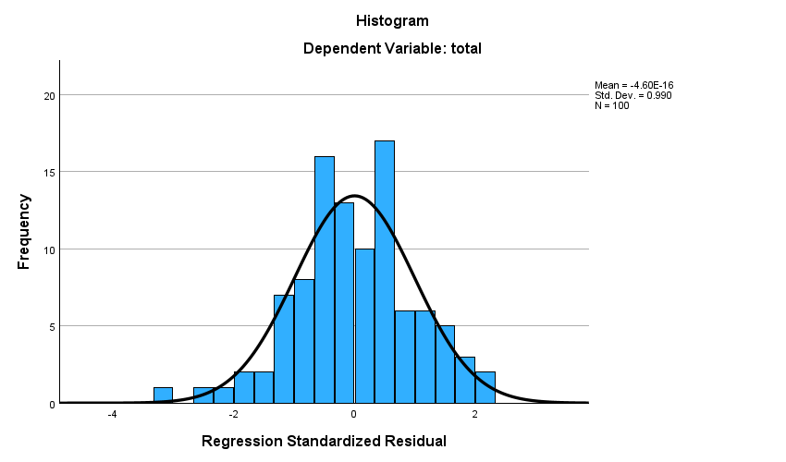

Lampiran C. 17 Hasil Uji P-P Plot
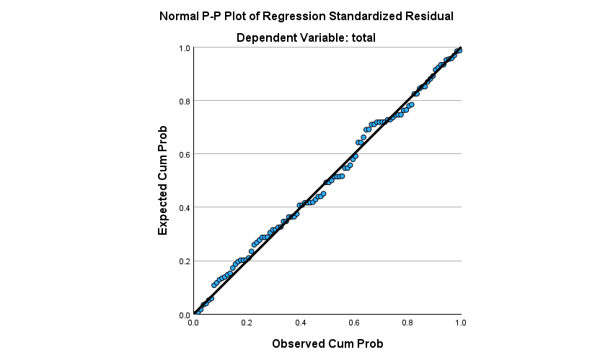

Lampiran C. 18 Hasil Uji Heteroskedastisitas (Scatterplot)
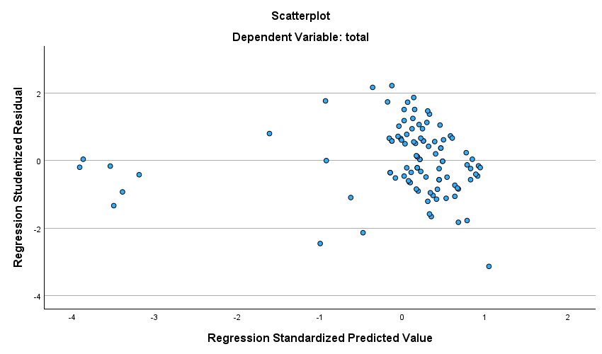

Lampiran C. 19 Hasil Uji Multikolinearitas
Coefficientsª
Model |  | Collinearity Statistics
 |  | Tolerance | VIF
1 | Total X1 | .195 | 5.138
1 | Total X2 | .195 | 5.138
a. Dependent Variable: Total Y

Lampiran C. 20 Hasil Uji Korelasi Pearson X1 dan Y
Correlations
 |  | Total_X1 | Total_Y
Total_X1 | Pearson Correlation | 1 | .791***
Total_X1 | Sig. (2-tailed) |  | <,001
Total_X1 | N | 100 | 100
Total_Y | Pearson Correlation | .791*** | 1
Total_Y | Sig. (2-tailed) | <,001
Total_Y | N | 100 | 100
***. Correlation is significant at the 0.001 level (2-tailed).

Lampiran C. 21 Hasil Uji Korelasi Pearson X2 dan Y
Correlations
 |  | Total_X2 | Total_Y
Total_X2 | Pearson Correlation | 1 | .874***
Total_X2 | Sig. (2-tailed) |  | <,001
Total_X2 | N | 100 | 100
Total_Y | Pearson Correlation | .874*** | 1
Total_Y | Sig. (2-tailed) | <,001
Total_Y | N | 100 | 100
***. Correlation is significant at the 0.001 level (2-tailed).

Lampiran C. 22 Hasil Korelasi Berganda X1, X2 dan Y
Model Summary
Model | R | R Square | Adjusted R Square | Std. Error of the Estimate
1 | .882ª | .778 | .774 | 3.318203
a. Predictors: (Constant), Total_X2, Total_X1

Lampiran C. 23 Hasil Koefisiensi Determinasi
Model Summary
Model | R | R Square | Adjusted R Square | Std. Error of the Estimate
1 | .882ª | .778 | .774 | 3.318203
a. Predictors: (Constant), Total_X2, Total_X1

Lampiran C. 24 Hasil Uji T (Parsial)
Coefficientsª
Model |  | Unstandardized Coefficients |  | Standardized Coefficients | t | Sig.
 |  | B | Std. Error | Beta | t | Sig.
1 | (Constant) | 2.584 | 2.042 |  | 1.266 | .209
1 | Total_X1 | .291 | .114 | .216 | 2.546 | .012
1 | Total_X2 | .563 | .069 | .695 | 8.191 | <,001
a. Dependent Variable: Total_Y

Lampiran C. 25 Hasil Uji F (Simultan)
ANOVAª
Model |  | Sum of Squares | df | Mean Square | F | Sig.
1 | Regression | 3753.472 | 2 | 1876.736 | 170.450 | <,001^{b}
1 | Residual | 1068.015 | 97 | 11.010
1 | Total | 4821.487 | 99
a. Dependent Variable: Total_Y
b. Predictors: (Constant), Total_X2, Total_X1

