WEB-BASED CASHIER AND SPARE PART INVENTORY INFORMATION SYSTEM AT MJ MOTOR WORKSHOP

Kanedi ^{1*};

Information Systems Study Program¹
Nusa Mandiri University, Depok, Indonesia¹
www.nusamandiri.ac.id¹
11250043@nusamandiri.ac.id^{1*}
(*) Corresponding Author

The creation is distributed under the Creative Commons Attribution-NonCommercial 4.0 International License.

Abstract—The rapid growth of the automotive industry increases the need for vehicle maintenance and spare parts. Bengkel MJ Motor feat Daarul Atsar currently relies on manual recording using paper receipts and ledgers, leading to physical stock discrepancies, slow transaction recapitulation, and a high risk of data loss. This research aims to design and build a web-based cashier and spare part inventory information system to replace the inefficient manual processes. The system development uses the Waterfall model, comprising requirements analysis, system design using UML, implementation using the Next.js framework and PostgreSQL database, testing, and maintenance. Data collection was conducted through direct observation, interviews, and literature reviews. The result of this research is a fully functional web-based Point of Sale (POS) and inventory system. Based on Blackbox testing, the system successfully automates daily transactions, deducts spare part stock in real-time, and generates accurate financial reports. The implementation of Next.js provides a highly responsive user interface, while PostgreSQL ensures high concurrency data integrity for cashier operations. The system significantly improves operational efficiency, minimizes human error, and provides accurate data for the workshop owner.

Keywords: inventory, next.js, point of sale, postgresql.

Intisari—Perkembangan industri otomotif yang pesat meningkatkan kebutuhan masyarakat terhadap perawatan kendaraan. Bengkel MJ Motor feat Daarul Atsar saat ini masih mengandalkan pencatatan manual menggunakan nota kertas dan buku besar, yang menyebabkan ketidaksesuaian stok fisik, lambatnya rekapitulasi transaksi, dan tingginya risiko kehilangan data. Penelitian ini bertujuan untuk merancang dan membangun sistem informasi kasir dan inventori suku cadang berbasis web guna menggantikan proses manual yang tidak efisien. Pengembangan sistem menggunakan metode Waterfall yang meliputi analisis kebutuhan, perancangan sistem menggunakan UML, implementasi menggunakan kerangka kerja Next.js dan basis data PostgreSQL, pengujian, serta pemeliharaan. Pengumpulan data dilakukan melalui observasi langsung, wawancara, dan studi pustaka. Hasil dari penelitian ini adalah sistem Point of Sale (POS) dan inventori berbasis web yang fungsional. Berdasarkan pengujian Blackbox, sistem ini berhasil mengotomatisasi transaksi harian, memotong stok suku cadang secara real-time, dan menghasilkan laporan keuangan yang akurat. Implementasi Next.js memberikan antarmuka pengguna yang sangat responsif, sementara PostgreSQL memastikan integritas data berkonkurensi tinggi untuk operasional kasir. Sistem ini secara signifikan meningkatkan efisiensi operasional, meminimalisir kesalahan manusia, dan menyediakan data yang akurat bagi pemilik bengkel.

Kata Kunci: inventori, next.js, point of sale, postgresql.

INTRODUCTION

The rapid development of the automotive industry is directly proportional to the high public demand for motor vehicle maintenance and repair. Bengkel MJ Motor feat Daarul Atsar is a business unit engaged in service and spare part sales that currently faces operational constraints due to a manual recording system. The use of paper receipts and ledgers often causes discrepancies between the physical number of spare parts and recorded data, slow daily transaction recapitulation, and a high risk of losing physical documents. Uncomputerized inventory and cashier management directly impact time inefficiency and financial losses due to human error. Therefore, an integrated system capable of automating this process is required. Previous research by (Alfarizi, 2025) stated that the integration of a Point of Sale (POS) system with inventory management allows automatic stock deduction on every transaction, ensuring real-time inventory data accuracy. Furthermore, the implementation of modern technology such as Next.js has been proven to significantly optimize front-end performance and accelerate application page load times (Anugerah & Kosasi, 2024; Firmansyah & Sihombing, 2025). The use of PostgreSQL is also highly ideal for systems requiring high concurrency handling and strict data integrity in cashier transactions (Prayoga et al., 2023). The novelty of this research lies in the utilization of the Next.js framework and PostgreSQL to digitalize service transactions while specifically automating income reports within a medium-scale automotive workshop ecosystem. The main objective of this research is to design and build a web-based Cashier and Spare Part Inventory Information System that can control stock in real-time, accelerate payment transactions, and generate accurate, computerized financial reports at Bengkel MJ Motor feat Daarul Atsar.

MATERIALS AND METHODS

The method used in this research includes data collection techniques and software development stages presented systematically. Data collection was conducted through direct observation at Bengkel MJ feat Daarul Atshar to observe the flow of item requests by mechanics, transaction recording by the cashier, and physical stock checking in the field. In addition, interviews were conducted with the workshop owner and cashier to explore the functional requirements of the application, along with a literature review to gather references related to inventory information systems, integrated cashier systems, and web interface development technology. System development in this study applies the Waterfall Model approach consisting of several structured stages. The first stage is system requirements analysis to identify the operational data needs of mechanics, spare parts, services, and user access rights. The next stage is design, which includes database architecture design, system flow using the Unified Modeling Language (UML), and User Interface design. Once the design is complete, the code generation stage is carried out by implementing the ReactJS library and Next.js framework for the interface and system logic, combined with the PostgreSQL database management system. The built system is then tested using the Blackbox Testing method to validate the functionality of each transaction menu and automatic stock deduction feature to ensure they run according to the design. The final stage is maintenance, where technical support is provided to the workshop to ensure the smooth implementation of the software on available hardware.

RESULTS AND DISCUSSION

Current System Analysis and Needs.
Based on the results of observations and analysis at Bengkel MJ Motor feat Daarul Atsar, the current operational procedures—ranging from service registration, spare part retrieval, to the payment process at the cashier—still rely entirely on manual recording. Mechanics use temporary paper media to record item retrieval, which is then recapitulated by the cashier using duplicate physical receipts as transaction proof. At the end of the period, the cashier must recount all receipts using a calculator to transfer them to a ledger as an income report. This manual workflow is identified as having a high risk of time inefficiency, physical stock data inaccuracy on the shelves, and vulnerability to document loss or damage. Therefore, the results of this analysis serve as the basis for designing a newly computerized information system architecture to automate the entire workflow.
Architecture and Database Design.
The proposed information system is built by adopting a modern component-based Client-Server architecture. The front-end is developed using the ReactJS library, optimally rendered by the Next.js framework. Data communication between the interface and the database is carried out through the built-in Application Programming Interface (API) routes of Next.js, securely processing queries on the server-side before responding to the client in JSON format. To support transaction and inventory data integrity, this system uses a PostgreSQL relational database. The table structure is designed to handle workshop operational complexity, including product entity management (with soft delete support), stock movement history, cashier transaction details, customer membership management, and user authentication settings featuring automatic account locking for enhanced security.
Furthermore, the system's functional boundaries and user interactions are mapped using a Use Case Diagram. The system accommodates two primary actors, namely the Administrator and the Cashier. The Administrator possesses full access rights to manage master data, including product entities, supplier information, and user accounts, as well as the authority to generate comprehensive financial reports. Conversely, the Cashier's role is strictly confined to executing daily operational tasks, such as processing Point of Sales (POS) transactions, registering new customers, and printing payment receipts. This role-based access control ensures data security and operational accountability within the workshop environment.
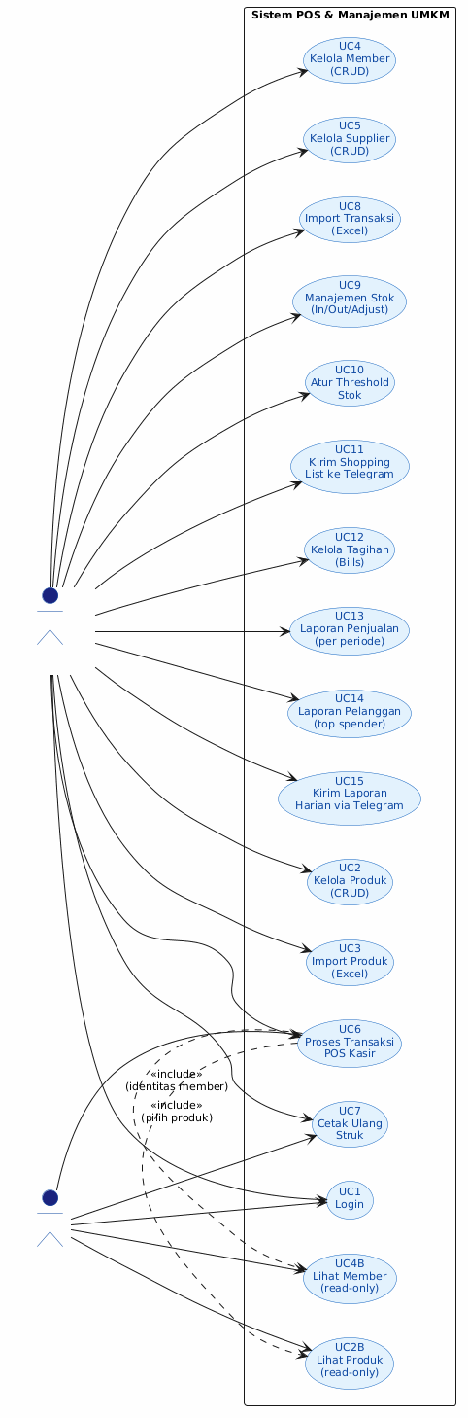
Source: (Research Results, 2026) Figure 1. Use Case Diagram of the Proposed System

System Interface Implementation.
The interface design is focused on responsiveness and user-friendliness to facilitate the mobility of cashiers and workshop admins. The system provides separate dashboards tailored to the access rights (roles) of each user. On the cashier's operational side, the Point of Sales (POS) interface is designed efficiently so that the process of searching for spare parts, adding service items, and calculating prices can be done very quickly. When a transaction is confirmed and validated, the system automatically executes stock quantity deduction in the inventory table and generates a digital receipt (thermal printout) as valid proof of payment. Meanwhile, on the admin side, the system provides an inventory panel to track item mutations in real-time and an income report recapitulation feature equipped with a custom date range filter to facilitate financial evaluation.
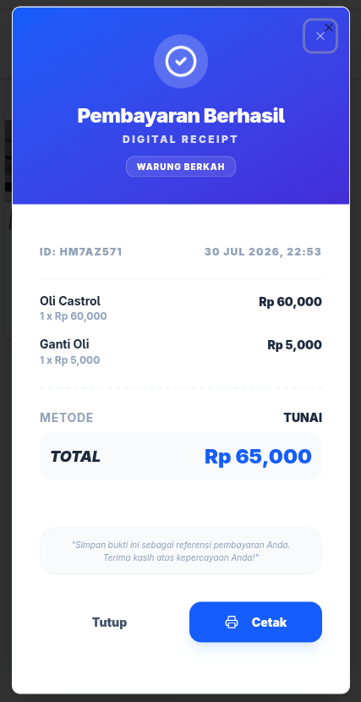

Source: (Research Results, 2026) Figure 2. Cashier Transaction Interface (Point of Sales)
In addition to the transaction interface, the system features a robust reporting dashboard specifically designed for the Administrator. This interface allows the workshop owner to monitor business performance through customizable income reports. Users can filter transaction data based on specific daily, monthly, or custom date ranges. The backend utilizes optimized PostgreSQL queries and denormalized calculation attributes to aggregate large volumes of historical transaction data instantly. Consequently, the system can display precise revenue subtotals and stock movement summaries without experiencing significant latency, thereby providing a highly efficient tool for managerial decision-making.
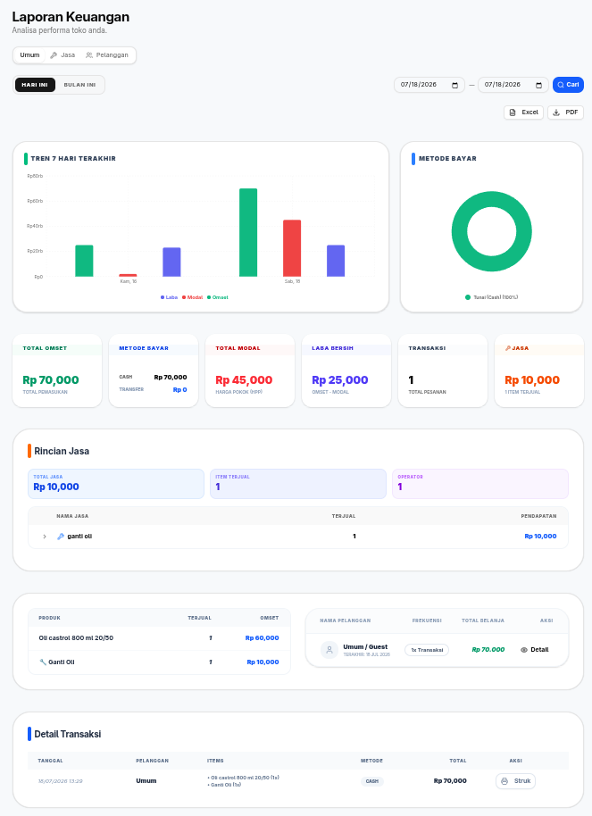
Source: (Research Results, 2026) Figure 3. Administrator Income Report Interface
System Testing and Deployment.
The built system was tested using the Blackbox Testing method, focusing on validating main menu functionalities to ensure no programming logic errors. Testing scenarios included access denial for incorrect login credentials, adding new spare part data entities to the database, and the accuracy of subtotal calculations in cashier transactions along with automated stock deduction. The test results proved that all system logic and features run validly as expected. Details of the test results can be seen in Table 1.

Table 1. Blackbox Testing Results
No | Skenario Pengujian | Hasil yang Diharapkan | Hasil Pengujian | Kesimpulan
1 | Entering incorrect username and password on the login form. | The system denies access and displays an invalid credentials warning message. | Access is denied, and the warning message appears correctly. | Valid
2 | Entering valid credentials on the login form. | The system validates the session and redirects to the dashboard according to the role. | User successfully logs into the appropriate homepage. | Valid
3 | Adding new spare part data via the inventory form. | The system saves the entity to the database and displays it in the table. | Data is saved and immediately appears in the interface table. | Valid
4 | Processing cashier transactions and completing payments. | The system calculates the total, prints the receipt, and automatically deducts stock. | Calculation is precise, receipt is generated, and stock decreases. | Valid
Source: (Research Results, 2026)

The implementation and deployment stage was carried out on a Virtual Private Server (VPS) infrastructure with a Linux operating system environment. The interface application is managed using the PM2 process manager so that the system remains running stably (keep-alive) in the background and can perform automatic recovery in the event of technical issues. Network access to the application is secured through encrypted external routing configurations using tunneling technology and a reverse proxy, allowing the system to be accessed publicly with high performance without the need to directly open ports on the production server's firewall.

CONCLUSION

This research successfully designed and implemented a web-based Cashier and Motor Spare Part Inventory Information System at Bengkel MJ Motor feat Daarul Atsar. The developed system efficiently digitalizes the cashier service process through a responsive Point of Sales (POS) interface, while accurately classifying physical spare part and service data without requiring a complex database structure. Stock availability can now be monitored precisely and in real-time as the system automatically deducts inventory quantities every time a transaction is validated by the cashier, thus minimizing the risk of unnoticed stock-outs and item discrepancies. Additionally, the system automates the generation of daily and monthly income reports instantly, replacing the manual recapitulation method of hundreds of physical receipts. Although this system has met the main operational needs of the workshop, for future development, it is recommended to add advanced accounting modules such as General Journal, General Ledger, and employee payroll management. Further development can also be done by integrating additional hardware in the form of a barcode scanner to speed up item input at the cashier's desk, as well as implementing a WhatsApp Gateway (API) to send digital receipts and automatic notifications to customers when their vehicle repairs are completed.

REFERENCE

Alfarizi, A. (2025). Perancangan Sistem Informasi Persediaan Barang Berbasis Web pada KCU Pos Bekasi [Tugas Akhir]. Universitas Bina Sarana Informatika.
Andaria, A. C. (2024). Komponen Sistem Informasi Manajemen. Agam: Yayasan Tri Edukasi Ilmiah.
Anugerah, D. A., & Kosasi, S. (2024). Penerapan Next.js dan GraphQL dalam Pengembangan Mobile Web Sistem Informasi Manajemen Puskesmas. CSRID Journal, 16(3), 1-12.
Firmansyah, D., & Sihombing, E. G. (2025). Implementasi dan Pengembangan Website Konversi Dokumen dan Analisis Semantik dengan Integrasi Gemini AI. Jurnal Informatika, 11(21), 1-14.
Givahri, A. (2023). Rancang Bangun Sistem Point of Sale (POS) Berbasis Website dengan Metode Waterfall pada Toko Nans Beauty Toili [Laporan Kerja Praktek]. Institut Sains & Teknologi AKPRIND Yogyakarta.
Kurniawati, E., & Ikhwan, A. (2023). Perancangan Sistem Informasi Manajemen Inventaris Kontrol Stok Barang Berbasis Web. Jurnal Teknologi Sistem Informasi dan Aplikasi, 6(3), 408-415.
Maximillian, L., & Kristianto, R. P. (2024). Pengujian Aplikasi Mobile Web Wisata Bandung Menggunakan Blackbox Testing dan Katalon Berbasis Manual dan Automation Testing.
Muslim, M. I., & Hendri. (2022). Sistem Informasi Point Of Sales (POS) Berbasis Web Dengan Menggunakan Framework Laravel 8 Pada Toko Draquatic. Journal of Accounting Information System, 2(2), 64-69.
Nugroho, S. A. (2023). Pengaruh Pemilihan Sistem Manajemen Basis Data Terhadap Kinerja Data Mart pada PT XYZ Retail Bahan Bangunan Yogyakarta [Tesis]. Universitas Atma Jaya Yogyakarta.
Prayoga, J., Sinurat, S., Rachman, A., Carolina, I., Jumaryadi, Y., Frieyadie, Irmayana, A., Supriyatna, A., Pasnur, Meilani, B. D., & Munawarah. (2023). Sistem Basis Data. CV. Graha Mitra Edukasi.
Rahmawati, T., Wirapraja, A., & Santoso, D. F. (2023). Perancangan Sistem Informasi Penjualan Suku Cadang Motor Dan Fitur Keluhan Pelanggan Berbasis Web Pada Pt. Fuboru Indonesia. Jurnal Manajemen Informatika Dan Sistem Informasi, 6(2), 159-171.
Rizqi, M. (2026). Perancangan Program Aplikasi Pendataan dan Pemeliharaan Aset IT Berbasis Web pada PT. SOG Indonesia [Skripsi]. Universitas Bina Sarana Informatika.
Saan, M. Y., Dalimunthe, Y. A., & Irwan, D. (2023). Rancang Bangun Aplikasi Point of Sale Penjualan Kopi Dengan Menggunakan Framework Codeigniter Berbasis Web. Syntax: Journal of Software Engineering, Computer Science and Information Technology, 4(1), 314-319.
Susanto, F. G. P., Fadlan, N. I. Y., & Haryani, P. (2023). Web-Based Management Information System Design for Student Organizations in Kendal Regency Using Next.js Framework. Compiler, 12(1), 9-20.
Syahri, W. O. (2024). Sistem Informasi Kasir Toko Lestari Abadi Menggunakan Metode Point of Sales (PoS) Berbasis Web [Skripsi]. Universitas Islam Kuantan Singingi.

PERIODIC ISSUES

SEMESTER |  | PUBLISH TIME
GENAP | MARET – AGUSTUS
GANJIL | SEPTEMBER – FEBRUARI

