Web-Based Transaction Management Information System with Staged Payment for Ade Decoration Wedding Organizer

……Blind Review….

(Article Received: date. month. year; Article Revised: date. month. year; Article Published: date. month. year)
Phone Number : ……………(will not be listed when the article is published)

ABSTRACT – A Wedding Organizer helps clients plan and run wedding events, yet many small operators in this line of business, including Ade Decoration, still manage transactions by hand. This study designs and builds a web-based Transaction Management Information System for Ade Decoration in which staged-payment recording and automatic payment-status validation form the central contribution, bringing package ordering, payment verification, invoice issuance, and transaction reporting onto one platform. Development follows the Waterfall model, with the system modeled in UML and implemented using Laravel and MySQL. Testing combined User Acceptance Testing (UAT) with three participants, performance testing with Apache JMeter, and security testing with OWASP ZAP. The performance test simulated 30 concurrent users and processed 40,620 requests with zero failures, an average response time of 516 ms, and a throughput of 33.8 requests/second; the security scan found no high- or critical-risk vulnerability. Staff at Ade Decoration report that, compared with the previous manual workflow, compiling a monthly report now takes 10–15 minutes instead of a full day, checking an installment's status takes 1–2 minutes instead of 30 minutes to an hour, and the recording errors typical of a manual order sheet are no longer observed. These figures come from the staff's own account of the transition rather than a controlled before-and-after measurement.

Keywords - Information System, Transaction Management, Wedding Organizer, Waterfall, Laravel.

Sistem Informasi Manajemen Transaksi Berbasis Web dengan Pembayaran Bertahap Pada Wedding Organizer Ade Decoration

ABSTRAK – Wedding Organizer merupakan penyedia jasa yang membantu pelanggan merencanakan dan melaksanakan acara pernikahan, namun pengelolaan transaksi pada banyak usaha kecil di bidang ini, termasuk Ade Decoration, masih berjalan manual. Penelitian ini merancang dan membangun Sistem Informasi Manajemen Transaksi berbasis web untuk Ade Decoration, dengan pencatatan pembayaran bertahap dan validasi status pembayaran otomatis sebagai kontribusi utamanya, yang mengintegrasikan pemesanan paket, verifikasi pembayaran, penerbitan invoice, dan penyusunan laporan transaksi dalam satu platform. Pengembangan mengikuti model Waterfall, dengan perancangan berbasis UML serta implementasi memakai Laravel dan MySQL. Pengujian dilakukan melalui User Acceptance Test (UAT) dengan tiga peserta, pengujian performa dengan Apache JMeter, dan pengujian keamanan dengan OWASP ZAP. Pengujian performa mensimulasikan 30 pengguna bersamaan dan memproses 40.620 request tanpa kegagalan, dengan waktu respons rata-rata 516 ms dan throughput 33,8 request/detik; pemindaian keamanan tidak menemukan kerentanan berkategori tinggi maupun kritis. Staf Ade Decoration melaporkan bahwa, dibandingkan alur manual sebelumnya, penyusunan laporan bulanan kini hanya 10–15 menit, pengecekan status cicilan kini 1–2 menit, dan kesalahan pencatatan yang biasa terjadi pada catatan manual tidak lagi muncul. Angka-angka ini berasal dari pengalaman staf saat menjalani transisi, bukan dari pengukuran before-after yang terkontrol.

Kata Kunci – Sistem Informasi, Manajemen Transaksi, Wedding Organizer, Waterfall, Laravel.

Introduction
Information technology has transformed operations across many business sectors, including micro, small, and medium-sized enterprises (MSMEs); several studies show that adopting information systems speeds up data processing and helps business processes run more effectively [1].
Wedding organizers (WOs) are a segment of MSMEs with complex, project-based business processes: each project involves service package provision, booking, payment, and transaction reporting tied to a fixed event date [2]. Ade Decoration, a WO operating in South Jakarta since 2003, faces this complexity directly, its transaction administration still relies on instant messaging apps and manual record keeping, so order data, payment details, and supporting documents end up scattered across disparate, unconnected platforms.
This lack of integration has tangible consequences: separate record keeping leads to data duplication, makes it difficult to track the status of down payments and installments, and causes transaction reporting to take days instead of minutes because data must be re-compiled from several sources by hand. Such financial management issues are common among MSMEs that have not yet digitized their administrative processes [3], and this gap has driven the emergence of digital platforms for managing invoices and purchase orders as a general solution [4].
Building on the gap identified in the next chapter’s review of related work, this research designs and develops a web-based transaction management information system for Ade Decoration, centered on a staged payment mechanism whose validation logic recalculates an order’s payment status automatically every time a payment is verified, with booking, invoice issuance, and transaction reporting built around that same mechanism.
More specifically, three issues underpin this research: transaction and payment recording are still manual and prone to calculation errors; there is no mechanism to track installment status in real time even though one wedding order may involve several payments before full settlement; and compiling operational and financial reports is time consuming because data is fragmented. These issues lead to the research questions addressed in this study, what is the current state of Ade Decoration’s transaction system, how can a web-based system, and a staged-payment mechanism in particular, be designed to address these issues, and to what extent can its implementation speed up invoice and payment recording and financial reporting.
This research is limited to four areas, recording customer orders, managing installment payments from down payment to settlement, issuing digital invoices, and generating revenue summary reports, while field-crew scheduling, attendance tracking, event rundown coordination, and inventory management are deliberately left out, so development stays focused on transaction administration. In practical terms, the research is expected to reduce the administrative workload at Ade Decoration directly, academically, its contribution is the design and validation of a staged payment mechanism, with automatic status recalculation, for a project-based service business where a single order is rarely settled in one transaction.

Literature Review
An information system is an integrated combination of hardware, software, databases, procedures, and human resources that interact to process data into information [5], while a Management Information System (MIS) emphasizes using that information to support planning and decision-making [6]. A website was chosen as the implementation medium for its accessibility across time and space, built on HTML, CSS, JavaScript, and server-side languages [7], and system requirements were translated into a design using standard UML notation before implementation [8]. The project-based characteristics of wedding organizers [9] and a systematic review of web-based WO booking systems [10] served as further references for defining functional requirements.
Several previous studies address the digitalization of wedding planning services, yet most stop at package catalogs and online booking [11], [12], [13], [14], [15], while research on event management more broadly focuses mainly on participant registration and attendance [16], [17]. A similar pattern appears in booking systems for other services, photography [18], printing [19], and IoT-based computer repair booking [20], showing that web-based service-transaction digitalization is a proven model across MSME sectors, though it has not reached the wedding planning industry to the same degree. Table 1 summarizes how five representative WO studies relate to the present research.
Table 1. Summary of Previous Research on Wedding Organizer Systems
Ref. | Focus | Gap vs. This Study
[11] | Desktop WO rental app | No installment tracking
[12] | Web WO booking only | No verification/report
[13] | WO portal: promotion | Not transactional
[14] | WO booking (XP method) | No staged payment
[15] | WO booking + notification | No auto status update
A consistent gap across these studies is the lack of a business rule that keeps an order's payment status current on its own, existing systems record a payment as a transaction but leave totaling installments and updating the matching invoice to a person exactly the step that, on paper, takes the longest and produces the most errors at Ade Decoration. The novelty pursued here is therefore not simply bundling features together, as in [11]-[20], but a staged payment mechanism whose validation logic recalculates an order's status automatically whenever a payment is verified, with booking, invoicing, and reporting built around that same mechanism rather than treated as separate modules.

Research Methodology
This study uses a Research and Development (R&D) approach, since its output is a product an information system, built from user needs rather than an issue analysis alone [21]. The subject is Ade Decoration, a wedding organizer in South Jakarta operating for more than 20 years.
Data were collected through three methods. First, semi-structured interviews with two respondents; the owner, who holds the highest position in the business, and the admin, who handles all transactions and the website's content. Second, direct observation of order-recording and payment workflows, carried out twice, an initial round to determine system requirements, and a second round, after the system was built, to adjust those requirements and run the tests reported in Chapter 4. Third, a literature review covering management information systems, wedding organizers, and the Waterfall method.
The interview and observation material was not processed through a formal coding scheme; findings were taken directly from what the owner and admin described missing features and where the current workflow broke down and compared against example systems already used by other businesses shown to them during the interviews. Requirements were validated the same way, after the owner and admin tried these comparable systems, the research team recommended, and the owner approved, building a system tailored specifically to Ade Decoration. This is a practical validation route rather than a formally instrumented one, a limitation returned to in the discussion.
Software development follows the Waterfall model, chosen because requirements were relatively clear from the outset, letting each stage run sequentially and be documented, as summarized in Table 2. Supporting tools include Draw.io for UML/ERD modeling, Visual Studio Code, Laravel 11 (PHP), MySQL, Apache JMeter, and OWASP ZAP a toolset comparable to other recent Laravel-based web development work [22]. User Acceptance Testing involved the same two interviewees plus one client acting as a sample end user, representing the three access levels in Table 4.
Table 2. System Development Stages Using the Waterfall Model
Stage | Activity | Output
Needs Analysis | Observe, interview, review literature | Requirements list
Design | UML & ERD design | Design diagram
Code Generation | Laravel & MySQL build | Web application
Testing | UAT, JMeter, ZAP | Test report
Support | Bug fixes, adjustments | System ready
Analysis of the Existing System
Ade Decoration has a simple organizational structure Owner, Admin, Marketing, a Field Coordinator, and Field Workers (Figure 1). The current workflow begins when a prospective client contacts Marketing to inquire about packages, followed by concept consultation, scheduling, down payment and settlement, decoration execution, and finally report recording by the Admin. These stages rely on separate spreadsheets and chat apps rather than an integrated database, risking lost or duplicated invoices and delayed reports.
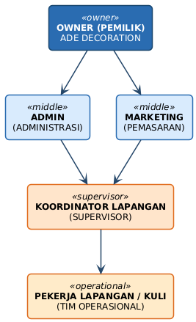
Figure 1. Organizational Structure of Ade Decoration
The seven procedures making up the workflow are summarized in Table 3; each still relies on manual coordination among actors, so information is easily lost as it passes from Marketing to Admin and then to the Field Coordinator. The fourth and seventh procedures are the most critical: manually recorded payments risk calculation discrepancies, while report consolidation can take several days.
Table 3. Business Procedures of the Current System
No. | Procedure | Executor
1 | Accept orders (chat/phone/in person) | Marketing
2 | Consult event concept | Marketing, Owner
3 | Schedule events manually | Admin
4 | Down payment & installments | Admin, Client
5 | Decoration on-site | Coordinator, Workers
6 | Dismantle & return equipment | Coordinator, Workers
7 | Consolidate into a report | Admin
Proposed System Requirements
Functional requirements are defined per actor so each user's access rights are maintained, as summarized in Table 4. The system must also meet three non-functional requirements, stable performance during login, ordering, payment, invoicing, and report generation, role-based security, and availability that keeps key features reachable when needed. These three aspects are tested with Apache JMeter, OWASP ZAP, and User Acceptance Testing respectively, with results reported in Chapter 4.
Table 4. Functional Requirements by Actor
Actor | Key Functional Requirements
Admin | Login; dashboard; manage bookings & pricing; verify payment; issue invoices; print reports
Client | Register; browse packages; checkout; upload payment proof; track status; download invoice
Owner | Login; executive dashboard; audit sales & cash flow
System Design
Requirements are translated into UML models. The use case diagram (Figure 2) maps three actors admin, client, and owner, to nine key functions, from registration and login to transaction management and report generation, activity and sequence diagrams further detail the behavior of login, ordering, payment, payment verification, and report printing.
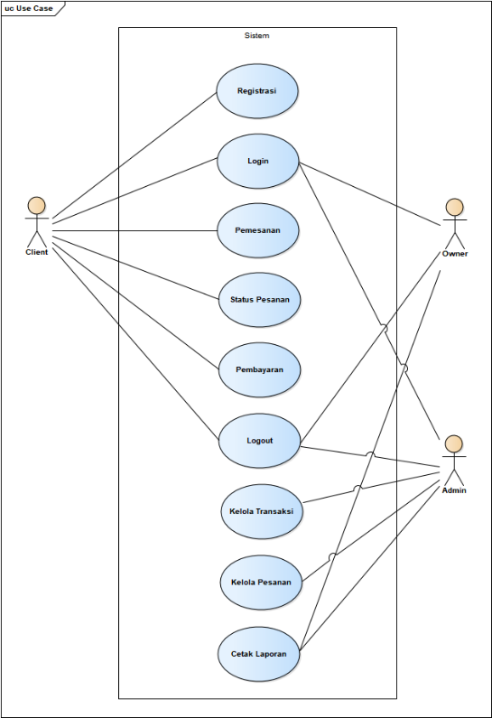
Figure 2. Use Case Diagram of the Proposed System
The class structure (Figure 3) is derived into an Entity-Relationship Diagram (Figure 4) as the basis for database design, the resulting tables, summarized in Table 5, are interrelated to keep user, package, and transaction data consistent. A payment transactions record does not stand alone, it feeds a status calculation on its parent order every time a row is inserted, so payment status and the event schedule stay current without an admin updating more than one place the core of the staged-payment mechanism.
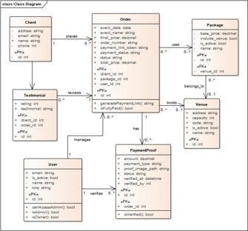
Figure 3. Class Diagram of the Proposed System
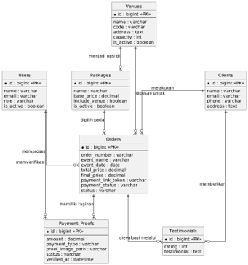
Figure 4. Entity-Relationship Diagram (ERD) of the Proposed System
Table 5. Database Table Specifications
Table | Content
users | Admin/owner accounts, access rights
client | Customer account and profile
packages | Package data, prices, details
orders | Order data, status, final price
payment_transactions | Payment history per order
events | Event schedule per paid order
Interface Implementation
The design was implemented with Laravel and MySQL. Client-side features include a login page, package catalog, checkout, payment-proof upload, and order-status tracking (Figure 5). the admin side includes a dashboard, order management, payment verification, and invoice/report generation. Besides standard orders requiring registration, a “mini-order” option lets admins record small or ad-hoc orders without a client account, so even minor transactions enter the same database.
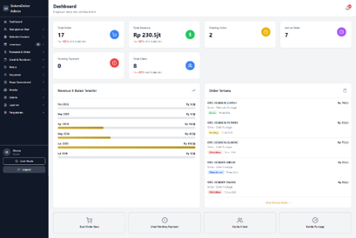
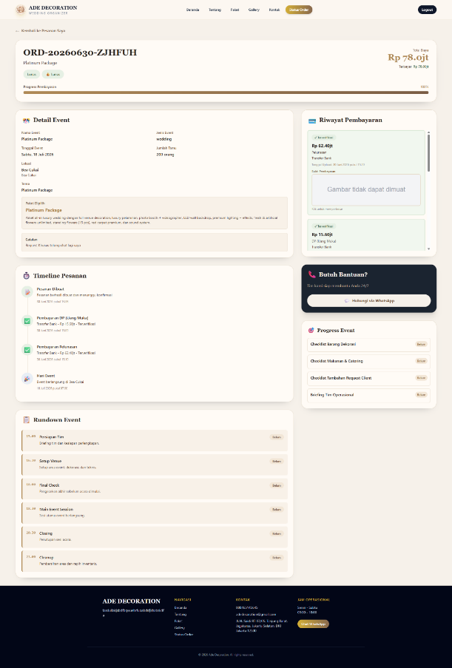
Figure 5. Admin Dashboard Interface and Client Order Status
Once an admin marks a proof of transfer as valid, the system tallies all verified payments for that order, updates its status to “paid in full” or “ongoing,” and schedules the event automatically on the first payment, removing the manual work of summing installments from a spreadsheet. Access is restricted with authentication and role-based authorization middleware, following the same role-based principle used in a Laravel single sign-on system [23], though that system also layers in multi-tenancy and audit logging outside this study's scope. Passwords are hashed, and uploaded file types are validated before saving.
Supporting Equipment Specifications
Minimum hardware and software requirements for server and user sides are summarized in Table 6, kept modest given Ade Decoration's status as an MSME, to keep hosting costs down without compromising stability; user-side requirements are minimal since the application runs in a standard browser.
Table 6. Hardware and Software Specifications
Component | Server | User
Processor | i3 / Ryzen 3 | i3 / Ryzen 3
RAM | 8 GB | 4 GB
Storage | SSD 128 GB | 100 MB free
Internet | 20 Mbps | 10 Mbps
OS | Linux | Win/Linux/Mac/Mobile
Stack | Nginx, MySQL, PHP, Laravel | —
Client | — | Chrome/Firefox/Safari

results and discussion
Results
Performance. Apache JMeter simulated concurrent HTTP requests, Table 7 shows the system processed 40,620 requests from 30 simulated users without a single failure, at an average response time of 516 ms and a throughput of 33.8 requests/second.
Table 7. Performance Testing Results
Metric | Result
Users / requests | 30 / 40,620
Error rate | 0.00%
Fastest/avg/longest | 127/516/1,048 ms
Throughput | 33.8 req/s
Security. OWASP ZAP identified no High or Critical-risk vulnerability. Findings were Medium and Low (Table 8, Figure 6), alongside Informational notes describing application characteristics rather than vulnerabilities.
Table 8. Security Testing Summary (OWASP ZAP)
Risk | Example Finding
Medium | CSP header not set; SRI missing
Low | Cookie not HttpOnly; header missing
Info | Standard session characteristics
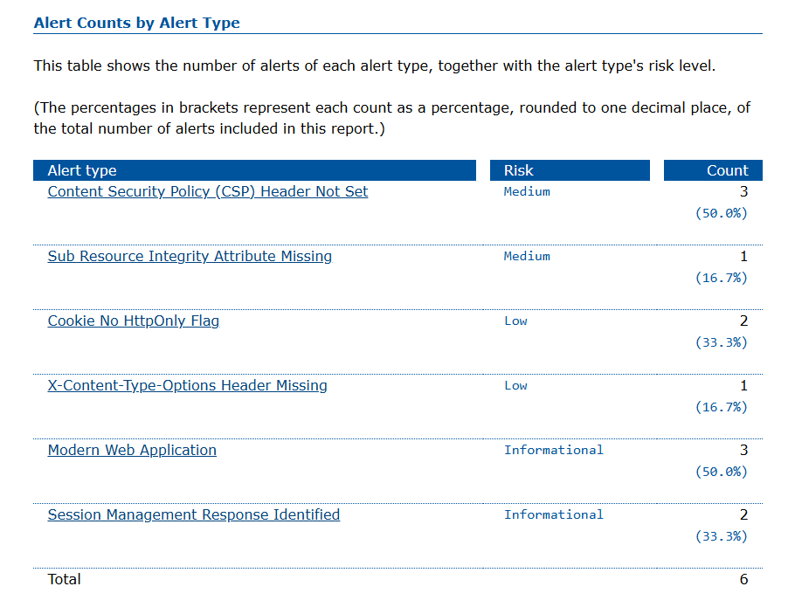
Figure 6. OWASP ZAP Alert Summary
User Acceptance Testing. UAT used the admin, owner, and a sample client against a pass/fail scenario checklist, without a numeric scale. Twenty scenarios were run (Table 9) and all succeeded on the first attempt.
Table 9. User Acceptance Testing Summary
Actor | Scenarios | Result
Admin | 9 | 9/9 Succeed
Client | 7 | 7/7 Succeed
Owner | 4 | 4/4 Succeed
Manual vs. system-assisted process. The admin and owner described, from memory, how the fourth and seventh procedures in Table 3 compared before and after the system (Table 10). These figures were not produced by a controlled experiment no baseline was logged while the manual process was in use, so Table 10 reflects staff recollection rather than a timed comparison.
Table 10. Staff-Reported Task Duration and Errors, Manual vs. System-Assisted
Task | Manual | With System
Monthly report | ~1 day | 10–15 min
Installment check | 30 min–1 hr | 1–2 min
Recording errors | 1–2 items/order | None since launch
Discussion
Performance and security. The 516 ms average response time sits inside the range other Indonesian studies report for JMeter-tested web information systems: stable results across comparable sample sizes [24], and reliable operation with no errors up to 200 concurrent users before degrading past 300 [25]. Measured against that pattern, a 0.00% error rate at 30 users indicates technical stability rather than proximity to a breaking point — though the 30 users were a synthetic JMeter load, not Ade Decoration's actual traffic, which is not yet logged at that level of detail; the test shows the system holds up under moderate load, not that 30 is a realistic ceiling. The Medium/Low security findings (missing CSP header, cookies without HttpOnly) match a pattern reported elsewhere as common rather than unusual [26], [27], and should still be addressed before the system handles public-facing traffic at scale.
Contribution. Compared with the prior studies in Table 1, the contribution here is not bundling features together but a single mechanism, automatic payment-status recalculation, underneath booking, verification, invoicing, and reporting alike, most evident in the fourth and seventh procedures of Table 3, where manual recording previously caused discrepancies and slow reports. A comparable Laravel/MySQL/Waterfall payment system for school tuition [28], handles a single lump-sum payment rather than variable installments, so it does not need to reconcile partial payments the way this system does; cloud-based invoice automation for a different small enterprise reports reduced recording errors from an automated workflow [29], a direction consistent with what Ade Decoration's staff describe in Table 10, though via a controlled test rather than a staff-recalled comparison.
Limitations. Four limitations qualify these results. First, Table 10 rests on staff recollection rather than a timed baseline, so the reported gains describe a perceived improvement, not one confirmed by controlled measurement. Second, UAT used only three participants and a pass/fail instrument with no numeric scoring a narrower check than studies using a validated usability questionnaire [30], so it confirms that features work, not how a larger group would rate the experience. Third, the JMeter load is synthetic, not drawn from real traffic, so the performance results describe stability under load rather than a validated capacity ceiling. Fourth, the system's scope excludes field-crew scheduling, inventory, and event rundown coordination, and still needs the missing security headers noted above before handling large-scale public traffic.

Conclusion
The developed web-based transaction management information system brings customer data management, package and mini-order booking, staged payments, payment verification, invoice issuance, and transaction reporting into one application, replacing manual record keeping that had been scattered across spreadsheets and chat apps. For clients, it supports online registration, booking, status tracking, and invoice retrieval; for administrators and the owner, payment verification no longer requires tallying installments by hand, and reports are compiled from a single database rather than several disconnected sources.
Whether this makes the reports themselves more accurate is a claim this study has not tested directly; what the results show is that the owner and admin report fewer recording errors and less time spent compiling reports since launch, based on their own recollection rather than a measured accuracy rate against the old process. Testing supports the rest of the picture: all twenty UAT scenarios across the three roles succeeded, performance stayed stable with zero failures under a simulated load of 30 concurrent users, and security testing found no high-severity or critical vulnerability, together indicating the system is ready to support Ade Decoration's day-to-day operations, subject to the security-header and traffic-scale caveats noted in the discussion.
For future development, integrating a payment gateway would automate payment processing and remove manual proof-of-transfer uploads, while WhatsApp or email notifications could speed up confirmations and schedule reminders. Implementing the missing security headers is a more immediate next step before the system handles public-facing traffic at scale, and the system's scope could expand to vendor management, decor inventory, and field-crew scheduling so the business runs on one platform instead of several.
Bibliography
[1] D. Astuti and R. Rosita, “Pentingnya Transformasi Digital UMKM dalam Pengembangan Ekonomi Indonesia Politeknik LP3I Jakarta , Indonesia Transformasi digital sangat penting untuk keberhasilan berkelanjutan UMKM di toko online dapat menjangkau audiens yang lebih luas di luar lokasi fisik mereka . Dengan,” 2024.
[2] M. Sidauruk, P. Handayani, and A. Hadiyanto, “Penyelesaian Wanprestasi dalam Hubungan Kontraktual Wedding Organizer dan Vendor Resolution of Breach of Contract in Contractual Relationships Wedding Organizers and Vendors yang semakin penting dalam menunjang aktivitas ekonomi . Salah satu bentuk usaha jasa,” vol. 9, no. 3, pp. 1628–1652, 2026.
[3] S. R. Dewi, “Upgrading Tata Kelola Keuangan Bagi UMKM Terintegrasi Dengan Financial Digital,” vol. 4, no. 1, pp. 135–147, 2023.
[4] P. T. Anugerah and W. Wicaksana, “Platform Digital untuk Mengelola Invoice dan Purchase Order dengan,” vol. 4, no. 2, pp. 51–60, 2024.
[5] A. A. J. Permana et al., Buku Ajar Pengantar Sistem Informasi. PT. Sonpedia Publishing Indonesia, 2024.
[6] R. Puspita, R. A. Ritonga, L. Ariani, E. Z. Yuni, H. Pasaribu, and S. P. Sitorus, Konsep Dasar Sistem Informasi Manajemen. Serasi Media Teknologi, 2025.
[7] D. M. Kusumawardani, S. Astiti, M. Y. Fathoni, D. Sunardi, and S. Fernandez, Web Dasar Menggunakan HTML, CSS, JS, PHP dan Studi Kasus. PT. Sonpedia Publishing Indonesia, 2023.
[8] R. Destriana, S. M. Husain, N. Handayani, and A. T. P. Siswanto, Diagram UML Dalam Membuat Aplikasi Android Firebase" Studi Kasus Aplikasi Bank Sampah". Deepublish, 2022.
[9] S. E. Meli Siagawati and C. T. MM, Meeting, Incentive Trip, Conference, Exhibition & Event Organizer. Kaizen Media Publishing, 2023.
[10] K. F. Yufanka, E. Lutfina, A. Nugroho, and M. Z. Abdillah, “Systematic Literature Review: Perancangan Sistem Informasi Pemesanan Wedding Organizer Berbasis Web,” Sci. Technol. Manag. J., vol. 3, no. 1, pp. 15–20, 2023.
[11] D. P. Ayu, N. Pravitasari, and R. Marlia, “Perancangan Sistem Informasi Penyewaan Wedding Organizer Berbasis Java Netbeans,” J. Unitek, vol. 15, no. 2, pp. 133–140, 2022.
[12] M. Marchelina, F. Fajriah, and I. Setiawan, “Perancangan Sistem Informasi Promosi dan Pemesanan Wedding Organizer Berbasis Web,” J. Minfo Polgan, vol. 15, no. 1, pp. 123–129, 2026.
[13] A. C. Murti and R. Meimaharani, “WEB PORTAL-BASED MANAGEMENT INFORMATION SYSTEM FOR WEDDING ORGANIZER SERVICE RENTAL,” Rabit J. Teknol. dan Sist. Inf. Univrab, vol. 11, no. 1, pp. 1818–1830, 2026.
[14] D. A. Prayoga, E. Firjatullah, N. Hidayati, and H. E. Fadlia, “Rancang Bangun Sistem Informasi Berbasis Web Responsif Untuk Pemesanan Paket Wedding Organizer Menggunakan Metode Extreme Programming,” J. Multimed. dan Teknol. Inf., vol. 7, no. 01, pp. 38–49, 2025.
[15] A. SAYUTI and S. Davizan, “Design of Wedding Organizer Information System at" Bella WO" using the waterfall method,” RADINKA J. Sci. Syst. Lit. Rev., vol. 3, no. 2, pp. 623–634, 2025.
[16] H. Amalia, A. Puspita, R. Utami, L. Mazia, and A. F. Lestari, “Penerapan Model Waterfall Dalam Perancangan Aplikasi Manajemen Event Pb Persatuan Cartur Seluruh Indonesia (Percasi) Berbasis Website,” IJIS-Indonesian J. Inf. Syst., vol. 9, no. 2, pp. 276–288, 2024.
[17] N. Mahfud, O. R. Sari, A. Salsabila, I. Ariyati, and N. Herlinawati, “Perancangan Sistem Manajemen Perencanaan Event Berbasis Website dengan Evaluasi Usability Testing,” JATI (Jurnal Mhs. Tek. Inform., vol. 8, no. 6, pp. 12767–12773, 2024.
[18] M. I. Pradana and N. Mariana, “Sistem informasi pemesanan jasa fotografi berbasis web pada Uncle Photo,” J. Teknol. Sist. Inf., vol. 5, no. 1, pp. 36–44, 2024.
[19] S. Sondang, “Penerapan metode RAD dalam pengembangan sistem informasi pemesanan jasa percetakan berbasis web pada percetakan Karya Sehati Jaya,” Remik Ris. dan E-Jurnal Manaj. Inform. Komput., vol. 8, no. 3, pp. 871–881, 2024.
[20] I. P. Sari, I. H. Batubara, M. Basri, and A. H. Hazidar, “Implementasi Internet of Things Berbasis Website dalam Pemesanan Jasa Rumah Service Teknisi Komputer dan Jaringan Komputer,” Blend Sains J. Tek., vol. 1, no. 2, pp. 157–163, 2022.
[21] D. A. Nusantara, J. Pendidikan, B. Vol, and O. S. Arrahmaniyah, “Research And Development ( R & D ) Penelitian Yang Inovatif Dalam Pendidikan,” vol. 1, no. 1, 2023.
[22] F. A. Valensyah and O. Irnawati, “Sistem informasi berbasis website menggunakan framework Laravel,” INSANtek, vol. 5, no. 1, pp. 7–14, 2024.
[23] P. Aswintama, E. Haryanto, and R. A. Setyawan, “Implementation of role-based access control, multi tenancy and audit logging in a single sign-on system,” J. Mandiri IT, vol. 14, no. 1, pp. 119–128, 2025.
[24] I. Indrianto, “Performance testing on web information system using Apache JMeter and BlazeMeter,” J. Ilm. Ilmu Terap. Univ. Jambi, vol. 7, no. 2, pp. 138–149, 2023.
[25] A. Annisa, M. Ardiana, P. N. Rahayu, T. Brian, and M. A. Jami’in, “Performance Evaluation of Web Applications Using JMeter Load Testing for Server Capacity and Response Efficiency,” J. Appl. Informatics Comput., vol. 10, no. 1, pp. 585–590, 2026.
[26] M. M. N. Arromadhani, T. Ariyadi, A. fahlevi Hadist, and M. D. Putra, “Analisis Website E-learning Bina Darma Menggunakan Metode Web Application Security Project Zap (Owasp Zap),” STORAGE J. Ilm. Tek. dan Ilmu Komput., vol. 4, no. 1, pp. 8–15, 2025.
[27] R. P. K. Kollepalli, M. J. S. Reddy, B. L. Sai, A. Natarajan, S. Mathi, and V. Ramalingam, “An Experimental Study on Detecting and Mitigating Vulnerabilities in Web Applications.,” Int. J. Saf. Secur. Eng., vol. 14, no. 2, p. 523, 2024.
[28] A. F. Maulana, M. G. Wicaksana, A. Z. Hisyam, and J. T. Kumaladari, “IMPLEMENTASI SISTEM PEMBAYARAN SPP PADA SMA HUTAMA KOTA BEKASI,” IKRA-ITH Inform. J. Komput. dan Inform., vol. 10, no. 2, pp. 1199–1209, 2026.
[29] R. D. Wicaksono and D. U. Soraya, “Cloud-Based Digital Invoice Automation Improves Accuracy and Efficiency for Small and Medium Enterprises: Otomatisasi Invoice Digital Berbasis Cloud Meningkatkan Akurasi dan Efisiensi Usaha Kecil dan Menengah,” Indones. J. Innov. Stud., vol. 27, no. 1, pp. 10–21070, 2026.
[30] M. A. Puspita, M. Mardiana, R. Ariesta, and M. A. Muhammad, “User Acceptance Testing dan Performance Testing Pada Pengembangan Website Kanal Pengetahuan Dikti,” JIEET (Journal Inf. Eng. Educ. Technol., vol. 8, no. 2, pp. 96–101, 2024.

