DAFTAR SIMBOL

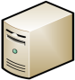 | Server
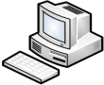 | Personal Komputer
 | User
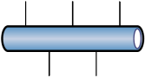 | Ethernet
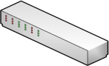 | Swicth
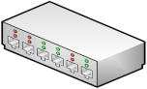 | HUB
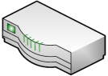 | Router
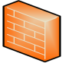 | Firewall
 | Communication Link
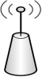 | Wireless Acses Point
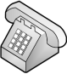 | Telephone
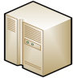 | Mainframe
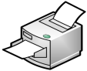 | Printer
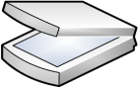 | Scanner

